Preparatory Survey for
Dalton Pass East Alternative Road in
the Republic of the Philippines

Contract

for

Provision of Traffic Survey Services

Between

JICA Study Team

And

SMDI Consultants, Inc.

October 2019

TABLE OF CONTENTS

Contract Agreement…………………………………………………………………………1
Conditions of Contract………………………………………………………………………2
Technical Specifications…………………………………………………………………… 6
Appendix

CONTRACT AGREEMENT

This Contract agreement made and entered into on the 14th of October 2019 by and between:

JICA Study Team represented by Nippon Koei Co., Ltd. duly organized and existing under the laws of Japan, with principal office located at 1-14-6, Kudan-kita, Chiyoda-ku, Tokyo, 102-8539, Japan (hereinafter called the “First Party”)

and

SMDI Consultants, Inc., duly organized and existing under the laws of the Philippines, with principal office located at 7 Annapolis St., Greenhills, San Juan, Metro Manila, Philippines (hereinafter called the “Second Party”)

WITNESSETH THAT:

WHEREAS, the First Party has been retained by the Japan International Cooperation Agency (JICA) for the execution of Preparatory Survey for Dalton Pass East Alternative Road in the Republic of the Philippines (hereinafter referred as the “Survey”) under the contract dated 27th September 2019.

WHEREAS, the First Party intends to employ a local consultant firm to carry out the Provision of Traffic Survey Services (hereinafter referred to as the “Works”).

WHEREAS, the Second Party is willing and agreed to provide the service in accordance with the terms and conditions specified in this Contract.

NOW, THEREFORE, the First Party and the Second Party have agreed to execute the Works in accordance with the terms and conditions in this Contract and within the ceiling Contract Amount of NINE HUNDRED SIXTY THOUSAND NINE HUNDRED SIXTY PESOS and 00/100 (P 960,960.00) only, inclusive of 12% Value-Added Tax.

JICA Study Team SMDI Consultants, Inc.

IPPEI IWAMOTO MERCIDTAS V. TUAZON
Sub Team Leader President

CONDITIONS OF CONTRACT

ARTICLE 1 DEFINITION

Unless the context otherwise requires, the following terms shall have the following meaning in the Contract:

- “JICA” shall mean the Japan International Cooperation Agency;
- “JICA Study Team” shall mean the Joint Venture constitured by of Nippon Koei Co., Ltd., Katahira & Engineers International, Nippon Engineering Consultants Co., Ltd. and Central Nippon Expressway Co., Ltd.
- “DPWH” shall mean the Department of Public Works and Highways;
- “Services” shall mean the work and services to be performed by the Second Party as set forth in Article 3 herein, or any part of the Work and Services as the context may require;
- “Pesos” and the sign “P” shall mean Peso Currency of the Government of the Philippines;
- “Bank(s)” shall mean the Bank(s) nominated by the Second Party for the payments according to Article 7; hereinafter;
- “Project Site” shall mean the location of proposed Dalton Pass East Alternative Road.

ARTICLE 2 THE PROJECT

The Works specified in this Contract shall be executed for the Dalton Pass East Alternative Road Construction Project.

ARTICLE 3 THE SERVICES AND SCOPE OF THE WORK

The Services to be performed by the Second Party include, but are not limited to carrying out the Provision of Traffic Survey Services for the Project, using its own equipment, materials, and labor on the Project Site, as per the Technical Specifications in this Contract.

ARTICLE 4 ASSIGNMENT AND SUBCONTRACTS

The Second Party shall not be allowed to assign the contract or sublet any portion of the Works.

ARTICLE 5 OBLIGATION OF THE SECOND PARTY

In the conduct of the Services, the Second Party shall cooperate fully with JICA, JICA Study Team and DPWH and shall always work in the best interest of them.

ARTICLE 6 COST OF THE SERVICES

The Second Party has agreed to undertake the Services with the Contract Price of NINE HUNDRED SIXTY THOUSAND NINE HUNDRED SIXTY PESOS and 00/100 (P 960,960.00) only, inclusive of 12% Value-Added Tax. The cost breakdown is shown in Appendix B.

ARTICLE 7 PAYMENT FOR THE SERVICES

The amount of the Contract shall be paid in Philippine Peso. The First Party shall pay the Second Party for the Services in accordance with the progress of the performed works as shown hereunder.
Initial Payment : Forty percent (40%) of the total Contract Price shall be paid upon mobilization for the Works.

Final Payment : Sixty percent (60%) of the total Contract Price shall be paid upon approval and final acceptance of the final output/ product.

ARTICLE 8 FORCE MAJEURE

The Second Party shall promptly notify the First Party and vice versa in writing of the occurrence of any event of Force Majeure. As used herein, the term “Force Majeure” shall mean attributable to the causes specified hereunder:

- Natural causes, such as earthquakes, epidemics and other similar causes affecting the project to the extent that would make it impossible or impracticable for the Second Party to carry out, in whole or in part its obligations under this Contract;

- Human causes, such as war, armed invasion, revolution, insurrection, blockages, riots, civil disturbances, strikes or other analogous or similar causes, including the occurrence of a national banking moratorium, to such extent that would make it impossible for the Second Party to carry out, in whole or in part, its obligations under this Contract. The Second Party as of the day of giving such notice shall be relieved from liability for the failure to carry out its obligation due to the occurrence of such event of Force Majeure.

In such event, either Party may terminate this Contract by giving five (5) days notice in writing to the other, upon the giving or receipt of such notice of termination, the Second Party shall take immediate steps to bring the work to a close in a prompt and orderly manner.

Upon termination of this Contract pursuant to the foregoing provisions, the First Party shall not be liable to make any payment to the Second Party except for work or services performed or expenditures incurred prior to the date of such termination of its work and the settlement of its obligation incurred by the Second Party as a result of the Force Majeure, which costs and expense may not have been incurred but for such Force Majeure.

ARTICLE 9 INDEMNITIES

Unless otherwise specified hereunder, the Second Party shall hold the JICA Study Team and its engineers, supervisors, officers, agents and employees free and harmless from any losses as well as any personal injury or damages that may arise out of the performance of the Services or in connection therewith.

ARTICLE 10 INSURANCE

The Second Party shall at its own expense, carry and maintain necessary insurance in accordance with the terms and conditions necessary for the performance of the Services and in accordance with provisions of the laws and/or regulations of the Government and with the prevailing practice in the Philippines, with insurance companies acceptable to the First Party for the whole period of the performance of the work, including but not limited to the following:

Comprehensive automobile liability insurance covering owned, non-owned and hired automotive equipment used by the Second Party for damages itself, injury, death or property damages caused against any Third Party. In spite of the aforesaid insurance, the Second Party shall still be fully responsible for the performance of all obligations as specified herein and the Second Party shall assume all risks.

ARTICLE 11 REPRESENTATIVE

Upon conclusion of the Contract, the Second Party shall assign a representative satisfactory to the JICA Study Team. The representative shall be responsible for handling all the important matters on behalf of the Second Party.

ARTICLE 12 TERMINATION OF THE SECOND PARTY’S SERVICES

The First Party shall have the right to terminate the Services of the Second Party under this Contract for good and sufficient causes by giving five (5) days notice in writing to the Second Party; upon termination of this Contract, the Second Party shall be entitled to receive remuneration for services performed under this Contract up to the termination.

Should the Second Party fail to comply with its obligations under Article 5 herein, or with any other requirements under this Contract, and such failure results in the suspension by the DPWH, this Contract shall be terminated. Should the Works be stopped under order of any court or other public authority through no fault of act of the Second Party, or if the First Party shall fail to comply with the provisions of Article 7 herein, then the Second Party may, on given notice of such occurrence, and unless further Contract is reached, stop work or terminate this Contract and recover payment from the First Party for all fees earned to date of termination all items procured for the work, and for any of all losses sustained by reason of the work stoppage and termination.

ARTICLE 13 TIME SCHEDULE

The time schedule for the Services is shown in Technical Specifications in the Contract.

ARTICLE 14 PROGRESS OF WORK

The Second Party shall execute the work in a professional manner and complete the work strictly in compliance with the provisions and description of the Contract.

ARTICLE 15 PENALTY CLAUSE

In case of failure by the Second Party to comply with the stipulated schedules in the Technical Specifications, a liquidated damage equivalent to one tenth of one (1) percent of the cost of unfinished work shall be paid by the Second Party to the First Party for every day of delay.

ARTICLE 16 LANGUAGE

The English language shall be used in all written communication between, the First Party and the Second Party with respect to this Contract.

ARTICLE 17 OBTAINING OF GOVERNMENT PERMISSION AND APPROVAL

The Second Party with assistance from DPWH shall obtain all necessary permissions and approvals to the Government and other competent authorities concerned required for the Works and shall acquire all the rights and privileges for access to and use of the work site for the purpose of executing the Works.

ARTICLE 18 APPLICABLE LAW

This Contract shall be deemed to be a contract made under, and shall be governed solely and construed in accordance with, the laws of the Republic of the Philippines.

ARTICLE 19 PRESERVATION OF PEACE

The Second Party shall take all reasonable precautions for preventing any unlawful, riotous or disorderly conduct which may be caused by the Second Party’s employees or may occur among them, and/or the preservation of peace and protection of persons and property in the work site and in the area adjacent thereto.

ARTICLE 20 INCOME TAX AND OTHER DUTIES

Under all phases of this Contract, the Second Party shall be liable for its Corporation Tax, Income Tax, duties, contributions and other taxes or charges which may be levied both in the Second Party and its local staff according to the laws and regulations of the Republic of the Philippines.

ARTICLE 21 DISPUTES

In the event of any disputes arising between the parties hereto with respect to the Contract and/or the performance of the Services, the parties hereto shall endeavor to take prompt steps amicable to settle the same.
TECHNICAL SPECIFICATIONS

ARTICLE 1 OBJECTIVES

The objective of the Works is to obtain traffic data and other related data for the route alternative study to be made in the Survey.

ARTICLE 2 FINAL PRODUCTS

The final products of the Works are as follows:
- Traffic volume count data
- OD and interview survey data
- Travel speed survey data including GIS shape file
- Field survey sheets
- Survey report (hard copy and CD-ROM)
- Photo presentation (soft copy only)

ARTICLE 3 SCOPE OF WORK

The Scope of Work shall consist of the following components:
- Roadside OD Interview Survey and Traffic Count Survey
- Travel Speed Survey

ARTICLE 4 METHODOLOGIES

4.1 Roadside OD Interview Survey
The roadside OD interview survey consists of OD interview survey and traffic count survey.
(1) Survey location
  - South side of Santa Fe, point near the border of Nueva Vizcaya and Nueva Ecija Provinces along Dalton Pass (see Figure-1)
  - The proposed survey point is as shown in Figure-2. Location coordinates are as follows: 16°08'00.1"N 120°55'53.4"E.

(2) Duration and date
- 3-day survey
2 weekdays and 1 Sunday

- 24 hours survey from 7:00am to 7:00am (next day)

- On the survey day, it is necessary to select a common day that is not affected by heavy rain or typhoon.

(3) Vehicle types
(For traffic count survey)
Vehicles shall be classified into 12 vehicle types according the DPWH Highway Planning Manual, as follows:
① “Motorcycles / Motor-tricycles”,
② “Passenger Cars (Car/vans, taxis, owner jeeps, SUV)”,
③ “Passenger Utilities (Jeepneys, minibus {less than 13 seats}, mega taxis)”,
④ “Goods utilities (Pick-ups, delivery vans, small trucks {max 4 tons GVW})”,
⑤ “Small Bus (13-30 seats)”, ⑥ “Large Bus (31+seats)”,
⑦ “Rigid Trucks (2 axles)”, ⑧ “Rigid Trucks (3+ axles)”,
⑨ “Truck Semi-Trailer (3-4 axles)”, ⑩ “Truck Semi-Trailer (5+ axles),
⑪ “Truck Trailer (4 axles)”, and ⑫ “Truck Trailer (5+ axles)”.

(For OD interview survey)
OD interview survey will be selected among all vehicle types mentioned above excluding motorcycles (under ① “Motorcycles / Motor-tricycles”).

(4) Preparation
- The Second Party should obtain all the permits required to conduct the surveys on the roads from the relevant administration (e.g., DPWH, traffic police and so on). Police officers are required for safety purposes and for stopping the vehicles on the road at the survey location when conducting the roadside OD interview survey.
- The Second Party should provide all equipment and instruments required for the survey, including the necessary facilities or shelter for protection from weather elements such as rain.
- Data entry format will be provided by the First Party. The Second Party should print necessary amount of copies for the survey.
- The Second Party should prepare the survey manual for surveyors.
- The Second Party should train the necessary personnel for survey works.
- The Second Party should transport the necessary personnel to and from the survey location and prepare their well-being and necessary insurance.
- The Second Party should file all of collected survey sheets by location, date, direction and interviewing time in sequence.
- The Second Party should input survey results in the format by using the software applications designated by the First Party.
- After finishing the data check by the First Party, the Second Party should revise the input data, if required.

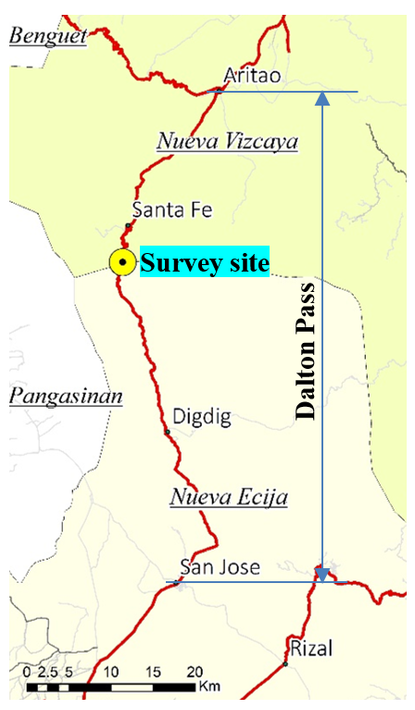

Figure -1 Survey Location

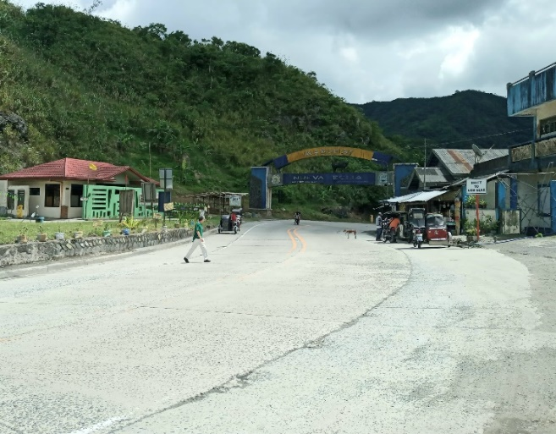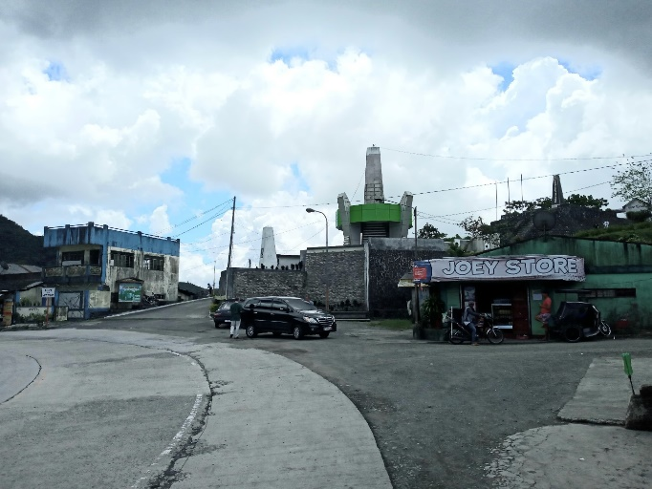
Figure -2 Proposed Survey Point

(5) Method
- Survey team of the Second Party shall stop vehicles to be interviewed at roadside safely with proper support/authorization from the authorities concerned, such as traffic police.
- The survey team shall conduct face-to-face interview with the drivers using the entry forms.
- Sampling ratio shall keep more than 30% of the daily traffic volume of each vehicle type.
- No need to conduct the interview survey to the following vehicle drivers such as motorcycles, unclassified motorized vehicles (emergency vehicle, farm tractor, and so on), and non-motorized vehicles.
- The Origin and Destination addresses obtained in the interview survey shall be coded using the OD zoning table provided by the client.
- Some surveyors of the survey team shall count traffic by vehicle type and record it hourly.
- All the survey results shall be entered into Excel.

(6) Contents of OD interview sheet
- Survey location, direction
- Names of surveyor and supervisor
- Survey date and time
- Vehicle type
- Origin, Destination (Name of location, Municipality and Province)
- Number of passengers including a driver (for all vehicle types except buses, jeepneys)
- Maximum seat numbers and occupancy rate% (for buses (③⑤⑥) only)
- Type of goods, loading weight or loading rate% and Maximum loading capacity (ton) of the vehicle (for trucks (④, ⑦-⑫ only)
- Travel time (hour) between Origin to Destination

4.2 Travel Speed Survey

(1) Duration and date
- One weekday: Morning peak, Evening peak, and Off peak (3 round trips for each Passenger car speed survey and Trailer truck speed survey = 6 round trips total)

(2) Method
  - Place the GPS device on the dashboard of the vehicle used for the travel speed survey and measure the speed for the entire duration of each trip.
  - For the Passenger car speed survey, it is necessary to drive a car by following another passenger car which to seem to drive at an average speed along the subject road for one round trip (San Jose Aritao San Jose) each during morning peak, evening peak, and off peak.
  - For the Trailer truck speed survey, it is necessary to drive a car by following a trailer truck along the subject road for one round trip (San Jose Aritao San Jose) each during morning peak, evening peak, and off peak.

ARTICLE 5 SURVEY SCHEDULE

The overall survey schedule is shown below.

Activity | October
Activity | 14 | 15 | 16 | 17 | 18 | 19 | 20 | 21 | 22 | 23 | 24 | 25 | 26 | 27 | 28 | 29 | 30
- Signing of this Contract
- Ocular inspection of survey area / location
- Coordination with local government unit (LGU), barangay officials and police
- Conduct of Roadside OD Interview Survey and Traffic Count Survey
- Conduct of Travel Speed Survey
- Data processing
- Preparation and submission of final output/ report

ARTICLE 6 SURVEY FORM

The survey forms to be used for the Works are shown in Appendix A.

ARTICLE 7 SPECIFICATIONS FOR PRODUCTS AND DELIVERY DATES

Specifications, file format and delivery date for each product are shown below.

No. | Item | Specification | File Format | Delivery Date
1 | Traffic volume count data | 3 days (2 weekdays, 1 weekend), 1 location, 24 hours, 12 vehicle types, both directions | Excel | Initial: 25  October 2019  Final: 30 October 2019
2 | OD and interview survey data | 3 days (2 weekdays, 1 weekend), 1 location, 24 hours, 12 vehicle types, both directions | Excel | Initial: 25  October 2019  Final: 30 October 2019
3 | Travel speed survey data | 1 weekday, 2 travel speeds at morning peak, evening peak, and off peak: a) passenger car, and b) trailer truck | Excel, GPX, GIS shape file | Initial: 25  October 2019  Final: 30 October 2019
4 | Field survey sheets |  | Hard copy | 30 October 2019
5 | Survey report |  | Hard copy and CD-ROM | 30 October 2019
6 | Photo presentation |  | jpeg | 30 October 2019

END

APPENDIX A

SURVEY FORMS

APPENDIX B

BREAKDOWN OF COST OF THE SERVICES



