Key Issues on Review of F/S
The Consultant will review the relevant documents in the Project with professional experiences especially the preliminary design in the F/S stage to take cognizance of the current arrangement in the Project, extract the key issues which materially affected to the Services and propose our measures.
The Consultant will compile the review results in the Review Report and discuss and obtain the agreement with relevant organizations on the fundamental conditions and approach in the Services.
The Consultant will conduct the review works in the following Main documents and subjects, and will submit the review report not later than 14th August, 2015.
Main Documents
- F/S Report (Oct. 2013)
- EIA Report (Decision No. 1093/QD-BGTVT dated 25th Apr., 2013)
- MOT Approval, List of Technical Standards (Decision No. 1502/QD-BGTVT dated 27th June, 2012)
- MOT Project Appraisal Report (Document No. 1006/KHDT dated 3rd Sep., 2013)
- MOT Approval, Project Investment (Decision No. 2660/QD-BGTVT dated 3rd Sep., 2013)
- MOT Approval, Bidding Plan (Decision No. 542/QD-BGTVT dated 26th Feb., 2014)
Main Subjects
- Comments raised by relevant organizations in the F/S stage¹⁾
- Geographical features in the Project area
- Accuracy of survey reports and data
- Update technical standards list
- Design criteria and conditions
- Alignment and design controls
- Typical cross sections
- Structural types of viaduct
- Girder election methods and detour plan
- Construction contract packaging
- Stage construction plan
- Right of way acquisition situations
- Environmental management plan
- Construction quantity elements and unit prices
Note 1): Refer to Section III, Document No. 1006/KHDT dated 3rd Sep., 2013
At the beginning of the Services, the Consultant already identified the following key issues.
Summary of Key issues are described from the next page.
Key Issues
(1) Modification of Alignment
(2) Road Safety (Beginning Point, Stage 1)
(3) Road Safety (End Point)
(4) Pavement Type
(5) Slab Structure on Steel Box Girders
(6) Weathering Steel
(7) Pier Structure at Steel Box Girders
(8) Pier Structure at Narrow Sections
(9) Location of Rotation Steel Pile
(10) Traffic Management during Girder Erection (Steel Box Girder)
(1) Modification of Alignment
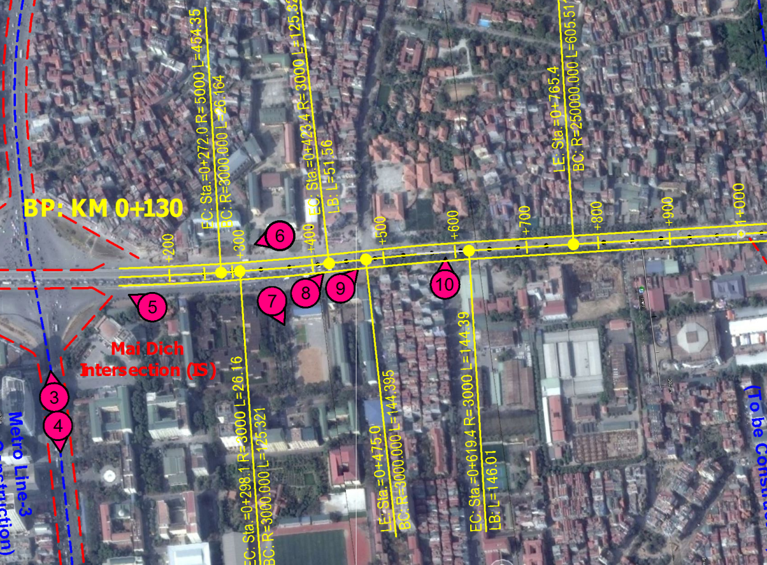
Figure 1 Alignment of the Project

There are several sections which do not satisfy the requirements in Vietnamese Highway design standard (TCVN 5729-2012/TCXDVN 104-2007) like above section.
The Consultant will submit a report titled “Review of Alignment and Proposed Modifications” soon for your review and comments.

(2) Road Safety (Beginning Point, Stage 1)
In order to minimize the land acquisition and resettlement in Stage 1, the Hoang Quoc Viet IC is scheduled in Stage 2 in the F/S plan; therefore, the on/off traffic at Mai Dich IC will be mixed at the weaving section (at grade) in Stage 1 as shown in Figure 1.
In accordance with the relevant international design standards, the Consultant understands that the road safety at the weaving section can be ensured by the following measures:
- Apply traffic regulation (reduce operation speed to 60km/hr) at Mai Dich IC section in Stage 1 of HRR3 to ensure same level of vehicular speeds with that in the frontage road.
- Ensure driver’s recognition to the traffic regulation by signboard and other measures.
Therefore, appropriate traffic safety measures shall be studied in the Services.
Source: F/S Report, PMUTL
Figure 2 Interchange Plan at Mai Dich IC (Stage 1)

(3) Road Safety (End Point)
Geometric design at KM4+995 (near End Point) in the F/S plan is applied as follows:
- Horizontal Curve Radius: R=450m
- Superelevation: e=8%
- Longitudinal Gradient: i=4%
This alignment is designed in conformity with design speed 100km/hr; however, it is applied three critical factors at the same location. In the operation phase, if actual driving speed does not reach to the design speed, it will be caused to the traffic accidents. In particular, this section will be connected to the approach road of Thang Long Bridge; therefore, traffic congestions may be sometime occurred. In such case, heavy truck has a risk to roll over at this section.
Furthermore, this location will be in the South Thang Long Interchange section; therefore, in case of applying the design speed 100km/hr, the maximum longitudinal gradient shall be applied 3% (refer to Table 7, TCVN5729: 2012).
Design speed and geometry at the end point (F/S plan) is shown in Figure 2.
Figure 3 Design Speed and Geometry at the End Point (F/S Plan)

For ensuring design standards and road safety in the operation phase, we propose to apply the design speed 80km/hr at section from KM4+700 to KM5+493.7 (end point) in conformity with the design speed of Thang Long Bridge.
In this case, the geometric design criteria can be applied as follows:
- Horizontal Curve Radius: R=450m
- Superelevation: e=5%
- Longitudinal Gradient: i=4%
Design speed and geometry at the end point (alternative) is shown in Figure 3.
Figure 4 Design Speed and Geometry at the End Point (Alternative)

(4) Pavement Type
Pavement structure is applied dense asphalt pavement in the F/S plan; however, rutting by heavy vehicles on the existing roads is currently important issue in Vietnam.
Therefore, the Consultant will study to apply polymer pavement to ensure smoothness of road surface and ensure life cycle cost in the Project road.
(5) Slab Structure on Steel Box Girder
Slab structure type on the steel box girder in the F/S Report has a discrepancy as follows:
- Section 9: Study of Bridge Type Selection, General Report: RC Slab
- Section 10: Study of Construction Method, General Report: Steel-Concrete Composite Slab
The Consultant understands that the RC slab is not suitable for span length: 4.5m.
On the other hand, the steel-concrete composite slab is not required traffic regulation after installation of steel bottom panel; however, economy and durability shall be studied.
Therefore, the Consultant will conduct comparison study in the following alternatives:
- Steel-Concrete Composite Slab
- PC Slab
Image of steel-concrete composite slab is shown in Figure 5.
Location of Steel Bottom Panel | Installation Works
Source: Japan Iron and Steel Federation
Figure 5 Image of Steel-Concrete Composite Slab

(6) Weathering Steel
It is not clearly mentioned on MOT Decision No. 2660/QD-BGTVT dated 3rd September, 2013; however, it seems weathering steel with paintings is applied as corrosion protection in the F/S Report.
However, weathering steel is inappropriate at the Project site by the following reasons:
- Project site is not at corrosive environment conditions.
- Life of fluoropolymer is around 40 to 50 years.
- Workability for touch-up and re-painting works at the Project site is quite well.
Moreover, applicability of weathering steel at the Project site was not evaluated by the exposure test and its analysis in the F/S stage and it will take more than 1 year, if the test conducted.
Therefore, the Consultant recommends applying the ordinary structural steel with fluoropolymer paintings by reason of technical and economical aspects.

(7) Pier Structure at Steel Box Girder
Two (2) steel box girder bridges (fewness type) are planned at Hoang Quoc Viet and West Thang Long Intersections in the F/S plan; however, depth of pier cross beam is very deep and it is critical design control in the profile of the Project road.
For improving the profile at the steel box girder bridge sections, the Consultant will study the following alternative pier structures:
- Center Pier: Hybrid Frame Pier
- End Pier: Treating girder end (by applying taper rounding girder)
Image of alternative pier structures at (steel box girder sections) are shown in Figure 6.
Source: F/S Report, PMUTL

Figure 6 Image of Alternative Pier Structures (Steel Box Girder Sections)

(8) Pier Structure at Narrow Sections
Cast-in-place RC pier (temporary portal frame support method) is planned at Narrow Sections in the F/S plan (see Figures 1-3 and 1-5); however, in consideration of traffic safety and flow during construction of cross beam, the Consultant will study the following alternative plan:
- Pre-cast RC Pier
- Cast-in-place RC Pier (Over-hanging Method)
- Steel-Concrete Hybrid Pier (Crane Erection method)
Image of alternative pier plan (narrow section) is shown in Figure 7 in the next page.

Figure 7 Image of Alternative Pier Plan (Narrow Section)

(9) Location of Rotation Steel Pile
Rotation steel piles are planned at all pier locations in the Narrow Sections in the F/S plan (see Figures 1-3 and 1-5); however, it is not clearly explained to apply the rotation steel piles in the F/S report.
The Consultant understands to apply the rotation steel piles by the following reasons:
- Reduce pile cap width to ensure existing road and pedestrian width during foundation works.
- Ensure completion of foundation works within night time.
- Ensure mitigation of noise and vibration to local residents and buildings in night time.
On the other hand, construction cost of rotation steel piles is higher than bored piles; therefore, the Consultant will review the locations of rotation steel pile taking into account the above requirements.
A part of detour plan during foundation works is shown in Figure 8.
Source: F/S Report, PMUTL
Figure 8 A Part of Detour Plan during Foundation Works (At Narrow Sections)

(10) Traffic Management during Girder Erection (Steel Box Girder)
Bridge construction method in the F/S plan is mostly appropriate and it is the most economical option in case of considering the impacts to the existing traffic and local residents during the construction works. On the other hand, it is not clearly mentioned the detour plan at the intersections in the F/S plan; therefore, the Consultant will propose applying the temporary roundabout as shown in Figure 9 in the next page.
It is necessary to obtain the approval from the existing road operators; however, this bridge construction method at the intersections may be appropriate by the following reasons:
- Safety during erection works can be ensured.
- Land space inside temporary roundabout can be utilized as construction yards.
- Serious traffic congestions were not occurred in the past projects (i.e. Kim Ma Flyover).
Image of temporary roundabout (Kim Ma Flyover) is shown in Figure 9 in the next page.

Photo: Temporary Roundabout at Intersection
Image: Temporary Roundabout and Traffic Flow
Source: HPC
Figure 9 Image of Temporary Roundabout (Kim Ma Flyover)

