Ministry of Transport
Vietnam Expressway Corporation
Project Management Unit No. 85

IDA Credit No. : 3843-VN
Project ID No. : P106235

Consulting Services

for

Detailed Design for Danang - Quang Ngai Expressway Development Project

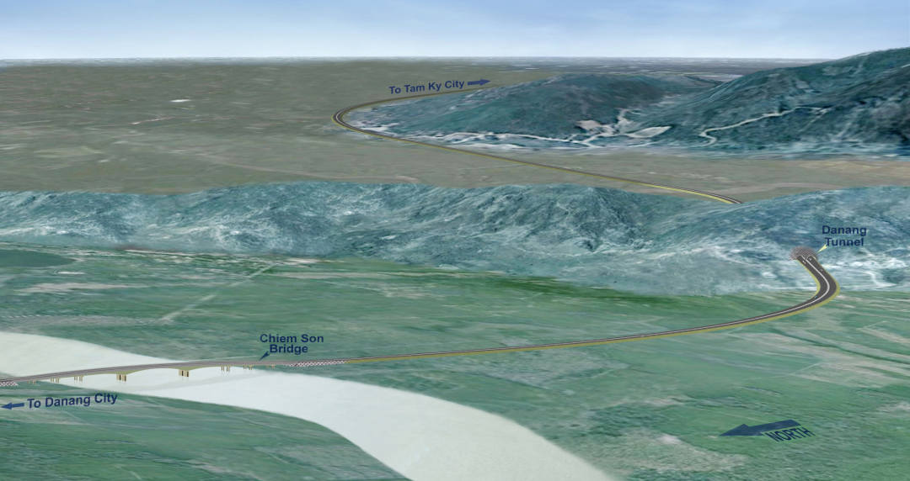

Inception Report

December 26, 2011

The Joint Venture of
THAI ENGINEERING CONSULTANTS CO., LTD.

