Letter of Submission
Project Location Map

Table of Contents

Letter of Submission i
Table of Contents i
Appendix iv
Abbreviations v
1. General 6
1.1. Composition of Basic Design Report 6
1.2. Objective 6
1.3. Background 6
1.4. Project Location 6
1.5. Technical Standards to be Applied to the Project 6
2. Major Updates from the F/S 6
2.1. Summary 6
2.2. Methodology of Basic Design 7
2.3. Technical Standards to be Applied to Road Design 7
2.4. Design Criteria 7
2.5. Typical Cross Sections 8
2.6. Modification of Horizontal Alignment 11
2.7. Modification of Vertical Alignment 12
2.7.1. Methodology 12
2.7.2. Design Control (1), Design High Water Levels 13
2.7.3. Design Control (2), Water Crossing Structures 24
2.7.4. Cross Structure Plan 30
2.7.5. Design of Vertical Alignments 31
2.8. Status of Agreement Process with Local Authorities 33
3. Basic Design of Interchanges 35
3.1. General 35
3.2. Review of Previous Studies 35
3.3. Location of Interchanges 36
3.4. Geometric Design Criteria 37
3.5. Typical Cross Sections 38
3.5.1. Rampway 38
3.5.2. Connecting Road 41
3.5.3. Ramp Terminal 44
3.6. Basic Design of Each Interchange 49
3.6.1. Tuy Loan IC 49
3.6.2. My Son IC 1
3.6.3. Ha Lam IC 2
3.6.4. Tam Ky IC 3
3.6.5. Chu Lai IC 4
3.6.6. Dung Quat IC 5
3.6.7. Binh Son IC 6
3.6.8. Quang Ngai North IC 7
3.7. Basic Layout of All Interchanges 8
4. Basic Design of Major River Bridges 8
4.1. General 8
4.1.1. Location of Major River Bridges 8
4.1.2. Summary of Major River Bridges 9
4.2. Review of Previous Studies 9
4.3. Basic Design of Four Major River Bridges 9
4.3.1. Ky Lam Bridge 9
4.3.2. Chime Son Bridge 9
4.3.3. Tra Bong Bridge 10
4.3.4. Tra Khuc Bridge 10
5. Basic Design of Other Bridges 2
6. Basic Design of Tunnel 2
7. O&M Plan and Design 2
7.1. Location of O&M Buildings 2
8. Updating EIA and EMP 2
8.1. Examination of validity of the proposed alignment 2
8.1.1. Alignment alternatives proposed by the studies in the past 2
8.1.2. Examination of validity of the proposed alignment 3
8.2. Checklist of Environmental Impacts 7
8.3. Potential Impacts and Mitigation Measures 9
8.3.1. Air Pollution and Mitigation Measures 10
8.3.2. Surface Water Pollution and Mitigation Measures 13
8.3.3. Impacts of Spoil/Waste Soils and Mitigation Measures 14
8.3.4. Excessive Noise and Mitigation Measures 15
8.3.5. Impacts on Terrestrial Ecosystem and Mitigation Measures 18
8.3.6. Impacts on Hydrological Situation (Flood and Inundation) and Mitigation Measures 19
8.3.7. Impacts on Topography, Soil Erosion and Mitigation Measures 20
8.3.8. Impacts of Land Acquisition and Resettlement and Mitigation Measures 21
8.3.9. Impacts on Local Residents’ Living, Livelihood, Economy and Mitigation Measures 21
8.3.10. Impacts to Cultural/Archaeological Properties and Mitigation Measures 21
8.3.11. Impacts to Local Communities (Traffic Congestion, Accidents) and Mitigation Measures 25
8.3.12. Impacts of Split of Communities and Mitigation Measures 27
8.3.13. Hazard and Mitigation Measures 28
8.3.14. Impacts of Construction Materials Exploitation and Transportation (Access Roads) and Mitigation Measures 28
8.4. Public Consultation 31
8.4.1. Organization of Public Consultation Meeting 31
8.4.2. Public Opinions 32
8.5. Environmental Management Plan (EMP) 33
8.5.1. Purpose of the Environmental Management Plan 33
8.5.2. Summary of the Environmental Management Plan 34
8.5.3. Implementing Organizations 35
8.5.4. Summary of the Environmental Monitoring Plan (EMoP) 36
8.6. Review of Previous Studies 37
9. Updating Resettlement Action Plan (RAP) 37
9.1. General 37
9.2. Review of Previous Studies 38
9.2.1. Relevant Regulations 38
9.2.2. Land Acquisition and Resettlement Plan 38
9.2.3. Results of Public Consultation 39
9.3. Mitigation measures to social and resettlement impacts 39
9.4. Working steps and the implementation arrangement 40
9.5. Division and schedule of Updated Resettlement Plan (URPs) Reports 41
10. Construction Planning 42
10.1. General 42
10.2. Review of Previous Studies 42
11. Project Cost Estimate 42
11.1. General 42
11.2. Comparison of Unit Cost between Now and F/S 42
11.3. Total Cost with Unit Cost of F/S 42
11.4. Total Cost with Unit Cost of Present Market 42
12. Conclusion 42

Appendix

---------Fixed--------------------------
Appendix 1 : Technical Standards to be applied to the Project
Appendix 2.1 : Review of Previous Studies (Expressway)
Appendix 2.2 : Typical Cross Sections (Report)
Appendix 2.3 : Typical Cross Sections (Drawings)
Appendix 2.4 : List of Cross Structure (As of June 2012)
Appendix 3.1 : Review of Previous Studies (Interchange)
Appendix 3.2 : Basic Layout of Interchanges (Drawings)
Appendix 4 : Review of Previous Studies (Three Major River Bridge)
Appendix 5.1 : List of Bridges in F/S
Appendix 5.2 : General View of Thruway Bridges in Package A4
Appendix 5.3 : General View of Bridges in IC Sections in Package A4
Appendix 5.4 : General View of Flyovers in Package A4
Appendix 5.5 : Main Bridge Structural Dimensions in Basic Design
Appendix 6 : Review of Previous Studies (Tunnel)
Appendix 7 : N/A
Appendix 8 : Review of Previous Studies (Social and Environmental)
---------Fixed--------------------------

Appendix 10 : List of Basic Documents for Cost Estimate
Appendix 19 : List of Collected Data
Appendix 20 : List of Crossing of Electrical Lines
Appendix 23 : List of Communes along the Expressway

Appendix 6 : Review of Previous Studies (Major River Bridges)
Appendix 7: Review of Previous Studies (Other Bridges)
Appendix 8 : Review of Previous Studies (Drainage)
Appendix 9 : Review of Previous Studies (O&M)
Appendix 10 : Review of Previous Studies (Social and Environmental)
Appendix 11 : Review of Previous Studies (RAP)
Appendix 12 : Review of Previous Studies (Construction Planning)
Appendix 13 : Review of Previous Studies (Project Cost Estimate)

Abbreviations

AASHTO : American Association of State Highway and Transportation Officials
B/D : Basic Design
BP : Beginning Point
CBR : California Bearing Ratio
DARD : Department of Agriculture and Rural Development
D/D : Detailed Engineering Design
DPC : District People’s Committee
DRC : District Resettlement Committee
EIA : Environmental Impact Assessment
EMP : Environmental Management Plan
EP : Ending Point
ESCRD : Environmental and Social Considerations Review Division
ETC : Electric Toll Collection
EVN : Electricity of Vietnam
FO : Flyover
F/S : Feasibility Study
GOVN : Government of Vietnam
GPS : Global Positioning System
HCMC : Ho Chi Minh City
HIDO : Highway Industry Development Organization, Japan
HIV : Human Immunodeficiency Virus
HVL : High-voltage Line
IBRD : International Bank for Reconstruction and Development
IC : Interchange
ICB : International Competitive Bidding
ICR : Inception Report
ID : Identification
IDA : International Development Association
I/P : Implementation Program
IS : Intersection
ITR : Interim Report
ITS : Intelligent Transport Systems
JEHDRA : Japan Expressway Holding and Debt Repayment Agency
JICA : Japan International Cooperation Agency
JPY : Japanese Yen
JRSO : Japan Road Structure Ordinance
MEX : Metropolitan Expressway Co., Ltd., Japan
MLIT : Ministry of Land, Infrastructure, Transport and Tourism, Japan
MOM : Minutes of Meeting
MONRE : Ministry of Natural Resources and Environment
MOT : Ministry of Transport
NEXCO : Nippon Expressway Company Limited, Japan
O&M : Operation and Maintenance
ORSE : Organization for Road System Enhancement, Japan
PA : Parking Area
PC : People’s Committee
PKG : Package
PMBOK : Project Management Body of Knowledge
PMU : Project Management Unit
PPC : Provincial People’s Committee
P/Q : Pre-qualification
PTC2 : Power Transmission Company No. 2
RAP : Resettlement Action Plan
RFP : Request for Proposals
RP : Resettlement Plan
SA : Service Area
SAE : Social and Environmental
TMC : Traffic Management Center
TOR : Terms of Reference
USD : United States Dollars
VEC : Vietnam Expressway Corporation
VICS : Vehicle Information and Communication System
VIETTEL : Vietnam Military Electronic and Telecommunications Corporation
VND : Vietnamese Dong
VNPT : Vietnam Posts and Telecommunications Group
WB : The World Bank

General

Composition of Basic Design Report
This basic design report consists of the following volumes:
Volume 1: Executive Summary (This book)
Volume 2: Main Text
Volume 3: Appendices
Volume 4: Drawings

Objective
The objective of the Basic Design Report, Civil, is to show the result of the basic design, to be confirmed by the relevant organization, as the basis of subsequent detail design.

Background
The preparation of the Project was started as BOT project back in the year 2000. However, this BOT scheme Project did not materialize because of funding sources were not identified at that time.
In the year 2007, the Project was approved as one of the top priority projects in transport sector by GOVN. In order to carry forward the Project, GOVN requested JETRO to assist a further study expecting materialization of the Project by a JBIC (currently JICA) loan scheme in June 2007. JETRO conducted the study and submitted the study report to MOT on April, 2008. After submission of the JETRO study report, WB conducted the WB supplemental study and the study report was prepared by PMU85 and submitted to MOT in his letter No. 551/BQl-KHDA2 dated on June 13, 2009.
During the WB appraisal study, three (3) sections of the expressway was modified, and subsequently, TEDI updated the supplemental study and finalized the F/S report. The F/S report was approved by MOT in Decision No. 2656/QD-BGTVT dated on September 10, 2010.
Utilizing the fund from WB’s RNIP, the Joint Venture of Nippon Koei Co., Ltd., Nippon Engineering Consultants Co., Ltd., Chodai Co., Ltd., and Thai Engineering Consultants Co., Ltd. (the Consultant) was selected for the detailed design, and the detailed design works was commenced on December 1, 2011.

Project Location
The Project road is a part of the North-South Expressway located in parallel with the existing NH1A and North-South Railway and passing through Da Nang city, Quang Nam and Quang Ngai provinces in the central region.
The road starts at the intersection of the Da Nang Bypass and NH14B in Da Nang city and ends at the connecting point with the planned City Ring Road at existing NH1A in Quang Ngai province, as shown in the project location map.

Technical Standards to be Applied to the Project
Technical standards to be applied in this project have been approved by MOT by Decision No. 362/QD-BGTVT dated 20 February 2009, and Decision No. 727/QD-BGTVT dated 6 April 2012 as shown in Appendix 1: Technical Standards to be applied to the Project.

Major Updates from the F/S

Summary
Major updates have been prepared for the following design elements:
- Horizontal Alignment
- Vertical Alignment
- Typical Cross Sections
- Type of Cross Structures
- Type of Major River Bridges
- Type of Other Bridges
- Locations of Interchanges

1) Horizontal Alignment
The Consultant updated all of the horizontal design controls by carrying out comprehensive site reconnaissance, utilizing the scale of 1/1,000 topographic map, accordingly eight (8) sections of centerline was modified.
2) Vertical Alignment
Vertical design controls were updated, firstly by design high water level (DHWL) updated by hydrological survey and analysis, and secondly by updated cross structure requirements, accordingly the vertical alignment was modified for the whole of the expressway.
3) Typical Cross Sections
Typical cross sections were studied carefully for the expressway, the linking road and the cross roads. For the expressway, considering practical cost reduction and future widening, several standard cross sections are developed. For the cross roads,
4) Type of Cross Structures
All cross structures, waterways and roadways, have been updated in accordance with the updated hydrological analysis,
5) Type of Major River Bridges
6) Type of Other Bridges
7) Locations of Interchanges

Methodology of Basic Design
- Confirmation of Applicable Technical Standards
- Establish Geometric Design Criteria
- Preparation of Typical Cross Sections
- Modification of Horizontal Alignment
- Modification of Vertical Alignment
- Relocation of Existing Roads, and Provision of Frontage Roads

Technical Standards to be Applied to Road Design
Geometric design standards are specified in Decision No. 362/QD-BGTVT and Decision No. 2656/QD-BGTVT, TCVN5729-97 shall be applied for the thruway design standard and TCVN5729-97 and 22TCN 273-01 shall be applied for interchange ramp-ways design standards.
AASHTO 2011 (6th Edition) or JRSO (Japan Road Structure Ordinance, 2004) were also be referred where some design elements are not clearly stipulated in TCVN5729-97 or 22TCN 273-01.

Design Criteria
According to Decision No. 2656/QD-BGTVT, application of “Type-A (design speed 120km/h)” highway classification in TCVN5729-97 is applied for the highway design.
The consultant established design criteria for thruway mainline based on the highway classification and examination of the geometric design standards as shown in Table 2.4-1.

Table 2.4-1 Geometric Design Criteria for Expressways (Thruway)
Design Elements |  |  |  |  | Type/Value | Remarks | Reference
1 | Expressway Classification
 | Expressway Type A |  |  |  | Grade 120 |  | TCVN5729
2 | Terrain |  |  |  | Flat |  | TCVN5729
3 | Design Speed (km/h) |  |  |  | 120 |  | TCVN5729
4 | Cross-Sectional Elements | Number of Travelled Way |  |  | 4 |  | F/S
4 | Cross-Sectional Elements | Formation Width (m) |  |  | 26.0(25.5) | Median narrowing is under consideration | F/S(D/D)
4 | Cross-Sectional Elements |  | Travelled Way Width(m) |  | 2 x 7.5 |  | TCVN5729
4 | Cross-Sectional Elements |  | Outer Shoulder Paved Width (m) |  | 3.0 |  | TCVN5729
4 | Cross-Sectional Elements |  | Outer Shoulder Earthen Width (m) |  | 0.75 |  | F/S
4 | Cross-Sectional Elements |  | Median Width (m) |  | 2.0(1.5) | Narrowing is under consideration | F/S(D/D)
4 | Cross-Sectional Elements |  | Median Marginal Strip (m) |  | 0.75 |  | TCVN5729
4 | Cross-Sectional Elements | Crossfall of Roadway (%) |  |  | 2.0 |  | TCVN5729
4 | Cross-Sectional Elements | Slope of Earthworks
4 | Cross-Sectional Elements |  | Fill |  | V : H = 1:2.0 |  | F/S
4 | Cross-Sectional Elements |  | Cut |  | V : H = 1:1.0 |  | F/S
4 | Cross-Sectional Elements |  |  |  | V : H = 1:0.75 | Stone Class 4 | F/S
5 | Sight Dist. | Stopping Sight Distance (m) |  |  | 210 |  | TCVN4054
6 | Horizontal Alignment | Horizontal Curve
6 | Horizontal Alignment |  | Desirable Minimum Radii of Horizontal Curve (m) |  | 1000 |  | TCVN5729
6 | Horizontal Alignment |  | Absolute Minimum Radii of Horizontal Curve (m) |  | 650 |  | TCVN5729
6 | Horizontal Alignment | Superelevation (Se) |  |  |  |  | TCVN5729
6 | Horizontal Alignment |  | Maximum Se for Desirable Min. Radius (%) |  | 5.0 |  | TCVN5729
6 | Horizontal Alignment |  | Maximum Se for Absolute Min. Radius (%) |  | 7.0 |  | TCVN5729
6 | Horizontal Alignment |  | Minimum Radii w/o Superelevation (m) |  | >4000 |  | TCVN5729
6 | Horizontal Alignment | Transition Curve
6 | Horizontal Alignment |  | Minimum Length for Desirable Min. Radius (m) |  | 210 |  | TCVN5729
6 | Horizontal Alignment |  | Minimum Length for Absolute Min. Radius (m) |  | 150 |  | TCVN5729
7 | Vertical Alignment | Maximum Grade-Up (%) |  |  | 4.0 |  | TCVN5729
7 | Vertical Alignment | Maximum Grade-Down (%) |  |  | 5.5 |  | TCVN5729
7 | Vertical Alignment | Minimum Grade (%) |  |  | 0.5 | Cut Section | TCVN5729
7 | Vertical Alignment |  |  |  | 1.0 | Transitional Sections  with SE of less than 1% | TCVN5729
7 | Vertical Alignment |  |  |  | 0.3 | Tunnel Section | TCVN5729
7 | Vertical Alignment | Critical Maximum Length of Grades
7 | Vertical Alignment |  | For 4.0 % (m) |  | 600 |  | TCVN5729
7 | Vertical Alignment | Minimum Length of Grade (m) |  |  | 300 |  | TCVN5729
7 | Vertical Alignment | Vertical Curve
7 | Vertical Alignment |  | Minimum Length of Vertical Curve (m) |  | 100 |  | TCVN5729
7 | Vertical Alignment |  | Minimum Radius of Crest Curve (m)
7 | Vertical Alignment |  |  | Absolute Minimum Radius (m) | 12000 |  | TCVN5729
7 | Vertical Alignment |  |  | Desirable Minimum Radius (m) | 17000 |  | TCVN5729
7 | Vertical Alignment |  |  | Desirable Radius (m) | 20000 |  | TCVN5729
7 | Vertical Alignment |  | Minimum Radius of Sag Curve (m)
7 | Vertical Alignment |  |  | Absolute Minimum Radius (m) | 5000 |  | TCVN5729
7 | Vertical Alignment |  |  | Desirable Minimum Radius (m) | 6000 |  | TCVN5729
7 | Vertical Alignment |  |  | Desirable Radius (m) | 12000 |  | TCVN5729
8 | Lateral Clearance (m) |  |  |  | Travelled width |  | TCVN5729
8 | Vertical Clearance (m) |  |  |  | 4.75 |  | TCVN5729

Typical Cross Sections
Number of lanes on thruway during the initial stage is four and widening to six lanes is planned as ultimate stage according to Decision No. 2656/QD-BGTVT issued by MOT on 10 September 2010. In the F/S, nonstandard and exceptional values of cross section elements were proposed.
Through several times of discussion, cross sectional elements of the thruway, including the initial stage and the ultimate stage, were decided as shown in Table 2.5-1.
Table 2.5-1 Total Width of Sections
Section | Total Width | Remarks
General  (Initial Stage) | 25.5m | Median 1.5m  Marginal Strip (Inner) 0.75m@2  Travelled Way 3.75@4  Paved Shoulder 3.0@2  Earthen Shoulder 0.75@2
Bridge (PC-Box) | 26.0m (Initial Stage) | Median 1.5m  Marginal Strip (Inner) 0.75m@2  Travelled Way 3.75@4  Paved Shoulder 3.0@2  Parapet, Service Space 1.0@2
Bridge (PC-Box) | 26.0m (Ultimate Stage) | Median 1.5m  Marginal Strip (Inner) 0.50m@2  Travelled Way 3.50@6  Marginal Strip (Outer) 0.50@2  Parapet, Service Space 0.75@2
Bridge (Other than PC-Box)  (Initial Stage) | 25.5m | Median 1.5m  Marginal Strip (Inner) 0.75m@2  Travelled Way 3.75@4  Paved Shoulder 3.0@2  Parapet, Service Space 0.75@2

The Consultant carried out the examination of cross sectional element of throughway and submitted the report as shown in Appendix 3: Typical Cross Sections (Report).
Accordingly, the consultant developed proposed 15 types of typical cross sections for thruway section (embankment, cut, cut and fill, bridge, and tunnel) and linking road section.
Drawings of the proposed typical cross section are as shown in and Appendix 4: Typical Cross Sections (Drawings).

Table 2.5-2 List of Proposed Typical Cross Section for Thruway (M Series)
No. | Classification | Width (m) | Initial Stage | Ultimate Stage
M-01 | Embankment | 25.50 | x | ---
M-02 | Embankment w Frontage Road | 25.50 | x | ---
M-03 | High Embankment | 25.50 | x | ---
M-04 | Cut & Fill Section | 25.50 | x | ---
M-05 | Cut Section (H <15m) | 25.50 | x | ---
M-06 | Cut Section (H >15m) | 33.00 | --- | x
M-07 | Cut Section with Climbing Lane | 33.00 | --- | x
M-08 | Embankment (w Noise Barrier) | 25.50 | x | ---
M-09 | PC-Box Girder (Initial) | 26.00 | x | ---
M-10 | PC-Box Girder (Ultimate) | 26.00 | --- | x
M-11 | Other Bridge (Initial) | 25.50 | x | ---
M-12 | Other Bridge (Ultimate) | 33.00 | --- | x
M-13 | Tunnel (Initial) | 12.80 | x | ---
M-14 | Tunnel (Ultimate) | 13.05 | --- | x
M-15 | Danang Bypass Section |  | x | x

Table 2.5-3 List of Proposed Typical Cross Section for Linking Road (L Series)
No. | Classification | Width (m) | Initial Stage | Ultimate Stage
L-01 | Embankment | 12.00 | x | ---
L-02 | Bridge | 12.00 | x | ---

Table 2.5-4 List of Proposed Typical Cross Section for Interchange Rampways (R Series)
No. | Classification | Width (m) | Initial Stage | Ultimate Stage
R-01 | 1 Direction 1 lane | 8.50 | x | ---
R-02 | 1 Direction 2 lane | 10.50 | x | ---
R-03 | 2 Direction 1 lane | 15.50 | x | ---
R-04 | 2 Direction 1-2 lane | 17.50 | x | ---
R-05 | 2 Direction 2 lane | 19.50 | x | ---
R-06 | 1 Direction 1 lane (Bridge) | 8.50 | x | ---
R-07 | 1 Direction 2 lane (Bridge) | 10.50 | x | ---
R-08 | 2 Direction 1 lane (Bridge) | 15.50 | x | ---
R-09 | 2 Direction 1-2 lane (Bridge) | 17.50 | x | ---
R-10 | 2 Direction 2 lane (Bridge) | 19.50 | x | ---

Table 2.5-5 List of Proposed Typical Cross Section for Cross Roads (R Series)
No. | Road  Classification | Width (m) | Remarks
X-RD-01 | I | 33.5 | National Highway
X-RD-02 | II | 23.5 | Provincial Road
X-RD-03 | III | 12 | District Road
X-RD-04 | IV | 9
X-RD-05 | V | 7.5
X-RD-06 | VI(AH) | 6.5
X-RD-07 | A | 5
X-RD-08 | B | 4
X-RD-09 | C | 3
X-BR-01 | I | 33.5 | National Highway
X-BR-02 | II | 23.5 | Provincial Road
X-BR-03 | III | 12 | District Road
X-BR-04 | IV | 9
X-BR-05 | V | 7.5
X-BR-06 | VI(AH) | 7.5
X-BR-07 | A | 6
X-BR-08 | B | 5
X-BR-09 | C | 4
X-BOX-01 | VI(AH) | 6.5
X-BOX-02 | A | 5
X-BOX-03 | B | 4
X-BOX-04 | C | 3

Modification of Horizontal Alignment
Identification of horizontal design controls, based on the scale of 1 to 1,000 topographical map and site investigation, was carried out.
Subsequently, horizontal alignment has examined based on the identified horizontal design controls in comparison with the horizontal alignment in F/S.
The alignment modification result has been discussed at several meetings with MOT, WB, VEC, and PMU and has basically obtained agreement.
Finally, there are eight (8) locations where the horizontal alignment were modified from that in the F/S as shown in Table 2.6-1.
A Technical Report titled “Finalization of Expressway Alignment is shown in Volume 2.

Table 2.6-1 List of Alignment Modifications
No. | Station |  |  |  | Contents of  Modification | Reason for  Modification
No. | F/S alignment |  | Modified alignment  (D/D alignment) |  | Contents of  Modification | Reason for  Modification
No. | BP | EP | BP | EP | Contents of  Modification | Reason for  Modification
1 | KM019+240 | KM030+681 | KM019+300 | KM030+796 | Substitute R1200 for R1000 and shift align southward | Remediation of tunnel plan  Avoid a school and a temple
2 | KM033+406 | KM036+773 | KM033+522 | KM036+900 | Shift align eastward by R4800 curves | Avoid a rocky mountain
3 | KM042+296 | KM047+608 | KM042+422 | KM047+731 | Shift align westward by R80000 | Avoid bending rivers
4 | KM047+608 | KM054+723 | KM047+731 | KM054+853 | Insert R5000 in tangent | Avoid a temple
5 | KM057+817 | KM059+898 | KM057+943 | KM060+025 | Insert a series of curves (R6000-R10000) | Avoid a long tangent
6 | KM071+313 | KM081+569 | KM071+443 | KM081+384 | Substitute spirals and curves for R5000 | Passing shooting area
7 | KM084+837 | KM096+125 | KM084+652 | KM095+922 | Shift align westward by R34000  Change a series of curves | Avoid Monument  Avoid water reservoir and HVL
8 | KM100+224 | KM106+854 | KM099+720 | KM106+535 | Change a series of curves | Avoid 500KV HVL

Modification of Vertical Alignment

Methodology
The Consultant finalized vertical alignment design, section by section, based on the results of the alternative study results and discussion results of local authority meetings. General work flow of the alternative study is shown in Figure 2.7-1.

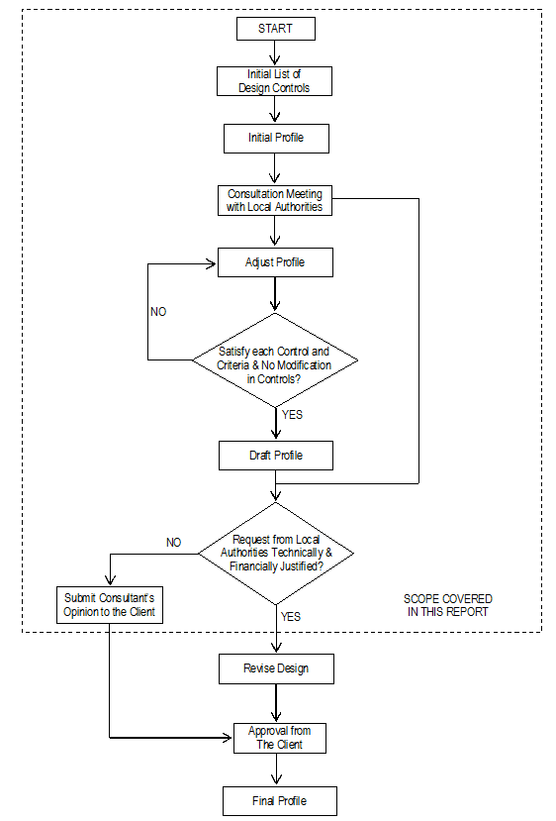
Figure 2.7-1 General Work Flow for Finalization of Vertical Alignment

Design Control (1), Design High Water Levels
Vertical alignment has modified from the F/S based on hydrological and inundation analysis result, and cross structure plan.
Based on TCVN5729, the minimum formation height of the roadway is determined from the following water levels;
- Design High Water Level
- Design Stagnant Water Level (inundation) if applicable
- The Design High Water Level shall be calculated based on one (1) percent frequency
- The lowest point on road surface (outer edge of shoulder) shall be 0.5 m higher than the estimated Design High Water Level.
Design Stagnant Water Level is caused by seepage of ground water from surrounding areas during prolonged rainfall at flat terrain conditions. Bottom of pavement shall be higher than the Design Stagnant Water Level by recommended depth (from 0.3m to 1.2m depending on different embankment material type and whether the number of days subjected to flooding per year is over or under 20 days).
In this project, mainly the Design High Water Level criteria govern the design, since viaduct is designed for the inundated areas. The design of vertical alignment will consider the design level required for 6-lanes of road in the ultimate stage.

Table 2.7-1 Design and Monitoring Framework for Determination of Vertical Alignment in Basic Design
Steps. | Input | Data Source | Problem Identification | Design Activity Requirements | Confirmation Requirements | Output | Outcome
1 | F/S Review of DHWL | F/S Report | Difference between F/S and D/D DHWL identified | Modify vertical alignment from DHWL requirements |  | Initial vertical alignment from DHWL requirements determined. | Vertical controls from DHWL determined and fixed
1 | F/S Review of DHWL | D/D Hydrological Report
1 | F/S Review of DHWL | D/D Topographical Survey Results
2 | F/S Review of culverts locations /dimensions | F/S Report | Difference between F/S and D/D locations and dimensions of culverts identified | Modify vertical alignment from hydrological and local irrigational requirements of culverts | Agreement with local authorities on culvert locations and dimensions | Interim vertical alignment from hydrological and local irrigational requirements of culverts determined. | Culvert locations/dimensions from hydrological and local irrigational requirements determined and fixed
2 | F/S Review of culverts locations /dimensions | D/D Hydrological Report
2 | F/S Review of culverts locations /dimensions | D/D Topographical Survey Results
3 | F/S Review of water crossing bridges | F/S Report | Difference between F/S and D/D locations and dimensions of water crossing bridges identified | Modify vertical alignment from hydrological requirements of water crossing bridges | Agreement with local authorities on water crossing bridges locations and dimensions | Interim vertical alignment from hydrological requirements of water crossing bridges determined | Water crossing bridges locations/ dimensions from hydrological requirements determined and fixed
3 | F/S Review of water crossing bridges | D/D Hydrological Report
3 | F/S Review of water crossing bridges | D/D Topographical Survey Results
4 | F/S Review of road crossing structures | F/S Report | Deficiency on F/S profile from D/D hydrological and irrigational requirements |  |  | Design concept for road crossing structures based on local road network requirements determined. | Type of road crossing structures determined and fixed at some locations based on profile from hydrological and irrigational requirements
4 | F/S Review of road crossing structures | D/D Topographical Survey Results
4 | F/S Review of road crossing structures | Future plans of crossing roads along the alignment
4 | F/S Review of road crossing structures | Satellite photos
5 | Alternate Analysis on type of road crossing structures | F/S Report | Deficiency on F/S road crossing structures identified from prepared design concept | Adjustment of vertical alignment for road crossing structures requirements | Agreement with local authorities on road crossing structures types, locations and dimensions | Vertical alignment for Basic Design determined and fixed. | Road crossing structures type, locations and dimensions determined and fixed
5 | Alternate Analysis on type of road crossing structures | D/D Topographical Survey Results
5 | Alternate Analysis on type of road crossing structures | Satellite photos

The design HWL in the F/S is given in Table 7.8.
Table 2.7-2 High Water Level (1%) Identified in F/S
No. | Station | HWL (1%) | Remarks | No. | Station | HWL (1%) | Remarks
1 | 0+061.990 | 7.64 |  | 45 | 58+120.000 | 9.50 | Cầu Km58+120
2 | 0+775.000 | 7.08 |  | 46 | 62+337.000 | 11.27 | Cầu Km62+337
3 | 1+158.800 | 6.98 |  | 47 | 66+350.000 | 8.63 | Cầu Km66+350
4 | 1+610.220 | 6.57 | Tuy Loan bridge | 48 | 68+308.000 | 6.70 | Cầu Km68+308
5 | 2+510.130 | 6.68 | Song Yen bridge | 49 | 74+300.000 | 8.00 | Ba Tuc river Overpass
6 | 3+000.000 | 6.77 |  | 51 | 80+000.000 | 10.40 | sewer
7 | 4+117.980 | 6.97 |  | 52 | 81+600.000 | 10.65 | bridge
8 | 5+000.000 | 7.13 |  | 53 | 82+545.000 | 6.95 | Trau river Overpass
9 | 5+623.000 | 7.24 | Yen Ne bridge | 54 | 84+160.000 | 13.32 | bridge
10 | 6+104.190 | 7.33 |  | 55 | 85+460.000 | 13.20
11 | 7+539.000 | 7.53 |  | 56 | 86+915.000 | 5.29
12 | 8+104.650 | 7.69 |  | 57 | 87+892.000 | 5.61 | bridge
13 | 8+844.330 | 7.85 |  | 58 | 88+200.000 | 5.60 | Mu Cua river Overpass
14 | 9+870.000 | 8.03 | Bau Sau bridge | 59 | 90+670.000 | 4.12 | bridge
15 | 10+442.040 | 8.16 |  | 60 | 92+658.000 | 4.00 | bridge
16 | 10+882.000 | 8.28 | La Tho bridge | 61 | 92+750.000 | 4.00 | bridge
17 | 11+904.480 | 8.51 | Bau Duc bridge | 62 | 94+330.000 | 16.51 | bridge
18 | 12+639.090 | 8.69 | My Yen bridge | 63 | 95+720.000 | 7.28 | bridge
19 | 13+210.090 | 8.87 | Bridge Km13+210.01 | 64 | 97+813.000 | 10.17 | bridge
20 | 13+500.610 | 8.96 |  | 65 | 99+400.000 | 8.15 | sewer
21 | 14+027.360 | 9.09 | Phong Thu bridge | 66 | 100+600.000 | 6.50 | sewer
22 | 14+501.090 | 9.23 |  | 67 | 101+700.000 | 4.21
23 | 14+826.050 | 9.52 |  | 68 | 102+400.000 | 4.05
24 | 14+873.450 | 9.52 | Bau Thinh 1 bridge | 71 | 105+500.000 | 4.59
25 | 15+171.400 | 9.49 | Bau Thinh bridge | 72 | 106+400.000 | 5.15
26 | 16+052.810 | 9.42 |  | 73 | 107+000.000 | 5.20
27 | 16+497.270 | 9.39 | Ky Long bridge | 74 | 109+169.000 | 7.32 | Tra Bong bridge
28 | 17+650.000 | 8.66 | Ky Lam bridge | 75 | 110+147.000 | 8.16
29 | 20+150.000 | 8.66 | Chiem Son bridge | 76 | 116+269.000 | 10.66 | bridge
30 | 23+350.000 | 6.77 | Bridge Km23+350.00 | 77 | 117+030.000 | 10.01 | bridge
31 | 24+648.000 | 6.24 | Bridge Km24+648.00 | 79 | 124+470.000 | 11.49 | bridge
32 | 25+720.000 | 11.97 | Bridge Km25+720.00 | 80 | 125+279.000 | 11.79 | Tra Khuc bridge
33 | 27+000.000 | 16.81 | Bridge Km27+000.00 | 81 | 127+340.000 | 11.99 | Viaduct area
34 | 27+900.000 | 17.79 | Bridge Km27+900.00 | 82 | 128+000.000 | 12.17
35 | 29+500.000 | 13.28 | Bridge Km29+500.00 | 83 | 129+980.000 | 9.02
36 | 32+440.000 | 16.55 | Bridge Km32+440.00 | 84 | 131+010.000 | 9.02
37 | 34+120.000 | 20.35 | Bridge Km34+120.00 | 85 | 132+000.000 | 8.34
38 | 38+300.000 | 15.70 | Cầu Km38+300 | 86 | 132+934.270 | 8.02
39 | 39+550.000 | 16.40 | Cầu Km39+550 | 87 | 134+160.500 | 7.56
40 | 44+350.000 | 13.60 | Cầu Km44+350 | 88 | 134+726.120 | 7.35
41 | 45+775.000 | 13.50 | Cầu Km45+775 | 89 | 135+859.270 | 6.46
42 | 47+850.000 | 13.10 | Cầu Km47+850 | 90 | 137+150.300 | 6.27
43 | 54+783.000 | 8.20 | Cầu Km54+783 | 91 | 137+825.130 | 5.92
44 | 55+510.000 | 8.00 | Cầu Km55+510 | 92 | 138+599.320 | 5.46

The Design High Water Levels calculated after the detailed survey in the Project is given in Table 7.9. The Design High Water Levels along the link road is also given in Table Table 7.10. The details of the analysis are given in Section 2.3 earlier and also a separate Report on the Hydrological Analysis.
From the detailed analysis, it was observed that the Design High Water Levels determined in the F/S are generally lower.

Table 2.7-3 Design High Water Levels along the Expressway Based on Hydrological Analysis
Station | Structure | Estimated High  Water Level (m) | Flood Record  Survey (m) | Design High  Water Level (m) | Ground  Level (m)
KM000+062.0 | Bridge | 7.30 | 5.68 | 7.30 | 9.00
KM001+172.5 | Bridge | 7.30 | 5.52 | 7.30 | 3.21
KM001+619.0 | Bridge | 7.30 | 5.55 | 7.30 | -3.96
KM002+510.0 | Bridge | 7.30 | 5.74 | 7.30 | -7.35
KM002+951.5 | Pipe Culvert | 7.36 |  | 7.36 | 1.78
KM003+515.0 | Box Culvert | 7.43 | 5.83 | 7.43 | 3.38
KM003+699.0 | Pipe Culvert | 7.46 |  | 7.46 | 1.87
KM004+270.0 | Box Culvert | 7.53 |  | 7.53 | 3.09
KM004+409.0 | Pipe Culvert | 7.55 |  | 7.55 | 3.26
KM004+785.0 | Pipe Culvert | 7.60 |  | 7.60 | 3.41
KM004+930.0 | Box Culvert | 7.62 |  | 7.62 | 3.82
KM005+060.0 | Box Culvert | 7.64 | 6.16 | 7.64 | 3.13
KM005+220.0 | Pipe Culvert | 7.69 |  | 7.69 | 3.61
KM005+623.0 | Bridge | 7.82 | 6.25 | 7.82 | 2.70
KM005+683.0 | Pipe Culvert | 7.84 | 6.25 | 7.84 | 4.28
KM005+780.0 | Box Culvert | 7.87 | 6.25 | 7.87 | 3.91
KM006+080.0 | Pipe Culvert | 7.97 |  | 7.97 | 2.67
KM006+423.0 | Pipe Culvert | 8.08 |  | 8.08 | 2.52
KM006+740.0 | Pipe Culvert | 8.19 |  | 8.19 | 1.88
KM006+850.0 | Pipe Culvert | 8.22 |  | 8.22 | 3.06
KM007+129.0 | Box Culvert | 8.31 | 5.97 | 8.31 | 3.86
KM007+380.0 | Box Culvert | 8.40 | 6.00 | 8.40 | 4.29
KM008+210.0 | Box Culvert | 8.67 | 6.65 | 8.67 | 3.22
KM008+600.0 | Box Culvert | 8.79 |  | 8.79 | 4.81
KM008+740.0 | Pipe Culvert | 8.84 |  | 8.84 | 5.62
KM009+361.0 | Bridge | 9.04 | 6.80 | 9.04 | 6.49
KM009+851.6 | Bridge | 9.20 | 7.68 | 9.20 | -0.75
KM010+770.0 | Box Culvert | 9.20 | 8.35 | 9.20 | 5.52
KM010+882.0 | Bridge | 9.20 | 8.35 | 9.20 | 0.92
KM011+274.0 | Box Culvert | 9.20 | 7.78 | 9.20 | 5.68
KM011+904.0 | Bridge | 9.20 | 7.62 | 9.20 | 1.24
KM012+016.0 | Pipe Culvert | 9.20 | 7.76 | 9.20 | 5.26
KM012+258.0 | Box Culvert | 9.20 | 7.76 | 9.20 | 5.21
KM012+428.0 | Pipe Culvert | 9.20 | 8.07 | 9.20 | 5.17
KM012+639.0 | Bridge | 9.20 | 8.19 | 9.20 | 1.45
KM013+036.0 | Bridge | 9.20 | 8.31 | 9.20 | 5.74
KM013+210.0 | Bridge | 9.20 | 8.42 | 9.20 | 5.51
KM013+461.5 | Pipe Culvert | 9.20 | 8.78 | 9.20 | 5.57
KM014+054.0 | Bridge | 9.20 | 8.63 | 9.20 | -0.59
KM014+274.0 | Bridge | 9.20 | 8.62 | 9.20 | 5.48
KM014+705.0 | Bridge | 9.20 | 8.62 | 9.20 | 5.41
KM014+950.0 | Pipe Culvert | 9.20 | 8.56 | 9.20 | 5.49
KM015+600.0 | Pipe Culvert | 9.20 | 8.60 | 9.20 | 5.18
KM015+835.0 | Pipe Culvert | 9.20 | 8.63 | 9.20 | 5.55
KM016+310.0 | Pipe Culvert | 9.20 | 8.63 | 9.20 | 5.01
KM016+548.5 | Bridge | 9.20 | 8.65 | 9.20 | 4.96
KM017+662.0 | Bridge | 9.20 | 8.35 | 9.20 | -5.54
KM019+619.0 | Pipe Culvert | 9.20 |  | 9.20 | 3.81
KM020+203.0 | Bridge | 9.20 | 8.33 | 9.20 | -1.21
KM020+860.0 | Box Culvert | 9.20 | 8.26 | 9.20 | 2.88
KM021+060.0 | Box Culvert | 9.20 | 8.28 | 9.20 | 3.56
KM021+240.0 | Box Culvert | 9.20 |  | 9.20 | 6.05
KM021+765.0 | Box Culvert | 9.10 |  | 9.10 | 6.10
KM021+850.0 | Bridge | 9.10 |  | 9.10 | 7.74
KM022+254.0 | Box Culvert | 13.73 |  | 13.73 | 11.73
KM023+233.0 | Box Culvert | 13.62 |  | 13.62 | 10.62
KM023+390.0 | Bridge | 7.48 | 8.32 | 8.62 | 6.06
KM023+720.0 | Pipe Culvert | 8.62 |  | 8.62 | 7.10
KM023+815.0 | Box Culvert | 8.62 |  | 8.62 | 4.87
KM024+340.0 | Box Culvert | 9.13 | 7.76 | 9.13 | 7.13
KM024+920.0 | Bridge | 9.30 |  | 9.30 | 5.44
KM025+450.0 | Pipe Culvert | 8.49 |  | 8.49 | 6.99
KM025+716.5 | Box Culvert | 9.46 | 7.64 | 9.46 | 6.46
KM025+971.0 | Pipe Culvert | 9.10 |  | 9.10 | 7.60
KM026+159.0 | Box Culvert | 10.05 | 8.31 | 10.05 | 7.55
KM026+323.0 | Box Culvert | 10.44 |  | 10.44 | 7.94
KM026+463.5 | Box Culvert | 10.61 |  | 10.61 | 9.41
KM026+621.5 | Pipe Culvert | 10.23 |  | 10.23 | 8.73
KM026+840.0 | Box Culvert | 10.66 |  | 10.66 | 8.66
KM027+082.0 | Box Culvert | 11.90 |  | 11.90 | 9.40
KM027+340.0 | Pipe Culvert | 10.95 |  | 10.95 | 9.45
KM027+620.0 | Box Culvert | 15.40 |  | 15.40 | 13.40
KM027+936.0 | Pipe Culvert | 17.04 |  | 17.04 | 15.54
KM028+024.0 | Box Culvert | 17.95 |  | 17.95 | 14.95
KM028+330.0 | Box Culvert | 15.21 |  | 15.21 | 13.21
KM028+464.0 | Pipe Culvert | 22.28 |  | 22.28 | 20.78
KM028+654.0 | Box Culvert | 18.27 |  | 18.27 | 15.27
KM028+909.0 | Bridge | 14.90 |  | 14.90 | 14.60
KM029+145.5 | Box Culvert | 13.21 | 12.57 | 13.21 | 11.21
KM029+200.0 | Box Culvert | 12.88 |  | 12.88 | 10.88
KM029+555.0 | Bridge | 12.36 | 12.54 | 12.84 | 9.59
KM030+315.0 | Box Culvert | 18.86 |  | 18.86 | 17.36
KM030+520.0 | Pipe Culvert | 21.49 |  | 21.49 | 19.99
KM030+640.0 | Pipe Culvert | 23.37 |  | 23.37 | 21.87
KM030+981.0 | Pipe Culvert | 23.15 |  | 23.15 | 21.65
KM031+123.0 | Box Culvert | 19.61 |  | 19.61 | 17.61
KM031+288.0 | Box Culvert | 19.13 |  | 19.13 | 16.63
KM031+675.0 | Pipe Culvert | 25.18 |  | 25.18 | 23.68
KM032+070.0 | Bridge | 21.56 |  | 21.56 | 20.06
KM032+380.0 | Box Culvert | 16.20 |  | 16.20 | 14.20
KM032+512.5 | Bridge | 15.21 |  | 15.21 | 13.80
KM032+660.0 | Pipe Culvert | 15.66 |  | 15.66 | 14.16
KM032+856.0 | Box Culvert | 17.80 |  | 17.80 | 15.30
KM033+230.0 | Pipe Culvert | 22.20 |  | 22.20 | 20.70
KM033+525.0 | Pipe Culvert | 28.70 |  | 28.70 | 27.20
KM033+834.0 | Pipe Culvert | 29.66 |  | 29.66 | 28.16
KM033+923.0 | Pipe Culvert | 28.02 |  | 28.02 | 26.52
KM034+173.0 | Bridge | 20.46 |  | 20.46 | 18.68
KM034+360.0 | Pipe Culvert | 20.45 |  | 20.45 | 19.88
KM035+100.0 | Pipe Culvert | 25.11 |  | 25.11 | 23.61
KM035+200.0 | Pipe Culvert | 28.08 |  | 28.08 | 26.58
KM035+488.0 | Bridge | 27.89 |  | 27.89 | 27.59
KM035+700.0 | Pipe Culvert | 25.54 |  | 25.54 | 24.04
KM036+605.0 | Pipe Culvert | 22.86 |  | 22.86 | 21.36
KM036+414.0 | Bridge | 18.96 | 18.93 | 19.23 | 15.67
KM036+887.5 | Bridge |  | 16.38 | 16.68 | 14.55
KM037+600.0 | Box Culvert | 16.88 |  | 16.88 | 14.38
KM038+220.0 | Pipe Culvert |  | 16.02 | 16.32 | 14.03
KM038+346.0 | Bridge | 14.78 | 15.98 | 16.28 | 11.70
KM039+138.0 | Box Culvert |  | 17.33 | 17.63 | 13.68
KM039+645.0 | Bridge | 15.92 | 17.43 | 17.73 | 9.08
KM040+109.0 | Bridge |  | 16.83 | 17.13 | 13.19
KM040+600.0 | Pipe Culvert | 19.35 |  | 19.35 | 17.85
KM040+714.0 | Pipe Culvert | 18.51 |  | 18.51 | 17.01
KM040+900.0 | Pipe Culvert |  | 16.15 | 16.45 | 15.40
KM041+110.0 | Pipe Culvert |  | 16.09 | 16.39 | 14.95
KM041+234.0 | Bridge |  | 16.09 | 16.39 | 16.20
KM042+189.0 | Bridge |  | 15.53 | 15.83 | 13.96
KM042+463.0 | Bridge | 15.27 |  | 15.27 | 13.86
KM042+723.0 | Bridge |  | 14.88 | 15.18 | 14.70
KM043+654.0 | Bridge |  | 14.24 | 14.54 | 12.87
KM043+916.0 | Pipe Culvert | 14.52 |  | 14.52 | 13.02
KM044+224.0 | Pipe Culvert | 14.84 |  | 14.84 | 13.34
KM044+435.0 | Bridge | 13.05 | 13.92 | 14.22 | 8.44
KM044+740.0 | Box Culvert |  | 14.02 | 14.32 | 10.94
KM045+005.0 | Pipe Culvert | 13.78 |  | 13.78 | 12.28
KM045+434.0 | Bridge | 12.44 | 13.99 | 14.29 | 10.41
KM045+584.0 | Bridge |  | 12.87 | 13.17 | 11.90
KM045+746.0 | Box Culvert | 12.85 |  | 12.85 | 10.85
KM045+889.0 | Bridge | 13.30 | 12.80 | 13.30 | 7.33
KM046+174.0 | Box Culvert | 14.50 |  | 14.50 | 13.00
KM046+832.0 | Box Culvert |  | 12.66 | 12.96 | 10.55
KM046+872.0 | Box Culvert |  | 12.66 | 12.96 | 11.06
KM047+135.0 | Box Culvert |  | 12.59 | 12.89 | 11.94
KM047+685.0 | Pipe Culvert | 13.42 |  | 13.42 | 11.92
KM047+925.0 | Bridge | 12.41 | 12.71 | 13.01 | 10.18
KM048+145.0 | Pipe Culvert |  | 12.72 | 13.02 | 10.56
KM048+393.5 | Bridge | 13.90 |  | 13.90 | 12.40
KM048+417.0 | Pipe Culvert | 13.59 |  | 13.59 | 12.09
KM048+767.0 | Box Culvert | 15.33 |  | 15.33 | 13.33
KM048+834.0 | Bridge | 15.33 |  | 15.33 | 13.37
KM049+037.0 | Bridge | 15.33 |  | 15.33 | 13.50
KM049+490.0 | Box Culvert | 14.67 |  | 14.67 | 12.67
KM049+700.0 | Pipe Culvert | 17.23 |  | 17.23 | 15.73
KM050+342.0 | Pipe Culvert | 22.14 |  | 22.14 | 20.64
KM050+483.0 | Pipe Culvert | 22.73 |  | 22.73 | 21.23
KM050+720.0 | Box Culvert | 17.57 |  | 17.57 | 16.07
KM051+134.0 | Box Culvert | 15.39 |  | 15.39 | 12.89
KM051+268.0 | Bridge | 13.61 |  | 13.61 | 17.70
KM051+330.0 | Box Culvert | 13.61 |  | 13.61 | 11.11
KM052+077.0 | Box Culvert | 16.64 |  | 16.64 | 14.64
KM052+670.0 | Pipe Culvert | 16.90 |  | 16.90 | 15.40
KM053+460.0 | Box Culvert | 13.28 |  | 13.28 | 11.28
KM053+960.0 | Box Culvert | 11.25 |  | 11.25 | 8.75
KM054+114.5 | Bridge | 11.25 |  | 11.25 | 10.16
KM054+352.0 | Bridge | 9.56 |  | 9.56 | 7.69
KM054+409.0 | Pipe Culvert | 9.56 |  | 9.56 | 7.56
KM054+791.0 | Box Culvert | 9.06 |  | 9.06 | 7.06
KM054+932.5 | Bridge |  | 7.97 | 8.27 | 3.73
KM055+080.0 | Box Culvert |  | 7.97 | 8.27 | 5.69
KM055+484.0 | Box Culvert |  | 8.06 | 8.36 | 6.88
KM055+615.0 | Bridge | 6.55 | 8.02 | 8.32 | 4.37
KM055+839.0 | Box Culvert | 8.36 |  | 8.36 | 6.86
KM056+405.0 | Pipe Culvert |  | 7.80 | 8.10 | 5.73
KM056+861.0 | Pipe Culvert |  | 7.99 | 8.29 | 7.36
KM057+091.0 | Bridge |  | 7.97 | 8.27 | 5.13
KM057+496.0 | Bridge | 9.72 |  | 9.72 | 8.22
KM057+877.0 | Pipe Culvert | 8.77 |  | 8.77 | 6.66
KM058+020.0 | Pipe Culvert |  | 8.47 | 8.77 | 7.19
KM058+255.0 | Bridge | 7.86 | 8.50 | 8.80 | 2.58
KM059+660.0 | Pipe Culvert | 18.25 |  | 18.25 | 16.75
KM060+245.0 | Pipe Culvert | 20.59 |  | 20.59 | 19.09
KM060+620.0 | Pipe Culvert |  | 18.56 | 18.86 | 18.34
KM061+460.0 | Pipe Culvert | 19.05 |  | 19.05 | 17.55
KM062+470.0 | Bridge |  | 11.68 | 11.98 | 6.60
KM062+528.0 | Pipe Culvert |  | 11.68 | 11.98 | 10.74
KM062+742.0 | Pipe Culvert | 11.41 |  | 11.41 | 9.91
KM063+079.0 | Pipe Culvert |  | 10.78 | 11.08 | 9.97
KM064+377.0 | Bridge | 12.73 | 12.21 | 12.73 | 9.73
KM064+680.0 | Pipe Culvert |  | 11.90 | 12.20 | 11.76
KM065+107.0 | Box Culvert | 13.13 | 11.69 | 13.13 | 11.63
KM065+621.0 | Box Culvert | 9.75 | 8.59 | 9.75 | 6.75
KM065+880.0 | Box Culvert |  | 8.58 | 8.88 | 5.38
KM065+907.0 | Bridge |  | 8.58 | 8.88 | 8.54
KM066+285.0 | Bridge |  | 8.57 | 8.87 | 4.19
KM066+483.0 | Bridge |  | 8.57 | 8.87 | 3.14
KM066+860.0 | Box Culvert |  | 8.59 | 8.89 | 1.37
KM067+316.0 | Bridge |  | 8.57 | 8.87 | 2.38
KM067+535.0 | Bridge |  | 8.45 | 8.75 | 0.45
KM068+155.0 | Bridge |  | 7.43 | 7.73 | 6.24
KM068+435.0 | Bridge | 5.44 | 6.88 | 7.18 | -5.60
KM068+906.0 | Pipe Culvert | 4.77 |  | 4.77 | 3.27
KM069+363.0 | Box Culvert | 6.75 | 5.20 | 6.75 | 3.75
KM070+092.0 | Pipe Culvert |  | 12.32 | 12.62 | 11.51
KM070+385.0 | Bridge | 15.22 |  | 15.22 | 13.22
KM070+840.0 | Box Culvert | 14.00 | 12.67 | 14.00 | 12.50
KM071+023.0 | Bridge | 12.61 |  | 12.61 | 10.61
KM071+228.0 | Box Culvert | 11.86 |  | 11.86 | 9.36
KM071+508.0 | Box Culvert | 9.56 | 7.35 | 9.56 | 7.06
KM071+774.0 | Pipe Culvert | 8.51 | 7.20 | 8.51 | 7.01
KM072+064.0 | Box Culvert | 8.45 | 7.05 | 8.45 | 6.45
KM072+330.0 | Box Culvert | 7.67 | 6.70 | 7.67 | 5.67
KM072+670.0 | Pipe Culvert |  | 6.58 | 6.88 | 5.16
KM072+807.0 | Box Culvert | 7.36 | 6.45 | 7.36 | 5.36
KM072+940.0 | Box Culvert | 7.62 | 6.40 | 7.62 | 5.62
KM073+330.0 | Box Culvert | 9.01 | 6.55 | 9.01 | 7.01
KM073+900.0 | Box Culvert |  | 6.76 | 7.06 | 4.61
KM074+058.0 | Box Culvert |  | 6.77 | 7.07 | 6.73
KM074+170.0 | Bridge | 8.28 | 6.77 | 7.07 | 2.70
KM074+264.0 | Bridge |  | 6.77 | 7.07 | 7.29
KM074+420.0 | Pipe Culvert |  | 6.88 | 7.18 | 6.71
KM074+834.0 | Box Culvert |  | 6.99 | 7.29 | 2.78
KM075+185.0 | Bridge |  | 7.05 | 7.35 | -1.00
KM075+560.0 | Pipe Culvert | 7.03 |  | 7.03 | 5.53
KM076+000.0 | Box Culvert | 9.04 | 7.47 | 9.04 | 7.04
KM076+430.0 | Box Culvert | 13.62 | 10.87 | 13.62 | 10.62
KM077+203.0 | Pipe Culvert |  | 17.42 | 17.72 | 17.26
KM077+460.0 | Pipe Culvert |  | 16.42 | 16.72 | 16.28
KM077+784.0 | Pipe Culvert |  | 18.66 | 18.96 | 18.04
KM078+041.0 | Box Culvert | 19.84 |  | 19.84 | 17.84
KM078+300.0 | Box Culvert | 21.15 |  | 21.15 | 19.65
KM078+690.0 | Pipe Culvert | 26.89 |  | 26.89 | 25.39
KM078+886.0 | Box Culvert | 17.19 | 14.37 | 17.19 | 14.19
KM079+180.0 | Box Culvert | 16.35 | 14.54 | 16.35 | 14.35
KM079+316.0 | Pipe Culvert | 16.33 | 15.13 | 16.33 | 14.83
KM079+703.0 | Box Culvert | 12.16 | 10.45 | 12.16 | 10.16
KM080+120.0 | Box Culvert | 12.48 | 10.32 | 12.48 | 9.98
KM080+414.0 | Box Culvert |  | 12.63 | 12.93 | 12.29
KM080+875.0 | Box Culvert | 17.42 | 15.17 | 17.42 | 14.92
KM081+076.0 | Box Culvert | 18.20 | 16.65 | 18.20 | 16.20
KM081+367.5 | Bridge |  | 12.30 | 12.60 | 11.60
KM081+430.0 | Box Culvert |  | 12.30 | 12.60 | 10.05
KM082+047.0 | Box Culvert | 7.96 | 6.71 | 7.96 | 5.46
KM082+158.0 | Bridge | 12.47 |  | 12.47 | 10.97
KM082+330.0 | Bridge |  | 5.75 | 6.05 | 4.02
KM082+489.0 | Box Culvert | 14.41 |  | 14.41 | 12.91
KM082+856.0 | Box Culvert | 12.51 |  | 12.51 | 11.01
KM083+048.0 | Pipe Culvert |  | 7.94 | 8.24 | 6.92
KM083+207.0 | Pipe Culvert | 9.25 | 8.18 | 9.25 | 7.25
KM084+030.0 | Pipe Culvert | 12.96 |  | 12.96 | 10.46
KM084+223.0 | Pipe Culvert | 14.42 | 12.94 | 14.42 | 11.92
KM084+650.0 | Pipe Culvert | 14.43 |  | 14.43 | 12.93
KM084+882.0 | Pipe Culvert | 15.65 |  | 15.65 | 14.15
KM085+077.0 | Pipe Culvert | 13.13 |  | 13.13 | 11.63
KM085+380.0 | Box Culvert | 13.16 |  | 13.16 | 11.66
KM085+390.0 | Box Culvert | 14.42 |  | 14.42 | 12.92
KM085+660.0 | Pipe Culvert | 12.95 |  | 12.95 | 11.45
KM085+743.0 | Bridge | 12.95 |  | 12.95 | 11.94
KM085+955.0 | Pipe Culvert |  | 7.56 | 7.86 | 6.72
KM086+080.0 | Box Culvert |  | 7.56 | 7.86 | 5.93
KM087+590.0 | Box Culvert |  | 3.70 | 4.00 | 1.93
KM087+710.0 | Bridge | 3.99 | 3.70 | 4.00 | -0.26
KM087+846.0 | Pipe Culvert |  | 3.68 | 3.98 | 1.94
KM087+996.0 | Bridge | 3.99 | 3.68 | 3.98 | 0.02
KM088+110.0 | Pipe Culvert |  | 3.67 | 3.97 | 2.47
KM088+437.0 | Pipe Culvert |  | 3.67 | 3.97 | 2.78
KM088+843.0 | Pipe Culvert | 8.66 |  | 8.66 | 7.16
KM089+820.0 | Pipe Culvert |  | 3.26 | 3.56 | 1.11
KM090+275.0 | Box Culvert |  | 3.22 | 3.52 | 3.05
KM090+466.0 | Bridge |  | 3.59 | 3.89 | 2.99
KM090+830.0 | Box Culvert | 5.00 |  | 5.00 | 3.50
KM090+887.0 | Box Culvert | 5.31 |  | 5.31 | 3.81
KM091+120.0 | Pipe Culvert |  | 2.97 | 3.27 | 0.31
KM091+140.0 | Bridge |  | 2.97 | 3.27 | 0.71
KM091+180.0 | Box Culvert |  | 2.97 | 3.27 | 0.32
KM091+330.0 | Pipe Culvert |  | 2.97 | 3.27 | 0.88
KM092+150.0 | Pipe Culvert | 5.10 |  | 5.10 | 3.60
KM092+220.0 | Box Culvert | 4.69 |  | 4.69 | 3.19
KM092+360.0 | Box Culvert |  | 3.62 | 3.92 | 2.01
KM092+825.0 | Pipe Culvert |  | 4.57 | 4.87 | 3.29
KM093+003.0 | Box Culvert | 5.94 |  | 5.94 | 4.44
KM093+500.0 | Pipe Culvert | 8.38 |  | 8.38 | 5.88
KM093+941.0 | Pipe Culvert | 8.91 |  | 8.91 | 7.22
KM094+118.0 | Box Culvert |  | 6.44 | 6.74 | 5.39
KM094+140.0 | Pipe Culvert |  | 6.44 | 6.74 | 4.33
KM094+365.0 | Pipe Culvert | 15.55 |  | 15.55 | 12.48
KM094+488.0 | Box Culvert | 6.76 |  | 6.76 | 4.26
KM094+617.0 | Box Culvert |  | 4.66 | 4.96 | 3.96
KM094+734.0 | Pipe Culvert | 5.17 |  | 5.17 | 3.67
KM094+961.0 | Box Culvert | 7.80 |  | 7.80 | 5.80
KM095+416.0 | Box Culvert | 7.97 |  | 7.97 | 6.47
KM095+516.0 | Box Culvert |  | 7.67 | 7.97 | 4.10
KM095+905.0 | Box Culvert | 9.23 | 7.86 | 9.23 | 6.23
KM096+240.0 | Pipe Culvert | 8.72 |  | 8.72 | 7.22
KM096+440.0 | Box Culvert | 12.43 |  | 12.43 | 9.43
KM097+040.0 | Box Culvert | 10.61 | 9.78 | 10.61 | 8.24
KM097+238.0 | Box Culvert | 9.71 |  | 9.71 | 8.28
KM097+450.0 | Box Culvert | 10.68 |  | 10.68 | 8.57
KM097+530.0 | Pipe Culvert | 10.68 | 9.34 | 10.68 | 9.18
KM098+712.0 | Box Culvert | 9.29 | 7.35 | 9.29 | 6.29
KM099+408.0 | Pipe Culvert |  | 7.88 | 8.18 | 6.08
KM099+543.0 | Bridge | 8.50 |  | 8.50 | 8.46
KM099+620.0 | Pipe Culvert | 9.36 |  | 9.36 | 7.86
KM099+632.0 | Pipe Culvert | 8.13 |  | 8.13 | 6.63
KM100+120.0 | Box Culvert | 7.63 | 5.88 | 7.63 | 5.13
KM100+843.0 | Box Culvert |  | 4.14 | 4.34 | 0.94
KM101+130.0 | Pipe Culvert |  |  | 4.34 | 1.36
KM101+218.0 | Pipe Culvert |  |  | 4.34 | 1.51
KM101+460.0 | Box Culvert |  | 4.11 | 4.34 | 1.20
KM101+629.0 | Pipe Culvert |  |  | 4.34 | 1.27
KM101+826.0 | Bridge |  | 4.10 | 4.34 | 0.40
KM101+934.0 | Pipe Culvert |  |  | 4.34 | 1.75
KM101+988.0 | Box Culvert |  | 4.10 | 4.34 | 1.75
KM102+327.0 | Box Culvert |  | 4.11 | 4.34 | 1.13
KM102+443.0 | Pipe Culvert |  |  | 4.34 | 2.73
KM102+516.0 | Pipe Culvert |  |  | 4.34 | 2.78
KM102+672.0 | Pipe Culvert |  |  | 4.34 | 2.74
KM102+846.0 | Pipe Culvert |  | 4.14 | 4.34 | 3.59
KM103+090.0 | Box Culvert |  |  | 11.60 | 8.60
KM104+520.0 | Box Culvert |  | 4.46 | 4.76 | 2.03
KM104+889.0 | Bridge |  | 4.34 | 4.76 | 0.29
KM105+831.0 | Box Culvert | 6.62 | 4.43 | 7.01 | 3.07
KM106+176.0 | Box Culvert | 6.62 | 4.37 | 7.01 | 0.97
KM106+611.0 | Bridge | 6.62 | 5.14 | 7.01 | 3.71
KM106+660.0 | Pipe Culvert | 6.62 |  | 7.01 | 3.44
KM107+307.0 | Pipe Culvert | 6.62 |  | 7.01 | 0.79
KM107+866.0 | Pipe Culvert | 6.62 | 5.75 | 7.01 | 2.59
KM108+269.0 | Box Culvert | 6.62 |  | 7.01 | 5.34
KM108+540.0 | Box Culvert | 6.62 | 6.40 | 7.01 | 2.34
KM108+687.5 | Pipe Culvert | 6.62 | 6.40 | 7.01 | 4.98
KM109+055.0 | Bridge | 6.62 | 6.71 | 7.01 | -1.22
KM109+810.0 | Bridge |  | 7.44 | 7.74 | 6.33
KM110+140.0 | Pipe Culvert |  | 7.99 | 8.29 | 4.55
KM110+253.0 | Bridge |  | 7.99 | 8.29 | 4.69
KM110+280.0 | Box Culvert | 7.60 |  | 7.60 | 5.60
KM110+677.0 | Pipe Culvert |  | 9.62 | 9.92 | 8.87
KM110+790.0 | Bridge |  | 9.62 | 9.92 | 17.90
KM110+920.0 | Pipe Culvert | 12.84 |  | 12.84 | 11.34
KM112+000.0 | Box Culvert | 53.90 |  | 53.90 | 51.40
KM112+078.0 | Bridge | 53.90 |  | 53.90 | 58.90
KM112+840.0 | Box Culvert | 57.17 |  | 57.17 | 54.67
KM113+152.0 | Box Culvert | 44.89 |  | 44.89 | 41.89
KM113+560.0 | Pipe Culvert | 39.10 |  | 39.10 | 37.60
KM113+860.0 | Box Culvert | 24.05 |  | 24.05 | 21.55
KM114+401.0 | Pipe Culvert | 21.34 |  | 21.34 | 19.84
KM114+678.0 | Pipe Culvert | 18.48 |  | 18.48 | 16.98
KM116+000.0 | Bridge | 11.47 | 12.22 | 12.52 | 8.40
KM116+227.0 | Box Culvert |  | 12.22 | 12.52 | 10.35
KM116+497.0 | Bridge | 15.00 |  | 15.00 | 14.00
KM116+800.0 | Pipe Culvert | 15.79 |  | 15.79 | 14.29
KM117+060.0 | Box Culvert | 15.26 |  | 15.26 | 13.76
KM118+049.5 | Bridge | 13.24 |  | 13.24 | 11.74
KM118+120.0 | Pipe Culvert | 15.52 |  | 15.52 | 14.02
KM118+640.0 | Box Culvert | 16.48 |  | 16.48 | 14.48
KM118+925.0 | Box Culvert | 13.08 |  | 13.08 | 10.08
KM018+973.0 | Box Culvert | 13.03 |  | 13.03 | 10.03
KM119+380.0 | Pipe Culvert | 15.35 |  | 15.35 | 13.35
KM119+478.0 | Bridge | 15.50 |  | 15.50 | 15.20
KM120+055.0 | Pipe Culvert | 16.16 |  | 16.16 | 14.66
KM120+260.0 | Pipe Culvert | 15.91 |  | 15.91 | 14.41
KM120+330.0 | Pipe Culvert | 15.57 |  | 15.57 | 14.07
KM120+550.0 | Pipe Culvert | 15.82 |  | 15.82 | 14.32
KM120+664.0 | Box Culvert | 16.87 |  | 16.87 | 14.37
KM120+828.0 | Bridge | 16.87 |  | 16.87 | 14.70
KM121+010.0 | Pipe Culvert | 17.15 |  | 17.15 | 15.65
KM121+241.0 | Box Culvert | 19.47 |  | 19.47 | 17.47
KM121+470.0 | Pipe Culvert | 18.70 |  | 18.70 | 16.70
KM122+464.0 | Box Culvert | 17.30 |  | 17.30 | 14.80
KM122+778.5 | Bridge | 12.16 |  | 12.32 | 11.18
KM122+962.0 | Box Culvert | 12.16 | 11.51 | 12.32 | 11.20
KM123+760.0 | Box Culvert | 12.16 | 11.59 | 12.32 | 8.85
KM123+880.0 | Box Culvert | 12.16 | 11.57 | 12.32 | 8.58
KM124+260.0 | Box Culvert | 12.16 | 11.64 | 12.32 | 7.12
KM124+637.5 | Pipe Culvert | 12.16 | 11.63 | 12.32 | 9.07
KM125+370.0 | Bridge | 12.16 | 12.02 | 12.32 | 3.61
KM126+240.0 | Pipe Culvert | 12.16 | 11.88 | 12.32 | 7.50
KM126+420.0 | Pipe Culvert | 12.16 |  | 12.32 | 8.11
KM126+560.0 | Box Culvert | 12.16 |  | 12.32 | 8.50
KM126+825.0 | Pipe Culvert | 12.16 |  | 12.32 | 7.12
KM127+070.0 | Bridge | 12.16 | 11.82 | 12.32 | 6.26
KM127+220.0 | Pipe Culvert | 12.16 |  | 12.32 | 8.95
KM127+632.0 | Pipe Culvert | 12.16 | 11.73 | 12.32 | 7.59
KM127+830.0 | Pipe Culvert | 12.16 | 11.69 | 12.32 | 6.53
KM128+080.0 | Pipe Culvert | 12.16 | 11.78 | 12.32 | 9.17
KM128+456.0 | Pipe Culvert | 14.03 |  | 14.03 | 12.53
KM128+614.0 | Bridge | 12.28 |  | 12.28 | 11.98
KM128+825.0 | Pipe Culvert | 10.40 |  | 10.40 | 8.90
KM128+930.0 | Pipe Culvert |  | 9.87 | 10.17 | 8.25
KM129+020.0 | Bridge |  | 9.84 | 10.14 | 9.70
KM129+204.0 | Pipe Culvert |  | 9.84 | 10.14 | 7.76
KM129+500.0 | Pipe Culvert |  | 9.59 | 9.89 | 8.21
KM129+682.0 | Pipe Culvert |  | 9.58 | 9.88 | 7.04
KM129+726.0 | Bridge |  | 9.58 | 9.88 | 7.85
KM129+894.0 | Box Culvert |  | 9.35 | 9.65 | 6.60
KM130+170.0 | Bridge |  | 9.21 | 9.51 | 5.69
KM130+315.0 | Bridge |  | 9.18 | 9.48 | 7.32
KM130+420.0 | Pipe Culvert |  | 9.11 | 9.41 | 6.40
KM130+620.0 | Box Culvert |  | 9.02 | 9.32 | 6.36
KM130+980.0 | Pipe Culvert | 12.06 |  | 12.06 | 10.56
KM131+340.0 | Box Culvert |  | 8.92 | 9.22 | 7.50
KM131+548.0 | Box Culvert |  | 8.88 | 9.18 | 5.80
KM132+121.5 | Box Culvert |  | 8.64 | 8.94 | 5.38
KM132+408.0 | Pipe Culvert |  | 8.40 | 8.70 | 4.98
KM132+616.5 | Bridge |  | 8.40 | 8.70 | 3.04
KM132+840.0 | Pipe Culvert |  | 8.47 | 8.47 | 4.63
KM132+946.0 | Pipe Culvert |  | 8.17 | 8.47 | 5.09
KM133+028.0 | Box Culvert |  | 8.15 | 8.45 | 2.85
KM133+285.0 | Box Culvert |  | 8.13 | 8.43 | 4.60
KM133+380.0 | Bridge |  | 8.12 | 8.71 | 5.71
KM133+575.0 | Pipe Culvert |  | 8.06 | 8.36 | 5.98
KM133+720.0 | Pipe Culvert |  | 8.04 | 8.34 | 5.91
KM133+915.0 | Box Culvert |  | 8.00 | 8.30 | 5.88
KM134+073.0 | Box Culvert |  | 7.95 | 8.25 | 5.55
KM134+360.0 | Pipe Culvert |  | 7.83 | 8.13 | 4.58
KM134+408.0 | Bridge |  | 7.83 | 8.13 | 4.64
KM134+510.0 | Box Culvert |  | 7.76 | 8.06 | 3.96
KM134+650.0 | Pipe Culvert |  | 7.71 | 8.01 | 4.96
KM134+824.0 | Box Culvert |  | 7.60 | 7.90 | 4.41
KM134+970.0 | Bridge |  | 7.60 | 7.90 | 5.84
KM135+138.0 | Pipe Culvert |  | 7.37 | 7.37 | 5.51
KM135+327.0 | Box Culvert |  | 7.07 | 7.37 | 5.43
KM135+651.0 | Box Culvert |  | 7.00 | 7.30 | 5.16
KM135+899.0 | Box Culvert |  | 6.93 | 7.23 | 4.55
KM136+037.0 | Box Culvert |  | 6.90 | 7.44 | 4.94
KM136+150.5 | Box Culvert |  | 6.87 | 7.17 | 5.13
KM136+419.5 | Box Culvert |  | 6.80 | 7.10 | 4.59
KM136+656.0 | Box Culvert |  | 6.72 | 7.02 | 4.18
KM136+908.0 | Box Culvert |  | 6.65 | 6.95 | 4.31
KM137+042.0 | Pipe Culvert |  | 6.61 | 6.91 | 5.17
KM137+045.0 | Pipe Culvert |  | 6.61 | 6.91 | 4.84
KM137+143.0 | Pipe Culvert |  | 6.58 | 6.88 | 4.60
KM137+405.0 | Pipe Culvert |  | 6.51 | 6.81 | 4.54
KM137+512.0 | Box Culvert |  | 6.48 | 7.08 | 4.08
KM138+036.0 | Pipe Culvert |  | 6.34 | 6.64 | 4.14
KM138+107.0 | Box Culvert |  | 6.33 | 6.63 | 1.93
KM138+283.0 | Bridge |  | 6.62 | 6.92 | 1.73
KM138+356.0 | Box Culvert |  | 6.27 | 6.57 | 3.78
KM139+140.0 | Box Culvert |  | 6.00 | 6.57 | 3.26

Table 2.7-4 Design Water Levels along the Link Road
Station | 1% Water Level (m) | 4% Water Level (m) | Ground Level (m)
KM130+170.0 | 9.51 | 9.06 | 5.69
KM130+315.0 | 9.48 | 9.03 | 7.32
KM130+420.0 | 9.41 | 8.96 | 6.40
KM130+620.0 | 9.32 | 8.88 | 6.36
KM130+980.0 | 12.06 | 11.49 | 10.56
KM131+340.0 | 9.22 | 8.78 | 7.50
KM131+548.0 | 9.18 | 8.75 | 5.80
KM132+121.5 | 8.94 | 8.52 | 5.38
KM132+408.0 | 8.70 | 8.29 | 4.98
KM132+616.5 | 8.70 | 8.29 | 3.04
KM132+840.0 | 8.47 | 8.07 | 4.63
KM132+946.0 | 8.47 | 8.07 | 5.09
KM133+028.0 | 8.45 | 8.05 | 2.85
KM133+285.0 | 8.43 | 8.03 | 4.60
KM133+380.0 | 8.71 | 8.30 | 5.71
KM133+575.0 | 8.36 | 7.96 | 5.98
KM133+720.0 | 8.34 | 7.95 | 5.91
KM133+915.0 | 8.30 | 7.91 | 5.88
KM134+073.0 | 8.25 | 7.86 | 5.55
KM134+360.0 | 8.13 | 7.75 | 4.58
KM134+408.0 | 8.13 | 7.75 | 4.64
KM134+510.0 | 8.06 | 7.68 | 3.96
KM134+650.0 | 8.01 | 7.63 | 4.96
KM134+824.0 | 7.90 | 7.53 | 4.41
KM134+970.0 | 7.90 | 7.53 | 5.84
KM135+138.0 | 7.37 | 7.02 | 5.51
KM135+327.0 | 7.37 | 7.02 | 5.43
KM135+651.0 | 7.30 | 6.95 | 5.16
KM135+899.0 | 7.23 | 6.89 | 4.55
KM136+037.0 | 7.44 | 7.09 | 4.94
KM136+150.5 | 7.17 | 6.83 | 5.13
KM136+419.5 | 7.10 | 6.76 | 4.59
KM136+656.0 | 7.02 | 6.69 | 4.18
KM136+908.0 | 6.95 | 6.62 | 4.31
KM137+042.0 | 6.91 | 6.58 | 5.17
KM137+045.0 | 6.91 | 6.58 | 4.84
KM137+143.0 | 6.88 | 6.55 | 4.60
KM137+405.0 | 6.81 | 6.49 | 4.54
KM137+512.0 | 7.08 | 6.75 | 4.08
KM138+036.0 | 6.64 | 6.33 | 4.14
KM138+107.0 | 6.63 | 6.32 | 1.93
KM138+283.0 | 6.92 | 6.59 | 1.73
KM138+356.0 | 6.57 | 6.26 | 3.78
KM139+140.0 | 6.57 | 6.26 | 3.26

Design Control (2), Water Crossing Structures
The list of culverts in F/S is given in Table 7.11. A total of 211 culverts have been designed for the expressway.
Table 2.7-5 List of Culverts in F/S Designed for the Expressway
No | Station | Type | Size | No | Station | Type | Size | No | Station | Type | Size | No | Station | Type | Size
1 | 0+095.96 | Pipe | 2D1.5 | 54 | 35+860 | Box | 2(3x3) | 107 | 72+315.90 | Pipe | 1D1.5 | 160 | 102+500 | Box | 1(2.0x2.0)
2 | 0+431.00 | Pipe | 1D1.5 | 55 | 36+600 | Pipe | 1D1.5 | 108 | 72+528.37 | Pipe | 1D1.5 | 161 | 103+000 | Pipe | 1D1.5
3 | 0+775.00 | Pipe | 1D1.5 | 56 | 37+600 | Pipe | 1D1.5 | 109 | 72+707.45 | Pipe | 1D1.5 | 162 | 103+400 | Pipe | 1D1.5
4 | 0+900.00 | Pipe | 1D1.5 | 57 | 37+900 | Pipe | 1D1.5 | 110 | 72+831.48 | Pipe | 1D1.5 | 163 | 104+700 | Pipe | 1D1.5
5 | 2+099.82 | Box | 1(5.0x3.5) | 58 | 39+950 | Pipe | 1D1.5 | 111 | 72+954.95 | Pipe | 1D1.5 | 164 | 105+000 | Pipe | 1D1.5
6 | 6+718.88 | Pipe | 2D1.5 | 59 | 40+550 | Pipe | 1D1.5 | 112 | 73+200 | Box | 1(3.0x3.0) | 165 | 105+900 | Pipe | 1D1.5
7 | 7+775.44 | Pipe | 2D1.5 | 60 | 40+800 | Pipe | 1D1.5 | 113 | 73+800 | Box | 1(3.0x3.0) | 166 | 106+300 | Pipe | 1D1.5
8 | 8+632.13 | Pipe | 2D1.5 | 61 | 41+750 | Pipe | 1D1.5 | 114 | 74+080 | Box | 1(3.0x3.0) | 167 | 107+100 | Box | 1D1.5 0
9 | 19+059.82 | Box | 2(3.0x3.2) | 62 | 42+700 | Pipe | 1D1.5 | 115 | 74+500 | Box | 1(3.0x3.0) | 168 | 108+000 | Pipe | 1D1.5
10 | 24+200.00 | Pipe | 1D1.5 | 63 | 42+880 | Pipe | 1D1.5 | 116 | 75+750 | Pipe | 1D1.5 | 169 | 109+663 | Box | 2(3.0x3.0)
11 | 26+100.00 | Box | 2(3.0x3.2) | 64 | 43+680 | Pipe | 1D1.5 | 117 | 76+000 | Pipe | 1D1.5 | 170 | 110+200 | Box | 1(2.0x2.0)
12 | 26+480.00 | Box | 2(3.0x3.2) | 65 | 43+900 | Pipe | 1D1.5 | 118 | 76+400 | Pipe | 1D1.5 | 171 | 110+400 | Box | 1(2.0x2.0)
13 | 27+200.00 | Box | 2(3.0x3.2) | 66 | 44+700 | Box | 2(3x3) | 119 | 77+000 | Pipe | 1D1.5 | 172 | 110+567 | Box | 1(2.0x2.0)
14 | 27+550.00 | Pipe | 1D1.5 | 67 | 46+300 | Pipe | 1D1.5 | 120 | 77+400 | Pipe | 1D1.5 | 173 | 112+311 | Pipe | 1D1.5
15 | 27+950.00 | Pipe | 2D1.5 | 68 | 46+550 | Pipe | 1D1.5 | 121 | 78+200 | Pipe | 1D1.5 | 174 | 113+447 | Pipe | 1D1.5
16 | 28+200.00 | Pipe | 2D1.5 | 69 | 46+900 | Pipe | 1D1.5 | 122 | 78+800 | Pipe | 1D1.5 | 175 | 114+180 | Pipe | 1D1.5
17 | 28+850.00 | Pipe | 1D1.5 | 70 | 47+130 | Pipe | 1D1.5 | 123 | 79+800 | Pipe | 2D1.5 | 176 | 114+975 | Pipe | 1D1.5
18 | 29+000.00 | Pipe | 1D1.5 | 71 | 48+100 | Pipe | 1D1.5 | 124 | 80+600 | Box | 1(2.0x2.0) | 177 | 116+441 | Pipe | 1D1.5
19 | 29+650.00 | Pipe | 1D1.5 | 72 | 48+420 | Pipe | 1D1.5 | 125 | 81+100 | Box | 1(2.0x2.0) | 178 | 116+892 | Pipe | 1D1.5
20 | 32+750.00 | Pipe | 1D1.5 | 73 | 48+900 | Pipe | 1D1.5 | 126 | 82+341 | Box | 2(3.0x3.0) | 179 | 117+356 | Pipe | 1D1.5
21 | 33+100.00 | Pipe | 2D1.5 | 74 | 49+400 | Pipe | 1D1.5 | 127 | 82+679 | Box | 2(3.0x3.0) | 180 | 118+547 | Pipe | 1D1.5
22 | 33+400.00 | Pipe | 1D1.5 | 75 | 49+640 | Pipe | 1D1.5 | 128 | 83+400 | Box | 2(3.0x3.0) | 181 | 118+958 | Pipe | 1D1.5
23 | 33+850.00 | Pipe | 1D1.5 | 76 | 50+160 | Pipe | 1D1.5 | 129 | 84+400 | Box | 1(2.0x2.0) | 182 | 119+234 | Pipe | 1D1.5
24 | 34+300.00 | Pipe | 1D1.5 | 77 | 50+340 | Pipe | 2D1.5 | 130 | 84+800 | Box | 1(2.0x2.0) | 183 | 119+481 | Box | 1(3.0x3.0)
25 | 01+158.80 | Box | 1(2.0x2.0) | 78 | 50+600 | Pipe | 1D1.5 | 131 | 85+941 | Pipe | 1D1.5 | 184 | 119+687 | Pipe | 1D1.5
26 | 03+210.64 | Pipe | 1D1.5 | 79 | 51+000 | Pipe | 1D1.5 | 132 | 86+300 | Pipe | 2D1.5 | 185 | 120+687 | Pipe | 1D1.5
27 | 03+512.05 | Pipe | 1D1.5 | 80 | 51+500 | Pipe | 1D1.5 | 133 | 86+800 | Pipe | 2D1.5 | 186 | 120+985 | Pipe | 1D1.5
28 | 04+926.42 | Pipe | 1D1.5 | 81 | 51+850 | Pipe | 1D1.5 | 134 | 87+000 | Pipe | 1D1.5 | 187 | 121+144 | Pipe | 1D1.5
29 | 05+519.67 | Pipe | 1D1.5 | 82 | 52+490 | Pipe | 2D1.5 | 135 | 87+500 | Pipe | 1D1.5 | 188 | 121+287 | Pipe | 1D1.5
30 | 05+681.41 | Pipe | 1D1.5 | 83 | 52+900 | Pipe | 1D1.5 | 136 | 88+500 | Pipe | 1D1.5 | 189 | 121+555 | Pipe | 1D1.5
31 | 05+761.13 | Pipe | 1D1.5 | 84 | 53+400 | Pipe | 1D1.5 | 137 | 89+000 | Pipe | 1D1.5 | 190 | 121+946 | Pipe | 1D1.5
32 | 08+219.68 | Pipe | 1D1.5 | 85 | 53+800 | Pipe | 1D1.5 | 138 | 89+674 | Pipe | 1D1.5 | 191 | 122+029 | Pipe | 1D1.5
33 | 08+737.94 | Pipe | 1D1.5 | 86 | 54+300 | Pipe | 2D1.5 | 139 | 90+400 | Box | 1(2.0x2.0) | 192 | 122+580 | Pipe | 1D1.5
34 | 09+391.28 | Box | 1(2.0x2.0) | 87 | 55+200 | Pipe | 1D1.5 | 140 | 91+162 | Pipe | 1D1.5 | 193 | 123+096 | Box | 1(3.0x3.0)
35 | 09+773.69 | Pipe | 1D1.5 | 88 | 55+800 | Pipe | 1D1.5 | 141 | 91+500 | Pipe | 1D1.5 | 194 | 123+131 | Pipe | 1D1.5
36 | 10+762.94 | Pipe | 1D1.5 | 89 | 55+900 | Pipe | 1D1.5 | 142 | 92+334 | Pipe | 1D1.5 | 195 | 123+281 | Box | 1(2.0x2.0)
37 | 11+088.18 | Box | 1(2.0x2.0) | 90 | 56+500 | Pipe | 1D1.5 | 143 | 93+100 | Pipe | 1D1.5 | 196 | 123+647 | Pipe | 1D1.5
38 | 11+271.56 | Pipe | 1D1.5 | 91 | 57+300 | Pipe | 1D1.5 | 144 | 93+399 | Box | 2(2.0x2.0) | 197 | 123+927 | Pipe | 1D1.5
39 | 12+011.94 | Pipe | 1D1.5 | 92 | 58+500 | Pipe | 1D1.5 | 145 | 93+629 | Box | 2(2.0x2.0) | 198 | 127+847 | Box | 1(2.0x2.0)
40 | 12+255.89 | Pipe | 1D1.5 | 93 | 59+100 | Pipe | 1D1.5 | 146 | 94+500 | Box | 1(2.0x2.0) | 199 | 128+402 | Box | 1(2.0x2.0)
41 | 12+426.61 | Pipe | 1D1.5 | 94 | 59+500 | Pipe | 1D1.5 | 147 | 95+000 | Box | 1(2.0x2.0) | 200 | 128+743 | Box | 1(2.0x2.0)
42 | 12+752.96 | Pipe | 1D1.5 | 95 | 59+800 | Pipe | 1D1.5 | 148 | 95+200 | Pipe | 1D1.5 | 201 | 129+246 | Pipe | 1D1.5
43 | 13+028.24 | Box | 1(2.0x2.0) | 96 | 62+216 | Pipe | 1D1.5 | 149 | 95+579 | Pipe | 1D1.5 | 202 | 129+339 | Box | 1(2.0x2.0)
44 | 13+162.13 | Pipe | 1D1.5 | 97 | 62+400 | Pipe | 1D1.5 | 150 | 96+118 | Box | 1(2.0x2.0) | 203 | 129+905 | Pipe | 1D1.5
45 | 13+460.21 | Pipe | 1D1.5 | 98 | 62+720 | Box | 1(3x3) | 151 | 96+600 | Box | 1(2.0x2.0) | 204 | 130+246 | Pipe | 1D1.5
46 | 14+269.00 | Box | 1(2.0x2.0) | 99 | 62+982.34 | Box | 1(2x2) | 152 | 97+400 | Box | 1(2.0x2.0) | 205 | 130+394 | Pipe | 1D1.5
47 | 14+699.96 | Box | 1(2.0x2.0) | 100 | 65+486.61 | Pipe | 2D1.5 | 153 | 98+300 | Box | 1(2.0x2.0) | 206 | 130+482 | Box | 3(3.5x3.5)
48 | 14+946.30 | Pipe | 1D1.5 | 101 | 67+188.42 | Pipe | 1D1.5 | 154 | 99+227 | Box | 2(2.0x2.0) | 207 | 130+630 | Box | 1(2.0x2.0)
49 | 15+409.19 | Pipe | 1D1.5 | 102 | 68+640 | Pipe | 1D1.5 | 155 | 99+400 | Pipe | 1D1.5 | 208 | 131+000 | Pipe | 1D1.5
50 | 15+592.67 | Pipe | 1D1.5 | 103 | 69+236.7 | Pipe | 1D1.5 | 156 | 100+000 | Pipe | 1D1.5 | 209 | 131+435 | Box | 1(2.0x2.0)
51 | 15+848.08 | Pipe | 1D1.5 | 104 | 70+245 | Box | 2(3x3) | 157 | 100+600 | Pipe | 1D1.5 | 210 | 131+605 | Box | 1(2.0x2.0)
52 | 35+050 | Pipe | 1D1.5 | 105 | 71+236 | Pipe | 1D1.5 | 158 | 101+200 | Pipe | 1D1.5 | 211 | 131+835 | Pipe | 1D1.5
53 | 35+480 | Pipe | 1D1.5 | 106 | 72+937.76 | Pipe | 1D1.5 | 159 | 101+846 | Pipe | 1D1.5

The culvert locations and sizes from the irrigation and drainage requirements are given in Table 7.12 after detailed hydrological analysis. A total of 335 culverts have been designed. Other culverts required from the design such as culverts for median drainage at superelevated sections and at cut sections will be added as required during detailed design.

Table 2.7-6 Proposed Culverts for Irrigation and Drainage
No. | Station | Structure | Area (km²) | Flow  (m³/s) | Size  (m) | Ground  Level (m) | Remarks
1 | KM002+140.0 | Pipe Culvert | - | - | Φ1.50 | 1.20 | Irrigation Canal
2 | KM002+280.0 | Pipe Culvert | - | - | Φ1.50 | 2.25 | Irrigation Canal
3 | KM002+760.0 | Pipe Culvert | - | - | Φ1.50 | 2.55 | Irrigation Canal
4 | KM002+951.5 | Pipe Culvert | - | - | Φ1.50 | 1.78 | Irrigation Canal
5 | KM003+515.0 | Box Culvert | - | - | 2(2.0×1.5) | 3.38 | Main Irrigation Canal
6 | KM003+699.0 | Pipe Culvert | - | - | Φ1.50 | 1.87 | Irrigation Canal
7 | KM004+270.0 | Box Culvert | - | - | HWT | 3.09 | Irrigation Canal + RD
8 | KM004+409.0 | Pipe Culvert | - | - | Φ1.50 | 3.26 | Irrigation Canal
9 | KM004+785.0 | Pipe Culvert | - | - | Φ1.50 | 3.41 | Irrigation Canal
10 | KM004+930.0 | Box Culvert | - | - | 2(1.5×1.5) | 3.82 | Main Irrigation Canal
11 | KM005+060.0 | Box Culvert | - | - | 2.0×2.0 | 3.13 | Drainage Canal
12 | KM005+220.0 | Box Culvert | - | - | HWT | 3.61 | Irrigation Canal + RD
13 | KM005+683.0 | Pipe Culvert | - | - | Φ1.50 | 4.28 | Irrigation Canal
14 | KM005+780.0 | Box Culvert | - | - | HWT | 3.91 | Irrigation Canal + RD
15 | KM006+080.0 | Pipe Culvert | - | - | Φ1.50 | 2.67 | Drainage Canal
16 | KM006+423.0 | Pipe Culvert | - | - | Φ1.50 | 2.52 | Irrigation Canal
17 | KM006+740.0 | Pipe Culvert | - | - | Φ1.50 | 1.88 | Drainage Canal
18 | KM006+850.0 | Pipe Culvert | - | - | Φ1.50 | 3.06 | Irrigation Canal
19 | KM007+129.0 | Box Culvert | - | - | 1.5×1.5 | 3.86 | Irrigation Canal
20 | KM007+380.0 | Box Culvert | - | - | 1.5×1.5 | 4.29 | Irrigation Canal
21 | KM008+210.0 | Box Culvert | - | - | 2(3.0×3.0) | 3.22 | Drainage Canal
22 | KM008+600.0 | Box Culvert | - | - | 2(3.0×3.0) | 4.81 | Drainage Canal
23 | KM008+740.0 | Box Culvert | - | - | HWT | 5.62 | Irrigation Canal + RD
24 | KM010+770.0 | Box Culvert | - | - | 3.0×2.5 | 5.52 | Irrigation Canal + RD
25 | KM011+274.0 | Box Culvert | - | - | 2.0×2.0 | 5.68 | Irrigation Canal + RD
26 | KM012+016.0 | Pipe Culvert | - | - | Φ1.50 | 5.26 | Irrigation Canal
27 | KM012+258.0 | Box Culvert | - | - | 2.0×2.0 | 5.21 | Irrigation Canal + RD
28 | KM012+428.0 | Pipe Culvert | - | - | Φ1.50 | 5.17 | Irrigation Canal
29 | KM013+461.5 | Pipe Culvert | - | - | Φ1.50 | 5.57 | Irrigation Canal
30 | KM014+950.0 | Pipe Culvert | - | - | Φ1.50 | 5.49 | Irrigation Canal
31 | KM015+600.0 | Pipe Culvert | - | - | Φ1.50 | 5.18 | Irrigation Canal
32 | KM015+835.0 | Pipe Culvert | - | - | Φ1.50 | 5.55 | Irrigation Canal
33 | KM016+310.0 | Pipe Culvert | - | - | Φ1.50 | 5.01 | Irrigation Canal
34 | KM019+619.0 | Pipe Culvert | - | - | Φ1.50 | 3.81 | Drainage Canal
35 | KM020+860.0 | Box Culvert | 2.651 | 48.944 | 3(3.0×3.0) | 2.88
36 | KM021+060.0 | Box Culvert | 2.651 | 48.944 | 3.0×3.0 | 3.56
37 | KM021+240.0 | Box Culvert | 0.233 | 5.206 | 2.0×2.0 | 6.05
38 | KM021+765.0 | Box Culvert | 1.142 | 21.084 | 2(3.0×3.0) | 6.10
39 | KM022+254.0 | Box Culvert | 0.205 | 4.580 | 2.0×2.0 | 11.73
40 | KM023+233.0 | Box Culvert |  |  | 4.0×3.0 | 10.62 | Drainage Canal + RD
41 | KM023+720.0 | Pipe Culvert | 0.050 | 1.117 | Φ1.50 | 7.10 | Drainage Canal
42 | KM023+815.0 | Box Culvert | 0.304 | 6.792 | 2.5×2.5 | 4.87
43 | KM024+340.0 | Box Culvert | 0.198 | 4.424 | 2.0×2.0 | 7.13
44 | KM025+450.0 | Pipe Culvert |  |  | Φ1.50 | 6.99 | Drainage Canal
45 | KM025+716.5 | Box Culvert | 1.427 | 26.346 | 2(4.0×3.0) | 6.46 | Drainage Canal + RD
46 | KM025+971.0 | Pipe Culvert |  |  | Φ1.50 | 7.60
47 | KM026+159.0 | Box Culvert | 0.330 | 7.373 | 2.5×2.5 | 7.55 | Drainage Canal
48 | KM026+323.0 | Box Culvert | 0.567 | 12.668 | 2(2.5×2.5) | 7.94
49 | KM026+463.5 | Box Culvert |  |  | HWT | 9.41 | Irrigation Canal + RD
50 | KM026+621.5 | Pipe Culvert | 0.060 | 1.341 | Φ1.50 | 8.73
51 | KM026+840.0 | Box Culvert | 0.194 | 4.334 | 2.0×2.0 | 8.66
52 | KM027+082.0 | Box Culvert | 0.747 | 16.689 | 2(2.5×2.5) | 9.40
53 | KM027+340.0 | Pipe Culvert |  |  | Φ1.50 | 9.45
54 | KM027+620.0 | Box Culvert | 0.226 | 5.049 | 2.0×2.0 | 13.40
55 | KM027+936.0 | Pipe Culvert |  |  | Φ1.50 | 15.54
56 | KM028+024.0 | Box Culvert | 0.416 | 9.294 | 3.0×3.0 | 14.95
57 | KM028+330.0 | Box Culvert | 0.102 | 2.279 | 2.0×2.0 | 13.21
58 | KM028+464.0 | Pipe Culvert |  |  | Φ1.50 | 20.78
59 | KM028+654.0 | Box Culvert | 0.397 | 8.870 | 3.0×3.0 | 15.27
60 | KM029+145.5 | Box Culvert |  |  | 2.0×2.0 | 11.21 | Concrete Irrigation Canal
61 | KM029+200.0 | Box Culvert | 0.241 | 5.384 | 2.0×2.0 | 10.88 | Drainage Canal
62 | KM030+315.0 | Box Culvert |  |  | HWT | 17.36 | Drainage Canal + RD
63 | KM030+520.0 | Pipe Culvert |  |  | Φ1.50 | 19.99
64 | KM030+640.0 | Pipe Culvert |  |  | Φ1.50 | 21.87
65 | KM030+981.0 | Pipe Culvert |  |  | Φ1.50 | 21.65
66 | KM031+123.0 | Box Culvert | 0.217 | 4.848 | 2.0×2.0 | 17.61
67 | KM031+288.0 | Box Culvert | 0.334 | 7.462 | 2.5×2.5 | 16.63 | Drainage Canal + RD
68 | KM031+675.0 | Pipe Culvert | 0.060 | 1.341 | Φ1.50 | 23.68
69 | KM032+380.0 | Box Culvert | 0.186 | 4.156 | 2.0×2.0 | 14.20
70 | KM032+660.0 | Pipe Culvert |  |  | Φ1.50 | 14.16 | Irrigation Canal
71 | KM032+856.0 | Box Culvert | 0.564 | 12.601 | 2(2.5×2.5) | 15.30
72 | KM033+230.0 | Pipe Culvert |  |  | Φ1.50 | 20.70
73 | KM033+525.0 | Pipe Culvert |  |  | Φ1.50 | 27.20
74 | KM033+834.0 | Pipe Culvert |  |  | Φ1.50 | 28.16
75 | KM033+923.0 | Pipe Culvert |  |  | Φ1.50 | 26.52
76 | KM034+360.0 | Pipe Culvert |  |  | Φ1.50 | 19.88
77 | KM035+100.0 | Box Culvert |  |  | HWT | 23.61 | Drainage Canal + RD
78 | KM035+200.0 | Pipe Culvert |  |  | Φ1.50 | 26.58
79 | KM035+700.0 | Pipe Culvert |  |  | Φ1.50 | 24.04
80 | KM036+605.0 | Box Culvert |  |  | HWT | 21.36 | Drainage Canal + RD
81 | KM037+600.0 | Box Culvert | 0.370 | 8.266 | 2.5×2.5 | 14.38 | Irrigation Canal + RD
82 | KM038+220.0 | Pipe Culvert |  |  | Φ1.50 | 14.03 | Concrete Irrigation Canal
83 | KM039+138.0 | Box Culvert |  |  | HWT | 13.68 | Drainage Canal + RD
84 | KM040+600.0 | Pipe Culvert |  |  | Φ1.50 | 17.85 | Concrete Irrigation Canal
85 | KM040+714.0 | Pipe Culvert |  |  | Φ1.50 | 17.01
86 | KM040+900.0 | Pipe Culvert |  |  | Φ1.50 | 15.40
87 | KM041+110.0 | Pipe Culvert |  |  | Φ1.50 | 14.95
88 | KM043+916.0 | Pipe Culvert |  |  | Φ1.50 | 13.02 | Irrigation Canal
89 | KM044+224.0 | Pipe Culvert |  |  | Φ1.50 | 13.34 | Irrigation Canal
90 | KM044+740.0 | Box Culvert |  |  | HWT | 10.94 | Drainage Canal + RD
91 | KM045+005.0 | Pipe Culvert |  |  | Φ1.50 | 12.28 | Irrigation Canal
92 | KM045+746.0 | Box Culvert |  |  | 2.0×2.0 | 10.85 | Drainage Canal
93 | KM046+174.0 | Box Culvert |  |  | HWT | 13.00 | Concrete Irrigation Canal + RD
94 | KM046+832.0 | Box Culvert |  |  | HWT | 10.55 | Drainage Canal + RD
95 | KM046+872.0 | Box Culvert |  |  | 2.0×2.0 | 11.06 | Irrigation Canal
96 | KM047+135.0 | Box Culvert |  |  | HWT | 11.94 | Drainage Canal + RD
97 | KM047+685.0 | Pipe Culvert |  |  | Φ1.50 | 11.92 | Irrigation Canal
98 | KM048+145.0 | Pipe Culvert |  |  | Φ1.50 | 10.56 | Drainage Canal
99 | KM048+417.0 | Pipe Culvert |  |  | Φ1.50 | 12.09 | Drainage Canal
100 | KM048+767.0 | Box Culvert |  |  | 3.0×2.0 | 13.33 | Irrigation Canal
101 | KM049+490.0 | Box Culvert | 0.070 | 1.564 | 2.0×2.0 | 12.67 | Drainage Canal
102 | KM049+700.0 | Pipe Culvert |  |  | Φ1.50 | 15.73
103 | KM050+342.0 | Pipe Culvert |  |  | Φ1.50 | 20.64
104 | KM050+483.0 | Pipe Culvert |  |  | Φ1.50 | 21.23
105 | KM050+720.0 | Box Culvert |  |  | HWT | 16.07 | Drainage Canal + RD
106 | KM051+134.0 | Box Culvert | 0.265 | 5.921 | 2.5×2.5 | 12.89 | Drainage Canal
107 | KM051+330.0 | Box Culvert | 0.634 | 14.165 | 2(2.5×2.5) | 11.11 | Drainage Canal
108 | KM052+077.0 | Box Culvert |  |  | HWT | 14.64 | Irrigation Canal + RD
109 | KM052+670.0 | Pipe Culvert |  |  | Φ1.50 | 15.40 | Irrigation Canal
110 | KM053+460.0 | Box Culvert | 0.198 | 4.424 | 2.0×2.0 | 11.28
111 | KM053+960.0 | Box Culvert | 0.284 | 6.345 | 2.5×2.5 | 8.75 | Drainage Canal
112 | KM054+409.0 | Pipe Culvert | 0.216 | 4.826 | 2.0×2.0 | 7.56 | Irrigation Canal
113 | KM054+791.0 | Box Culvert |  |  | HWT | 7.06 | Irrigation Canal + RD
114 | KM055+080.0 | Box Culvert |  |  | HWT | 5.69 | Irrigation Canal + RD
115 | KM055+484.0 | Box Culvert |  |  | HWT | 6.88 | Irrigation Canal + RD
116 | KM055+839.0 | Box Culvert |  |  | HWT | 6.86 | Irrigation Canal + RD
117 | KM056+405.0 | Pipe Culvert |  |  | Φ1.50 | 5.73 | Concrete Irrigation Canal
118 | KM056+861.0 | Pipe Culvert |  |  | Φ1.50 | 7.36 | Concrete Irrigation Canal
119 | KM057+877.0 | Pipe Culvert |  |  | Φ1.50 | 6.66 | Irrigation Cana
120 | KM058+020.0 | Pipe Culvert |  |  | Φ1.50 | 7.19 | Irrigation Canal
121 | KM059+660.0 | Pipe Culvert |  |  | Φ1.50 | 16.75
122 | KM060+245.0 | Pipe Culvert |  |  | Φ1.50 | 19.09 | Concrete Irrigation Canal
123 | KM060+620.0 | Pipe Culvert |  |  | Φ1.50 | 18.34
124 | KM061+460.0 | Pipe Culvert |  |  | Φ1.50 | 17.55
125 | KM062+528.0 | Pipe Culvert |  |  | Φ1.50 | 10.74 | Irrigation Canal
126 | KM062+742.0 | Pipe Culvert |  |  | Φ1.50 | 9.91 | Irrigation Canal
127 | KM063+079.0 | Pipe Culvert |  |  | Φ1.50 | 9.97 | Irrigation Canal
128 | KM064+377.0 | Box Culvert | 1.340 | 24.740 | 2(3.0×3.0) | 9.73 | Stream
129 | KM064+680.0 | Pipe Culvert |  |  | Φ1.50 | 11.76 | Drainage Canal
130 | KM065+107.0 | Box Culvert |  |  | 3.0×2.5 | 11.63 | Irrigation Canal
131 | KM065+621.0 | Box Culvert | 2.050 | 37.848 | 2(3.0×3.0) | 6.75 | Drainage Canal
132 | KM065+880.0 | Box Culvert | 2.050 | 37.848 | 3.0×3.0 | 5.38
133 | KM066+812.0 | Box Culvert |  |  | HWT | 1.37 | Drainage Canal+RD
134 | KM068+906.0 | Pipe Culvert |  |  | Φ1.50 | 3.27 | Irrigation Canal
135 | KM069+363.0 | Box Culvert | 1.080 | 19.940 | 2(3.0×3.0) | 3.75
136 | KM070+092.0 | Pipe Culvert |  |  | Φ1.50 | 11.51
137 | KM070+840.0 | Box Culvert | 0.115 | 2.569 | 1.5×1.5 | 12.50
138 | KM071+228.0 | Box Culvert | 0.255 | 5.697 | 2.5×2.5 | 9.36 | Drainage Canal + RD
139 | KM071+508.0 | Box Culvert | 0.612 | 13.673 | 2(2.5×2.5) | 7.06 | Drainage Canal
140 | KM071+774.0 | Pipe Culvert |  |  | Φ1.50 | 7.01 | Irrigation Canal
141 | KM072+064.0 | Box Culvert | 0.492 | 10.992 | 2.0×2.0 | 6.45 | Drainage Canal
142 | KM072+330.0 | Box Culvert |  |  | 2.0×2.0 | 5.67 | Drainage Canal
143 | KM072+670.0 | Pipe Culvert | 0.060 | 1.341 | Φ1.50 | 5.16 | Drainage Canal
144 | KM072+807.0 | Box Culvert |  |  | HWT | 5.36 | Drainage Canal + RD
145 | KM072+940.0 | Box Culvert | 0.172 | 3.843 | 2.0×2.0 | 5.62 | Drainage Canal
146 | KM073+330.0 | Box Culvert |  |  | HWT | 7.01 | Drainage Canal + RD
147 | KM073+900.0 | Box Culvert | 0.204 | 4.558 | 2.0×2.0 | 4.61 | Drainage Canal
148 | KM074+058.0 | Box Culvert |  |  | Φ1.50 | 6.73 | Irrigation Canal + RD
149 | KM074+420.0 | Pipe Culvert | 0.052 | 1.162 | Φ1.50 | 6.71
150 | KM074+834.0 | Box Culvert | 0.789 | 17.628 | 2(3.0×2.5) | 2.78
151 | KM075+560.0 | Pipe Culvert | 0.090 | 2.011 | Φ1.50 | 5.53
152 | KM076+000.0 | Box Culvert | 0.200 | 4.468 | 2.0×2.0 | 7.04
153 | KM076+430.0 | Box Culvert | 0.871 | 19.460 | 2(3.0×3.0) | 10.62
154 | KM077+203.0 | Pipe Culvert | 0.095 | 2.122 | Φ1.50 | 17.26
155 | KM077+460.0 | Pipe Culvert | 0.052 | 1.162 | Φ1.50 | 16.28
156 | KM077+784.0 | Pipe Culvert |  |  | Φ1.50 | 18.04
157 | KM078+041.0 | Box Culvert | 0.214 | 4.781 | 2.0×2.0 | 17.84 | Drainage Canal + RD
158 | KM078+300.0 | Box Culvert | 0.494 | 11.037 | 2(2.5×1.5) | 19.65
159 | KM078+690.0 | Pipe Culvert |  |  | Φ1.50 | 25.39
160 | KM078+886.0 | Box Culvert | 0.465 | 10.389 | 3.0×3.0 | 14.19
161 | KM079+180.0 | Box Culvert | 0.242 | 5.407 | 2.5×2.0 | 14.35
162 | KM079+316.0 | Pipe Culvert |  |  | Φ1.50 | 14.83
163 | KM079+703.0 | Box Culvert | 0.182 | 4.066 | 2.0×2.0 | 10.16
164 | KM080+120.0 | Box Culvert | 0.594 | 13.271 | 2(2.5×2.5) | 9.98
165 | KM080+414.0 | Box Culvert | 0.120 | 2.681 | 1.5×1.5 | 12.29
166 | KM080+875.0 | Box Culvert | 0.247 | 5.518 | 2.5×2.5 | 14.92
167 | KM081+076.0 | Box Culvert | 0.250 | 5.585 | 2.5×2.0 | 16.20
168 | KM081+430.0 | Box Culvert |  |  | 2.0×2.0 | 10.05 | drainage canal
169 | KM082+047.0 | Box Culvert | 0.312 | 6.971 | 3.0×2.5 | 5.46
170 | KM082+489.0 | Box Culvert |  |  | 2(3.0×3.0) | 12.91 | Main Irrigation Canal
171 | KM082+856.0 | Box Culvert |  |  | HWT | 11.01 | Irrigation Canal + RD
172 | KM083+048.0 | Pipe Culvert |  |  | Φ1.50 | 6.92 | Drainage Canal
173 | KM083+207.0 | Box Culvert | 0.234 | 5.228 | 2.0×2.0 | 7.25 | Drainage Canal
174 | KM084+030.0 | Box Culvert | 0.308 | 6.881 | 2.5×2.5 | 10.46
175 | KM084+223.0 | Box Culvert | 0.324 | 7.239 | 2.5×2.5 | 11.92
176 | KM084+650.0 | Pipe Culvert | 0.060 | 1.341 | Φ1.50 | 12.93
177 | KM084+882.0 | Pipe Culvert | 0.072 | 1.609 | Φ1.50 | 14.15
178 | KM085+077.0 | Pipe Culvert |  |  | Φ1.50 | 11.63
179 | KM085+1360.0 | Box Culvert |  |  | HWT | 11.66 | Drainage Canal + RD
180 | KM085+390.0 | Box Culvert |  |  | HWT | 12.92 | Irrigation Canal + RD
181 | KM085+660.0 | Pipe Culvert |  |  | Φ1.50 | 11.45
182 | KM085+955.0 | Pipe Culvert |  |  | Φ1.50 | 6.72
183 | KM086+080.0 | Box Culvert | 0.162 | 3.619 | 2.0×2.0 | 5.93
184 | KM087+590.0 | Box Culvert |  |  | 2.0×2.0 | 1.93 | Drainage Canal
185 | KM087+846.0 | Pipe Culvert |  |  | Φ1.50 | 1.94 | Irrigation Canal
186 | KM088+110.0 | Pipe Culvert |  |  | Φ1.50 | 2.47 | Irrigation Canal
187 | KM088+437.0 | Pipe Culvert |  |  | Φ1.50 | 2.78 | Irrigation Canal
188 | KM088+843.0 | Pipe Culvert |  |  | Φ1.50 | 7.16
189 | KM089+820.0 | Box Culvert | 0.453 | 10.121 | 2(2.0×2.0) | 1.11
190 | KM090+275.0 | Box Culvert |  |  | HWT | 3.05 | Irrigation Canal + RD
191 | KM090+830.0 | Box Culvert |  |  | HWT | 3.50 | Irrigation Canal + RD
192 | KM090+887.0 | Pipe Culvert |  |  | Φ1.50 | 3.81 | Irrigation Canal
193 | KM091+120.0 | Pipe Culvert | 0.070 | 1.564 | Φ1.50 | 0.31 | Drainage Canal
194 | KM091+140.0 | Box Culvert |  |  | 2(2.5×2.5) | 0.71 | Mail Irrigation Canal
195 | KM091+180.0 | Box Culvert | 0.236 | 5.273 | 2.0×2.0 | 0.32 | Drainage Canal
196 | KM091+330.0 | Pipe Culvert |  |  | Φ1.50 | 0.88 | Irrigation Canal
197 | KM092+150.0 | Pipe Culvert |  |  | Φ1.50 | 3.60 | Drainage Canal
198 | KM092+220.0 | Box Culvert |  |  | HWT | 3.19 | Irrigation Canal + RD
199 | KM092+825.0 | Pipe Culvert |  |  | Φ1.50 | 3.29 | Irrigation Canal
200 | KM093+003.0 | Box Culvert |  |  | 1.5×1.5 | 4.44 | Mail Irrigation Canal
201 | KM093+500.0 | Box Culvert | 0.365 | 8.155 | 2.5×2.5 | 5.88 | Drainage Canal
202 | KM093+941.0 | Pipe Culvert | 0.050 | 1.117 | Φ1.50 | 7.22
203 | KM094+118.0 | Box Culvert |  |  | 3.0×3.0 | 5.39 | Irrigation Canal
204 | KM094+140.0 | Pipe Culvert | 0.050 | 1.117 | Φ1.50 | 4.33
205 | KM094+365.0 | Pipe Culvert | 0.030 | 0.670 | Φ1.50 | 12.48
206 | KM094+488.0 | Box Culvert | 0.714 | 15.952 | 2(2.5×2.5) | 4.26 | Irrigation Canal
207 | KM094+617.0 | Box Culvert |  |  | 5.0×3.5 | 3.96 | Drainage Canal + RD
208 | KM094+734.0 | Pipe Culvert | 0.050 | 1.117 | Φ1.50 | 3.67 | Irrigation Canal
209 | KM094+961.0 | Box Culvert | 0.150 | 3.351 | 2.0×2.0 | 5.80
210 | KM095+416.0 | Box Culvert |  |  | HWT | 6.47 | Drainage Canal + RD
211 | KM095+516.0 | Box Culvert | 1.706 | 31.497 | 3(3.0×3.0) | 4.10
212 | KM095+905.0 | Box Culvert | 0.531 | 11.863 | 3.0×3.0 | 6.23
213 | KM096+240.0 | Pipe Culvert | 0.061 | 1.372 | Φ1.50 | 7.22
214 | KM096+440.0 | Box Culvert | 1.050 | 19.386 | 2(3.0×3.0) | 9.43
215 | KM097+040.0 | Box Culvert | 0.467 | 10.434 | 3.0×2.0 | 8.24
216 | KM097+238.0 | Box Culvert | 0.156 | 3.485 | 2.0×1.5 | 8.28
217 | KM097+450.0 | Box Culvert |  |  | HWT | 8.57 | Drainage Canal + RD
218 | KM097+530.0 | Pipe Culvert | 0.049 | 1.095 | Φ1.50 | 9.18
219 | KM098+712.0 | Box Culvert | 1.500 | 27.694 | 3(3.0×3.0) | 6.29
220 | KM099+408.0 | Pipe Culvert | 0.063 | 1.408 | Φ1.50 | 6.08 | Irrigation Canal
221 | KM099+620.0 | Pipe Culvert |  |  | Φ1.50 | 7.86 | Irrigation Canal
222 | KM099+632.0 | Pipe Culvert |  |  | Φ1.50 | 6.63 | Drainage Canal
223 | KM100+120.0 | Box Culvert | 1.362 | 25.146 | 3(2.5×2.5) | 5.13
224 | KM100+843.0 | Box Culvert | 0.995 | 22.230 | 3(2.5×2.5) | 0.94
225 | KM101+130.0 | Pipe Culvert |  |  | Φ1.50 | 1.36 | Irrigation Canal
226 | KM101+218.0 | Pipe Culvert |  |  | Φ1.50 | 1.51 | Irrigation Canal
227 | KM101+460.0 | Pipe Culvert |  |  | Φ1.50 | 1.20 | Drainage Canal
228 | KM101+629.0 | Pipe Culvert |  |  | Φ1.50 | 1.27 | Irrigation Canal
229 | KM101+826.0 | Box Culvert |  |  | 2(3.0×3.0) | 0.40 | Drainage Canal
230 | KM101+934.0 | Pipe Culvert |  |  | Φ1.50 | 1.75 | Irrigation Canal
231 | KM101+988.0 | Box Culvert |  |  | HWT | 1.75 | Drainage Canal + RD
232 | KM102+327.0 | Box Culvert |  |  | 5.0×4.0 | 1.13 | Drainage Canal
233 | KM102+443.0 | Pipe Culvert |  |  | Φ1.50 | 2.73 | Irrigation canal
234 | KM102+516.0 | Pipe Culvert |  |  | Φ1.50 | 2.78 | Irrigation canal
235 | KM102+672.0 | Pipe Culvert |  |  | Φ1.50 | 2.74 | Irrigation canal
236 | KM102+846.0 | Pipe Culvert |  |  | Φ1.50 | 3.59 | Irrigation canal
237 | KM103+090.0 | Box Culvert | 0.333 | 7.440 | 5.0×3.5 | 8.60
238 | KM104+520.0 | Box Culvert |  |  | HWT | 2.03 | Irrigation Canal + RD
239 | KM105+831.0 | Box Culvert |  |  | HWT | 3.07 | Irrigation Canal + RD
240 | KM106+176.0 | Box Culvert |  |  | HWT | 0.97 | Drainage Canal + RD
241 | KM106+660.0 | Pipe Culvert |  |  | Φ1.50 | 3.44 | Drainage Canal
242 | KM107+307.0 | Pipe Culvert |  |  | Φ1.50 | 0.79 | Irrigation canal
243 | KM107+866.0 | Pipe Culvert |  |  | Φ1.50 | 2.59 | Drainage Canal
244 | KM108+269.0 | Box Culvert |  |  | HWT | 5.34 | Irrigation Canal + RD
245 | KM108+540.0 | Box Culvert |  |  | 2.0×2.0 | 2.34
246 | KM108+687.5 | Box Culvert |  |  | 2(2.0×2.0) | 4.98 | Irrigation canal
247 | KM110+140.0 | Pipe Culvert |  |  | Φ1.50 | 4.55 | Drainage canal
248 | KM110+253.0 | Box Culvert |  |  | 2(2.0×2.0) | 4.69 | Irrigation Canal
249 | KM110+280.0 | Box Culvert | 0.160 | 3.575 | 2.0×2.0 | 5.60 | Drainage canal
250 | KM110+677.0 | Pipe Culvert |  |  | Φ1.50 | 8.87
251 | KM110+920.0 | Pipe Culvert |  |  | Φ1.50 | 11.34
252 | KM112+000.0 | Box Culvert | 0.294 | 6.568 | 2.5×2.5 | 51.40
253 | KM112+840.0 | Box Culvert | 0.332 | 7.417 | 2.5×2.5 | 54.67
254 | KM113+152.0 | Box Culvert | 0.984 | 21.984 | 2(3.0×3.0) | 41.89
255 | KM113+560.0 | Pipe Culvert | 0.054 | 1.206 | Φ1.50 | 37.60
256 | KM113+860.0 | Box Culvert | 0.730 | 16.309 | 2(2.5×2.5) | 21.55
257 | KM114+401.0 | Pipe Culvert | 0.069 | 1.542 | Φ1.50 | 19.84
258 | KM114+678.0 | Pipe Culvert | 0.071 | 1.586 | Φ1.50 | 16.98
259 | KM116+227.0 | Box Culvert |  |  | 3.0×2.0 | 10.35 | Drainage canal
260 | KM116+800.0 | Pipe Culvert | 0.078 | 1.743 | Φ1.50 | 14.29
261 | KM117+060.0 | Box Culvert |  |  | Φ1.50 | 13.76
262 | KM118+120.0 | Pipe Culvert |  |  | Φ1.50 | 14.02 | Drainage canal
263 | KM118+640.0 | Box Culvert | 0.185 | 4.133 | 2.0×2.0 | 14.48
264 | KM118+925.0 | Box Culvert | 2.600 | 48.003 | 3(3.0×3.0) | 10.08
265 | KM018+973.0 | Box Culvert |  |  | 3.0×3.0 | 10.03
266 | KM119+380.0 | Box Culvert | 0.200 | 4.468 | 2.0×2.0 | 13.35 | Drainage canal
267 | KM120+055.0 | Pipe Culvert |  |  | Φ1.50 | 14.66 | Drainage canal
268 | KM120+260.0 | Pipe Culvert |  |  | Φ1.50 | 14.41 | Drainage canal
269 | KM120+330.0 | Pipe Culvert |  |  | Φ1.50 | 14.07 | Irrigation Canal
270 | KM120+550.0 | Pipe Culvert |  |  | Φ1.50 | 14.32 | Irrigation Canal
271 | KM120+664.0 | Box Culvert | 0.770 | 17.203 | 2(2.5×2.5) | 14.37 | Drainage canal
272 | KM121+010.0 | Pipe Culvert |  |  | Φ1.50 | 15.65 | Drainage canal
273 | KM121+241.0 | Box Culvert | 0.100 | 2.234 | 3.0×2.0 | 17.47
274 | KM121+470.0 | Box Culvert | 0.204 | 4.558 | 2.0×2.0 | 16.70 | Drainage canal
275 | KM122+464.0 | Box Culvert | 0.325 | 7.261 | 2.5×2.5 | 14.80 | Drainage canal
276 | KM122+962.0 | Box Culvert | 0.614 | 13.718 | 2(2.5×2.5) | 11.20 | Drainage canal
277 | KM123+760.0 | Box Culvert | 2.365 | 43.66 | 3(3.0×3.0) | 8.85
278 | KM123+880.0 | Box Culvert | 2.365 | 43.66 | 3.0×3.0 | 8.58
279 | KM124+260.0 | Box Culvert | 0.520 | 11.618 | 3.0×3.0 | 7.12
280 | KM124+637.5 | Pipe Culvert |  |  | Φ1.50 | 9.07 | Drainage Canal
281 | KM126+240.0 | Pipe Culvert |  |  | Φ1.50 | 7.50 | Drainage Canal
282 | KM126+420.0 | Pipe Culvert |  |  | Φ1.50 | 8.11 | Irrigation Canal
283 | KM126+560.0 | Box Culvert |  |  | 2.0×2.0 | 8.50 | Concrete Irrigation Canal
284 | KM126+825.0 | Pipe Culvert |  |  | Φ1.50 | 7.12 | Irrigation Canal
285 | KM127+220.0 | Pipe Culvert |  |  | Φ1.50 | 8.95 | Irrigation Canal
286 | KM127+632.0 | Pipe Culvert |  |  | Φ1.50 | 7.59 | Drainage Canal
287 | KM127+830.0 | Pipe Culvert |  |  | Φ1.50 | 6.53 | Drainage Canal
288 | KM128+080.0 | Pipe Culvert |  |  | Φ1.50 | 9.17
289 | KM128+456.0 | Pipe Culvert |  |  | Φ1.50 | 12.53 | Brick Irrigation canal
290 | KM128+825.0 | Pipe Culvert |  |  | Φ1.50 | 8.90
291 | KM128+930.0 | Box Culvert |  |  | 2.5×2.5 | 8.25 | Drainage Canal
292 | KM129+020.0 | Box Culvert |  |  | 2(1.5×1.5) | 9.70 | Irrigation Canal
293 | KM129+204.0 | Pipe Culvert |  |  | Φ1.50 | 7.76
294 | KM129+500.0 | Pipe Culvert |  |  | Φ1.50 | 8.21
295 | KM129+682.0 | Pipe Culvert |  |  | Φ1.50 | 7.04
296 | KM129+894.0 | Box Culvert |  |  | 2.5×2.5 | 6.60 | Drainage Canal
297 | KM130+315.0 | Box Culvert |  |  | 2(3.0×3.0) | 7.32 | Concrete Irrigation Canal
298 | KM130+420.0 | Pipe Culvert |  |  | Φ1.50 | 6.40 | Drainage Canal
299 | KM130+620.0 | Pipe Culvert |  |  | Φ1.50 | 6.36
300 | KM130+980.0 | Pipe Culvert |  |  | Φ1.50 | 10.56 | Drainage Canal
301 | KM131+340.0 | Box Culvert |  |  | 2.0*2.0 | 7.50 | Drainage Canal
302 | KM131+548.0 | Box Culvert |  |  | 1.25×1.25 | 5.80 | Drainage Canal
303 | KM132+121.5 | Box Culvert |  |  | 1.5×1.5 | 5.38 | Drainage Canal
304 | KM132+408.0 | Pipe Culvert |  |  | Φ1.50 | 4.98 | Drainage Canal
305 | KM132+840.0 | Pipe Culvert |  |  | Φ1.50 | 4.63 | Drainage Canal
306 | KM132+946.0 | Pipe Culvert |  |  | Φ1.50 | 5.09 | Irrigation Canal
307 | KM133+028.0 | Box Culvert |  |  | 2(3.0×3.0) | 2.85 | River 2
308 | KM133+285.0 | Box Culvert |  |  | 2.0×2.0 | 4.60 | Drainage Canal
309 | KM133+380.0 | Box Culvert |  |  | 2(3.0×3.0) | 5.71 | N8 Irrigation Canal
310 | KM133+575.0 | Pipe Culvert |  |  | Φ1.50 | 5.98 | Brick Irrigation Canal
311 | KM133+720.0 | Pipe Culvert |  |  | Φ1.50 | 5.91 | Drainage Canal
312 | KM133+915.0 | Box Culvert |  |  | 1.5×1.5 | 5.88 | Drainage Canal
313 | KM134+073.0 | Box Culvert |  |  | 2(1.5×1.5) | 5.55 | Drainage Canal
314 | KM134+360.0 | Pipe Culvert |  |  | Φ1.50 | 4.58 | Irrigation Canal
315 | KM134+510.0 | Box Culvert | 1.290 | 23.817 | 2(3.0×3.0) | 3.96 | Drainage Canal
316 | KM134+650.0 | Pipe Culvert |  |  | Φ1.50 | 4.96 | Drainage Canal
317 | KM134+824.0 | Box Culvert |  |  | 2(2.5×2.5) | 4.41 | Drainage Canal
318 | KM135+138.0 | Pipe Culvert |  |  | Φ1.50 | 5.51
319 | KM135+327.0 | Box Culvert |  |  | Φ1.50 | 5.43
320 | KM135+651.0 | Box Culvert |  |  | 1.0×1.0 | 5.16
321 | KM135+899.0 | Box Culvert |  |  | 1.5×1.5 | 4.55
322 | KM136+037.0 | Box Culvert |  |  | 2(2.5×2.5) | 4.94 | Drainage Canal
323 | KM136+150.5 | Box Culvert |  |  | 1.0×1.0 | 5.13
324 | KM136+419.5 | Box Culvert |  |  | 2.5×2.5 | 4.59
325 | KM136+656.0 | Pipe Culvert |  |  | Φ1.50 | 4.18 | Irrigation Canal
326 | KM136+908.0 | Box Culvert |  |  | 2.0×2.0 | 4.31
327 | KM137+042.0 | Pipe Culvert |  |  | Φ1.50 | 5.17 | Drainage Canal
328 | KM137+045.0 | Pipe Culvert |  |  | Φ1.50 | 4.84 | Concrete Irrigation Canal
329 | KM137+143.0 | Pipe Culvert |  |  | Φ1.50 | 4.60 | Drainage Canal
330 | KM137+405.0 | Pipe Culvert |  |  | Φ1.50 | 4.54 | Drainage Canal
331 | KM137+512.0 | Box Culvert |  |  | 3.0×3.0 | 4.08 | Drainage Canal
332 | KM138+036.0 | Pipe Culvert |  |  | Φ1.50 | 4.14 | Irrigation Canal
333 | KM138+107.0 | Box Culvert |  |  | 2(2.5×2.5) | 1.93 | Drainage Canal
334 | KM138+356.0 | Box Culvert |  |  | 1.5×1.5 | 3.78 | Irrigation Canal
335 | KM139+140.0 | Box Culvert |  |  | 2.5×2.5 | 3.26 | Drainage Canal

Cross Structure Plan
Draft cross structure plan of roadway culverts, waterway culverts, and pipe culverts for entire section was carried out. In the draft cross structure plan, classification and corresponding dimension are given to each cross structures.
List of all cross structure, as of June 2012, is in Appendix 5: List of Cross Structure (June 2012).

Design of Vertical Alignments

Vertical Alignment in the F/S
Table 2.7-7 shows vertical alignment in the F/S for reference.
Table 2.7-7 Vertical Alignment in the F/S
PVI | Station | Elevation | Grade (%) | Curve Length | PVI | Station | Elevation | Grade (%) | Curve Length
1 | 0+000.000 | 8.960 | 0.000 |  | 88 | 60+899.734 | 23.994 | -0.500 | 159.898
2 | 0+381.000 | 8.960 | 0.000 |  | 89 | 61+642.734 | 20.279 | -1.547 | 209.476
3 | 0+431.000 | 8.960 | 0.500 | 100.000 | 90 | 62+079.734 | 13.517 | 0.297 | 221.349
4 | 0+775.000 | 10.680 | -0.500 | 160.000 | 91 | 63+099.734 | 16.548 | 0.968 | 134.145
5 | 1+139.793 | 8.856 | 0.943 | 173.190 | 92 | 63+656.145 | 21.934 | -1.640 | 312.977
6 | 1+618.660 | 13.373 | -0.943 | 301.840 | 93 | 64+119.734 | 14.330 | 0.914 | 306.518
7 | 1+991.091 | 9.860 | 0.000 | 113.190 | 94 | 64+569.734 | 18.443 | -0.628 | 262.218
8 | 2+657.314 | 9.860 | -0.493 | 78.948 | 95 | 65+472.709 | 12.769 | -0.300 | 164.181
9 | 3+051.000 | 7.917 | -0.032 | 92.200 | 96 | 66+359.734 | 10.108 | 0.325 | 125.100
10 | 3+511.570 | 7.768 | 0.000 |  | 97 | 66+859.734 | 11.736 | -0.446 | 154.380
11 | 3+952.750 | 7.768 | 0.064 |  | 98 | 67+359.734 | 9.504 | 0.818 | 189.597
12 | 4+607.740 | 8.188 | 0.000 |  | 99 | 67+879.734 | 13.755 | -0.714 | 306.374
13 | 5+080.500 | 8.190 | 0.593 | 118.559 | 100 | 68+672.293 | 8.094 | 0.500 | 182.143
14 | 5+492.460 | 10.634 | 0.000 | 118.652 | 101 | 69+483.034 | 12.148 | 1.045 | 163.592
15 | 5+866.890 | 10.634 | -0.646 | 129.230 | 102 | 70+285.647 | 20.538 | -0.663 | 290.345
16 | 6+225.010 | 8.320 | 0.000 | 96.923 | 103 | 71+322.502 | 13.667 | -0.300 | 145.043
17 | 6+935.090 | 8.320 | 0.341 | 85.192 | 104 | 71+900.334 | 11.934 | -0.500 | 120.000
18 | 7+825.440 | 11.354 | -0.688 | 164.545 | 105 | 72+476.604 | 9.052 | 0.300 | 160.000
19 | 8+219.685 | 8.643 | 0.000 | 82.517 | 106 | 73+126.400 | 11.174 | 0.000 | 240.000
20 | 8+737.940 | 8.643 | 0.902 | 108.223 | 107 | 74+839.734 | 11.174 | -0.268 | 214.135
21 | 9+299.890 | 13.711 | -0.500 | 224.298 | 108 | 75+728.891 | 8.794 | 0.000 | 214.135
22 | 9+747.490 | 11.473 | 0.000 | 79.979 | 109 | 77+199.734 | 8.794 | 0.500 | 225.000
23 | 11+271.563 | 11.471 | 0.041 |  | 110 | 77+899.734 | 12.294 | -0.129 | 251.498
24 | 12+063.768 | 11.792 | 0.000 |  | 111 | 78+800.734 | 11.134 | 0.500 | 251.497
25 | 12+804.864 | 11.792 | 0.081 |  | 112 | 79+531.438 | 14.787 | -0.500 | 200.000
26 | 13+583.932 | 12.421 | 0.000 |  | 113 | 80+259.516 | 11.147 | 0.650 | 230.001
27 | 14+171.000 | 12.421 | 0.047 |  | 114 | 81+544.734 | 19.501 | -0.967 | 242.596
28 | 14+792.015 | 12.711 | 0.000 |  | 115 | 82+340.384 | 11.804 | 0.500 | 220.095
29 | 15+306.527 | 12.711 | -0.275 | 110.043 | 116 | 82+932.234 | 14.764 | 0.149 | 210.729
30 | 16+000.000 | 10.803 | 0.456 | 87.762 | 117 | 84+152.383 | 16.579 | -0.076 | 225.145
31 | 16+362.516 | 12.457 | 0.151 | 91.656 | 118 | 85+316.324 | 15.690 | -0.865 | 236.682
32 | 16+991.840 | 13.406 | 1.730 | 189.513 | 119 | 86+299.734 | 7.181 | 0.000 | 259.592
33 | 17+661.906 | 24.998 | -1.730 | 692.000 | 120 | 87+099.734 | 7.181 | 0.500 | 224.995
34 | 18+461.130 | 11.171 | 0.373 | 210.348 | 121 | 87+678.027 | 10.072 | -0.269 | 230.679
35 | 19+000.000 | 13.184 | -0.183 | 111.277 | 122 | 88+552.490 | 7.720 | 0.500 | 230.685
36 | 19+699.787 | 11.794 | 1.539 | 206.587 | 123 | 89+223.901 | 11.077 | -1.000 | 300.003
37 | 20+184.787 | 19.257 | -1.539 | 492.369 | 124 | 89+899.734 | 4.319 | 0.500 | 210.002
38 | 20+849.164 | 9.034 | 0.000 | 184.638 | 125 | 90+811.704 | 8.879 | -0.500 | 200.003
39 | 21+299.787 | 9.034 | 1.052 | 126.240 | 126 | 91+339.216 | 6.241 | 0.750 | 250.002
40 | 21+799.787 | 14.294 | 0.300 | 150.400 | 127 | 92+049.266 | 11.567 | -0.710 | 262.717
41 | 23+399.787 | 19.094 | -0.700 | 200.000 | 128 | 93+020.256 | 4.677 | 1.400 | 316.430
42 | 24+099.787 | 14.194 | -0.300 | 200.000 | 129 | 94+317.234 | 22.835 | -1.055 | 294.568
43 | 24+599.787 | 12.694 | 0.300 | 210.000 | 130 | 95+571.879 | 9.602 | 0.500 | 233.211
44 | 25+099.787 | 14.194 | -0.300 | 210.000 | 131 | 96+500.077 | 14.243 | -0.500 | 200.000
45 | 25+599.787 | 12.694 | 1.650 | 234.000 | 132 | 97+099.398 | 11.244 | -0.031 | 210.979
46 | 25+999.787 | 19.294 | 0.000 | 264.000 | 133 | 97+999.398 | 10.964 | 0.427 | 205.971
47 | 27+999.787 | 19.294 | 0.380 | 95.000 | 134 | 98+619.528 | 13.609 | -1.000 | 213.983
48 | 28+499.787 | 21.194 | -0.942 | 211.520 | 135 | 99+099.398 | 8.810 | 0.600 | 240.000
49 | 28+999.787 | 16.484 | 0.000 | 113.040 | 136 | 99+999.398 | 14.210 | -1.182 | 213.848
50 | 29+499.787 | 16.484 | 1.516 | 181.920 | 137 | 100+799.398 | 4.754 | 0.250 | 214.810
51 | 29+999.787 | 24.064 | 1.276 |  | 138 | 101+547.908 | 6.625 | -0.250 | 300.008
52 | 30+699.787 | 32.994 | -2.000 | 524.114 | 139 | 101+994.251 | 5.509 | 0.000
53 | 31+199.787 | 22.994 | 0.500 | 300.000 | 140 | 103+040.250 | 5.509 | 2.700 | 270.000
54 | 31+699.787 | 25.494 | -1.000 | 240.000 | 141 | 104+114.958 | 34.526 | -3.500 | 744.000
55 | 32+199.787 | 20.494 | 0.300 | 208.000 | 142 | 104+896.745 | 7.164 | 0.000 | 280.000
56 | 32+699.787 | 21.994 | 2.500 | 308.000 | 143 | 105+671.806 | 7.164 | 0.800 | 120.000
57 | 33+499.787 | 41.994 | -2.000 | 675.000 | 144 | 106+020.244 | 9.951 | 0.200 | 90.000
58 | 34+099.787 | 29.994 | 4.000 | 480.000 | 145 | 106+708.109 | 11.327 | -1.200 | 210.000
59 | 34+749.787 | 55.994 | -4.000 | 800.000 | 146 | 107+146.543 | 6.066 | 0.100 | 195.000
60 | 35+320.768 | 33.155 | -0.475 | 423.035 | 147 | 107+999.506 | 6.919 | 0.500 | 200.000
61 | 36+579.734 | 27.178 | -0.750 | 27.529 | 148 | 108+999.509 | 11.919 | 0.150 | 105.000
62 | 37+899.734 | 17.278 | 0.507 | 150.879 | 149 | 110+704.663 | 14.477 | 4.000 | 481.250
63 | 38+786.734 | 21.778 | -0.239 | 149.250 | 150 | 111+886.847 | 61.764 | -0.500 | 540.000
64 | 39+752.476 | 19.471 | 0.866 | 165.702 | 151 | 113+129.402 | 55.551 | -2.850 | 282.000
65 | 40+359.734 | 24.728 | -0.287 | 230.485 | 152 | 114+181.824 | 25.557 | -0.950 | 228.000
66 | 41+899.734 | 20.314 | 0.102 | 116.651 | 153 | 114+974.539 | 18.026 | 0.800 | 210.000
67 | 42+596.616 | 21.026 | -0.148 | 125.318 | 154 | 115+984.266 | 26.104 | -3.000 | 456.000
68 | 43+519.734 | 19.655 | -0.456 | 153.978 | 155 | 116+462.573 | 11.755 | 0.500 | 280.000
69 | 44+199.734 | 16.552 | 0.122 | 144.638 | 156 | 118+386.034 | 21.372 | -1.000 | 180.000
70 | 45+524.734 | 18.170 | -0.162 | 142.007 | 157 | 119+280.195 | 12.431 | 0.500 | 150.000
71 | 46+199.734 | 17.077 | 0.069 | 138.794 | 158 | 120+286.729 | 17.463 | -0.100 | 150.001
72 | 47+439.734 | 17.938 | -0.460 | 158.983 | 159 | 121+286.229 | 16.464 | 0.850 | 142.500
73 | 48+070.983 | 15.032 | 0.558 | 152.785 | 160 | 122+206.229 | 24.284 | -1.850 | 324.000
74 | 49+419.734 | 22.558 | 0.803 | 122.656 | 161 | 122+736.874 | 14.467 | -0.300 | 232.500
75 | 50+299.733 | 29.628 | -1.307 | 358.836 | 162 | 123+280.893 | 12.835 | 0.000 | 120.000
76 | 51+436.719 | 14.763 | 0.999 | 345.959 | 163 | 123+913.568 | 12.835 | 1.500 | 180.000
77 | 52+249.139 | 22.879 | -0.579 | 315.544 | 164 | 124+400.799 | 20.143 | -1.500 | 690.000
78 | 53+299.734 | 16.798 | -0.343 | 117.925 | 165 | 124+909.296 | 12.516 | 1.500 | 240.000
79 | 54+714.359 | 11.948 | 0.200 | 162.870 | 166 | 125+685.579 | 24.160 | -1.500 | 690.000
80 | 55+259.734 | 13.038 | -0.305 | 151.389 | 167 | 126+461.152 | 12.526 | 0.550 | 307.500
81 | 55+799.734 | 11.393 | 0.301 | 151.507 | 168 | 127+199.501 | 16.587 | -0.150 | 175.000
82 | 56+369.734 | 13.111 | -0.200 | 150.419 | 169 | 128+367.599 | 14.835 | -0.500 | 157.499
83 | 56+819.734 | 12.211 | 0.671 | 130.631 | 170 | 129+045.148 | 11.448 | 0.150 | 162.499
84 | 57+362.312 | 15.851 | -0.419 | 217.939 | 171 | 130+045.139 | 12.948 | -0.250 | 200.000
85 | 58+436.075 | 11.354 | 1.682 | 315.092 | 172 | 130+906.717 | 10.794 | 0.000 | 125.000
86 | 59+254.782 | 25.123 | -0.513 | 373.186 | 173 | 131+499.629 | 10.794
87 | 59+999.734 | 21.298 | 0.299 | 162.583

Vertical Alignment in Basic Design
Based on the vertical design controls, the vertical alignment for the basic design are given in Table 2.7-8.
Table 2.7-8 Vertical Alignment in the Basic Design (Version 3.0)
PVI | Station | Elevation | Grade (%) | Curve Length | PVI | Station | Elevation | Grade (%) | Curve Length
1 | 0 | 8.960 |  |  | 92 | 71520 | 12.335 | -1.300% | 200
2 | 480 | 10.400 | 0.300% | 200 | 93 | 72280 | 14.615 | 0.300% | 200
3 | 900 | 8.300 | -0.500% | 300 | 94 | 72800 | 10.403 | -0.810% | 200
4 | 1620 | 14.780 | 0.900% | 300 | 95 | 73340 | 12.023 | 0.300% | 300
5 | 3000 | 9.261 | -0.400% | 100 | 96 | 73840 | 10.023 | -0.400% | 300
6 | 3700 | 12.061 | 0.400% | 100 | 97 | 74300 | 14.150 | 0.879% | 200
7 | 4800 | 8.761 | -0.300% | 100 | 98 | 74800 | 8.650 | -1.100% | 320
8 | 5960 | 12.241 | 0.300% | 100 | 99 | 75260 | 11.410 | 0.600% | 300
9 | 6800 | 9.721 | -0.300% | 100 | 100 | 75640 | 8.104 | -0.870% | 400
10 | 7720 | 12.481 | 0.300% | 100 | 101 | 76440 | 15.204 | 0.888% | 300
11 | 8500 | 10.141 | -0.300% | 100 | 102 | 78380 | 25.874 | 0.550% | 200
12 | 9500 | 15.141 | 0.500% | 200 | 103 | 79700 | 13.897 | -0.907% | 200
13 | 10120 | 12.041 | -0.500% | 200 | 104 | 81260 | 19.824 | 0.380% | 300
14 | 10600 | 14.441 | 0.500% | 200 | 105 | 81720 | 16.144 | -0.800% | 300
15 | 11200 | 11.441 | -0.500% | 100 | 106 | 82580 | 21.476 | 0.620% | 400
16 | 12100 | 14.141 | 0.300% | 100 | 107 | 83280 | 12.026 | -1.350% | 200
17 | 12900 | 11.741 | -0.300% | 100 | 108 | 84240 | 20.282 | 0.860% | 100
18 | 13800 | 14.441 | 0.300% | 100 | 109 | 84940 | 16.782 | -0.500% | 200
19 | 14740 | 11.621 | -0.300% | 100 | 110 | 85720 | 19.122 | 0.300% | 200
20 | 15420 | 13.661 | 0.300% | 100 | 111 | 86640 | 7.622 | -1.250% | 200
21 | 16000 | 10.761 | -0.500% | 200 | 112 | 87340 | 13.432 | 0.830% | 200
22 | 16400 | 13.360 | 0.650% | 200 | 113 | 88120 | 6.568 | -0.880% | 200
23 | 16700 | 12.460 | -0.300% | 300 | 114 | 88740 | 12.768 | 1.000% | 200
24 | 17495 | 22.000 | 1.200% | 400 | 115 | 90060 | 5.904 | -0.520% | 300
25 | 18300 | 12.340 | -1.200% | 400 | 116 | 90700 | 9.936 | 0.630% | 300
26 | 18800 | 14.340 | 0.400% | 100 | 117 | 91180 | 5.136 | -1.000% | 300
27 | 20020 | 10.180 | -0.341% | 200 | 118 | 92020 | 9.336 | 0.500% | 300
28 | 20600 | 13.080 | 0.500% | 200 | 119 | 92560 | 6.262 | -0.569% | 400
29 | 21100 | 10.580 | -0.500% | 300 | 120 | 93880 | 14.842 | 0.650% | 200
30 | 22200 | 23.901 | 1.211% | 300 | 121 | 94460 | 8.441 | -1.100% | 160
31 | 22713 | 27.492 | 0.700% | 300 | 122 | 96340 | 14.645 | 0.330% | 200
32 | 24460 | 10.022 | -1.000% | 400 | 123 | 97000 | 12.665 | -0.300% | 340
33 | 25460 | 16.117 | 0.580% | 200 | 124 | 97920 | 19.105 | 0.700% | 240
34 | 26340 | 11.717 | -0.500% | 100 | 125 | 98620 | 11.405 | -1.100% | 240
35 | 27000 | 13.922 | 0.334% | 120 | 126 | 99520 | 15.905 | 0.500% | 300
36 | 27240 | 12.242 | -0.700% | 360 | 127 | 101100 | 5.161 | -0.680% | 160
37 | 28520 | 25.554 | 1.040% | 500 | 128 | 101600 | 8.661 | 0.700% | 200
38 | 29360 | 15.390 | -1.210% | 480 | 129 | 102480 | 6.021 | -0.300% | 400
39 | 30900 | 25.400 | 0.650% | 200 | 130 | 103620 | 19.701 | 1.200% | 300
40 | 31380 | 23.000 | -0.500% | 300 | 131 | 104580 | 7.221 | -1.300% | 200
41 | 31800 | 28.460 | 1.300% | 480 | 132 | 105520 | 10.041 | 0.300% | 200
42 | 32660 | 17.280 | -1.300% | 800 | 133 | 106020 | 7.541 | -0.500% | 200
43 | 33400 | 30.018 | 1.721% | 480 | 134 | 106700 | 10.938 | 0.500% | 200
44 | 34200 | 23.778 | -0.780% | 540 | 135 | 107520 | 7.740 | -0.390% | 300
45 | 34860 | 36.978 | 2.000% | 540 | 136 | 108100 | 11.220 | 0.600% | 400
46 | 35520 | 33.678 | -0.500% | 200 | 137 | 108500 | 8.396 | -0.706% | 300
47 | 36899.811 | 19.880 | -1.000% | 200 | 138 | 109000 | 14.896 | 1.300% | 200
48 | 36900 | 19.880 | -1.000% | 200 | 139 | 109420 | 11.684 | -0.765% | 400
49 | 37300 | 21.880 | 0.500% | 200 | 140 | 110220 | 15.684 | 0.500% | 1000
50 | 38000 | 18.380 | -0.500% | 100 | 141 | 111960 | 67.884 | 3.000% | 500
51 | 39060 | 22.620 | 0.400% | 200 | 142 | 113000 | 57.166 | -1.031% | 340
52 | 39660 | 20.820 | -0.300% | 200 | 143 | 114720 | 22.766 | -2.000% | 500
53 | 40180 | 23.836 | 0.580% | 300 | 144 | 115340 | 35.166 | 2.000% | 200
54 | 40940 | 26.116 | 0.300% | 400 | 145 | 116200 | 17.966 | -2.000% | 320
55 | 41700 | 18.136 | -1.050% | 200 | 146 | 117460 | 25.526 | 0.600% | 240
56 | 42360 | 22.756 | 0.700% | 100 | 147 | 118820 | 17.638 | -0.580% | 200
57 | 43200 | 18.136 | -0.550% | 200 | 148 | 119800 | 22.538 | 0.500% | 200
58 | 43720 | 20.736 | 0.500% | 200 | 149 | 120620 | 18.766 | -0.460% | 400
59 | 44640 | 16.596 | -0.450% | 200 | 150 | 121960 | 26.806 | 0.600% | 300
60 | 46000 | 20.676 | 0.300% | 100 | 151 | 123300 | 13.406 | -1.000% | 200
61 | 46740 | 16.680 | -0.540% | 100 | 152 | 124020 | 16.430 | 0.420% | 200
62 | 48200 | 21.060 | 0.300% | 200 | 153 | 124520 | 14.650 | -0.356% | 300
63 | 48720 | 18.460 | -0.500% | 400 | 154 | 125405 | 23.500 | 1.000% | 200
64 | 49360 | 22.940 | 0.700% | 400 | 155 | 126020 | 14.275 | -1.500% | 100
65 | 49760 | 20.058 | -0.721% | 400 | 156 | 127100 | 17.515 | 0.300% | 100
66 | 50400 | 26.258 | 0.969% | 400 | 157 | 127620 | 15.955 | -0.300% | 200
67 | 51000 | 19.658 | -1.100% | 200 | 158 | 128640 | 19.015 | 0.300% | 100
68 | 51620 | 17.798 | -0.300% | 300 | 159 | 129220 | 14.375 | -0.800% | 100
69 | 52360 | 23.348 | 0.750% | 200 | 160 | 129520 | 15.275 | 0.300% | 100
70 | 53560 | 16.628 | -0.560% | 200 | 161 | 130300 | 12.155 | -0.400% | 100
71 | 54160 | 18.428 | 0.300% | 200 | 162 | 130780 | 13.595 | 0.300% | 100
72 | 55040 | 11.916 | -0.740% | 100 | 163 | 131580 | 9.595 | -0.500% | 200
73 | 55620 | 13.656 | 0.300% | 100 | 164 | 131950 | 10.705 | 0.300% | 140
74 | 56100 | 12.216 | -0.300% | 100 | 165 | 132270 | 8.286 | -0.756% | 180
75 | 57500 | 16.416 | 0.300% | 400 | 166 | 132490 | 11.476 | 1.450% | 160
76 | 58540 | 11.000 | -0.521% | 300 | 167 | 132720 | 11.476 | 0.000% | 160
77 | 59430 | 27.061 | 1.800% | 200 | 168 | 132940 | 9.056 | -1.100% | 40
78 | 60200 | 21.671 | -0.700% | 200 | 169 | 133390 | 9.056 | 0.000% | 40
79 | 60940 | 23.891 | 0.300% | 200 | 170 | 133610 | 8.665 | -0.178% | 150
80 | 61420 | 20.531 | -0.700% | 400 | 171 | 134533.72 | 8.665 | 0.000% | 250
81 | 62000 | 23.275 | 0.473% | 400 | 172 | 134960 | 19.322 | 2.500% | 150
82 | 62580 | 13.415 | -1.700% | 300 | 173 | 135434.28 | 7.465 | -2.500% | 100
83 | 63800 | 22.565 | 0.750% | 300 | 174 | 137530 | 7.465 | 0.000% | 100
84 | 64400 | 15.605 | -1.160% | 300 | 175 | 137730 | 6.405 | -0.530% | 100
85 | 64900 | 18.105 | 0.500% | 200 | 176 | 137980 | 6.405 | 0.000% | 100
86 | 65660 | 10.505 | -1.000% | 200 | 177 | 138190 | 8.715 | 1.100%
87 | 66120 | 12.115 | 0.350% | 200 | 178 | 138405 | 8.715 | 0.000%
88 | 66680 | 9.595 | -0.450% | 400 | 179 | 138605 | 6.575 | -1.070%
89 | 68080 | 15.895 | 0.450% | 400 | 180 | 139000 | 6.575 | 0.000%
90 | 68880 | 7.095 | -1.100% | 500 | 181 | 139203.627 | 5.676 | -0.442%
91 | 70600 | 24.295 | 1.000% | 400

Status of Agreement Process with Local Authorities
Agreement with local authorities is essential process to carry out the basic design.
The consultant has held the meeting with local authorities to discuss about cross structure plan together with vertical and horizontal alignment design to obtain agreement for the plan.
As of this reporting period, meeting with all districts except Quang Ngai City were held and two districts have not signed on minutes of meeting as shown in Table 2.8-1. The Consultant soon continue to coordinate with those two districts to get official replying letter or signed minutes of meeting. If failure, PMU85 and Consultant will coordinate with the local authorities of these two districts.

Table 2.8-1 Progress & Schedule of Agreement Process with Local Authorities
Province | District | Package | Progress & Schedule |  | Remarks
Province | District | Package | District Meeting | MOM | Remarks
Danang | Hòa Vang | PKG1 | 21-Feb | 21-Feb
Quang Nam | Điện Bàn | PKG1 | 8-Feb | 8-Feb
Quang Nam | Điện Bàn | PKG2 | 8-Feb | 8-Feb
Quang Nam | Điện Bàn | PKG3A | 8-Feb | 8-Feb
Quang Nam | Điện Bàn | PKG3B | 8-Feb | 8-Feb
Quang Nam | Duy Xuyên | PKG3B | 16-Apr |  | Shooting area
Quang Nam | Duy Xuyên | PKG4 | 16-Apr |  | Shooting area
Quang Nam | Quế Sơn | PKG4 | 11-Apr | 11-Apr
Quang Nam | Quế Sơn | PKG5 | 11-Apr | 11-Apr
Quang Nam | Thăng Bình | PKG5 | 5-Apr | 5-Apr
Quang Nam | Thăng Bình | PKG6 | 5-Apr | 5-Apr
Quang Nam | Thăng Bình | PKG7 | 5-Apr | 5-Apr
Quang Nam | Phú Ninh | PKG7 | 29-Mar | 23-Apr
Quang Nam | Phú Ninh | PKG A1 | 29-Mar | 23-Apr
Quang Nam | Tam Kỳ | PKG A1 | 7-Mar | 7-Mar
Quang Nam | Núi Thành | PKG A1 | 21-Mar |  | Sent Draft MOM
Quang Nam | Núi Thành | PKGA2 | 21-Mar |  | Sent Draft MOM
Quang Ngai | Bình Sơn | PKGA2 | 16-Mar | 16-Mar
Quang Ngai | Bình Sơn | PKGA3 | 16-Mar | 16-Mar
Quang Ngai | Bình Sơn | PKGA4 | 16-Mar | 16-Mar
Quang Ngai | Sơn Tịnh | PKGA4 | 2-Mar | 19-Mar
Quang Ngai | Sơn Tịnh | PKGA5 | 2-Mar | 19-Mar
Quang Ngai | Tư Nghĩa | PKGA5 | 18-Apr | 18-Apr
Quang Ngai | TP Quảng Nghãi | PKGA5 |  |  | Omit (confirmed in meeting with PMU)
Quang Ngai | Nghĩa Hành | PKGA5 | 19-Apr | 19-Apr

Basic Design of Interchanges

General

Background
Nine interchanges (hereinafter referred to as “IC”) were planned on Da Nang –Quang Ngai Expressway in F/S. However, some interchanges has been modified from the F/S as mentioned below.
My Son IC was relocated from km20+200 at PR610A to km13+260 at PR609 based on result of the alternative study requested by Quang Nam Peoples Committee. The alternative study report titled “Technical Report – Alternative Study on Location of My Son Interchange” was prepared by the consultant and submitted to PMU85 on 25 October 2011.
Type of IC of Tuy Loan IC was discussed in joint meeting held on 15th February 2012 with participants of WB, VEC, PMUs, and Double Trumpet type was recommended by senior highway engineer of WB. Comparative study of the type of IC was carried out.
Additional interchange at km117+040 to provide access to Dung Quat II Harbor through Thin Phong Road was planned and Quang Ngai Peoples Committee requested approval to MOT. The consultant studied necessity of the additional interchange from comprehensive point of view and concluded that development of the additional interchange is recommended in ultimate stage.

Scope of Work for Basic Design
Process and contents of planning and designing works of IC are presented in Table 5.2-1. In general, stages from “IC arrangement plan” to “IC Type Selection” are carried out until the end of F/S stage. However, some modification were proposed after the F/S as mentioned in above, process of “IC arrangement plan” to “IC Type Selection” are needed to carried out for some interchanges in the basic design stage.
Table 3.1-1 Procedures of Interchange Design
Stage | Contents of Works | Necessary Materials
IC Arrangement Plan | - Preliminary location plan | - 1:25,000 Map  - Traffic demand forecast result  - Socio-economic statistics and plans
IC Site Location Plan | - Planning coordination with mainline design  - Review of the preliminary location plan  - Traffic analysis for lampway plan | - Preliminary design of mainline  - Topographic map (1:5,000)  - Existing and planned road network and land use maps
IC Type Selection | - Determination of connecting road  - Examination of connecting position  - Design traffic volume of IC  - Examination of IC type and preliminary cost estimate | - Preliminary design of mainline  - Detailed topographic map (1:5,000)  - Existing and planned road network and land use maps
Basic Design | - Determination of ramp alignment (Geometric conditions and typical cross sections)  - IC Facilities layout plan  - Cost estimate  - Design of the connecting road  - Determination of ROW | - Basic Design of mainline  - Detailed topographic map (1:1,000)  - Detailed Road network plan and land use plan map  - Hydrological analysis results
Detailed Design | - Detailed design of earthwork, drainage, structures, pavement, traffic operation and management facilities, building, and etc. | - Basic Design of mainline  - Detailed topographic map (1:500)  - Detailed Road network plan and land use plan map  - Hydrological analysis results

Review of Previous Studies
Review of Previous Studies is summarized in Appendix 6: Review of Previous Studies (Interchange)

Location of Interchanges
Based on the results of the modification from F/S, collection and analysis of necessary materials, and site investigations to understand natural and social conditions of subjected interchanges on the basic design, basic design of the interchanges are carried out. List and location of nine subjected ICs are shown in Figure 5.4-1 and Table 5.4-1.
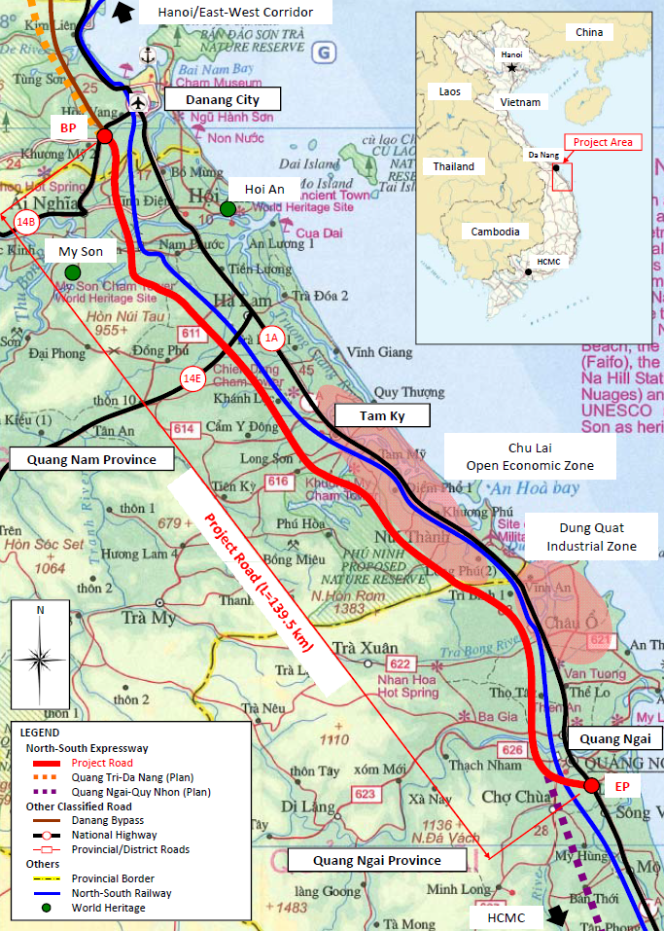
1
2
3
4
5
6
7
8
9
Figure 3.3-1 Location of Interchanges in B/D

Table 3.3-1 Subjected Interchanges for B/D
No. | Interchange | Connecting Road
No. | Interchange | Name | Crossing Location  on Expressway | Distance between IC(km) | Province
1 | Tuy Loan IC | NH14B  Da Nang BP | Km0+000 |  | Da Nang City
2 | My son IC | PR609 | Km13+260 | 13.260 | Quang Nam Province
3 | Ha Lam IC | NH14E | Km40+940 | 27.68 | ditto
4 | Tam Ky IC | PR616 | Km64+540 | 23.60 | ditto
5 | Chu Lai IC | Planning Road | Km82+985.76 | 19.09 | ditto
6 | Dung Quat IC | Planning Road | Km101+737.86 | 18.11 | Quang Ngai Province
7 | Binh Son IC | Tra Bong-Binh Long Rd. | Km111+410 | 9.67 | ditto
8 | Quang Ngai  North IC | PR623 | Km123+680 | 12.27 | ditto
9 | Quang Ngai IC | Urban Road | Km130+502 | 6.82 | ditto

Geometric Design Criteria

Rampway
The consultant established design criteria for interchange rampway with reference to practical standards in developed country as shown in Table 5.5-1.
Table 3.4-1 Design Criteria for Interchange Rampway
Design Elements |  |  |  | 1 direction |  | 2 direction |  | Reference
 |  |  |  | 1lane | 2lane | 2 x 1lane | 2 x 2lane | Reference
1 | Expressway Classification Type A |  |  | Grade 120 |  |  |  | TCVN5729
2 | Rampway Classification |  |  | Other Roads |  |  |  | TCVN5729
3 | Design Speed of Rampway (km/h) |  |  | 40 |  |  |  | TCVN5729
4 | Cross-Sectional Elements | Basic Lane Width (m) |  | 3.5*1 | 3.5 | 3.5*1 | 3.5 | *1:JRSO, TCVN5729
4 | Cross-Sectional Elements | Total Number of Lanes |  | 1 | 2 | 2 | 4 | Traffic Forecast
4 | Cross-Sectional Elements | Widening (for R<100 m) of Basic Lane (m) |  | 1 x 50/R | 1 x 50/R | 2 x 50/R | 2 x 50/R | TCVN5729
4 | Cross-Sectional Elements | Number of Traveled Way |  | 1 | 1 | 2 | 2 | Traffic Forecast
4 | Cross-Sectional Elements | Formation Width (m) |  | 8.5 | 10.5 | 15.5 | 19.5 | TCVN5729
4 | Cross-Sectional Elements |  | Traveled Way Width(m) | 3.5*1 | 7.0 | 2 x 3.5*1 | 2 x 7.0 | *1:JRSO, TCVN5729
4 | Cross-Sectional Elements |  | Outer Shoulder Paved Width (m) | 2.5*1 | 1.0 | 2 x 2.5*1 | 2 x 1.0 | *1:JRSO, TCVN5729
4 | Cross-Sectional Elements |  | Inner Shoulder Paved Width (m) | 1.0*1 | 1.0 | - | - | *1:JRSO, TCVN5729
4 | Cross-Sectional Elements |  | Shoulder Earthen Width (m) | 2 x 0.75*1 | 2 x 0.75*1 | 2 x 0.75 | 2 x 0.75 | *1:JRSO, TCVN5729
4 | Cross-Sectional Elements |  | Median Width (m) | - | - | 1.0 | 1.0 | JRSO
4 | Cross-Sectional Elements |  | Median Marginal Strip (m) | - | - | 2 x 0.5 | 2x 0.5 | JRSO
4 | Cross-Sectional Elements | Cross fall of Roadway (%) |  | 2.0 |  |  |  | TCVN5729
4 | Cross-Sectional Elements | Slope of Earthworks |  |  |  |  |  | TCVN5729
4 | Cross-Sectional Elements |  | Fill | V : H = 1:2.0 |  |  |  | TCVN5729
4 | Cross-Sectional Elements |  | Cut | V : H = 1:1.0 (0.75) |  |  |  | TCVN5729
5 | Sight Dist. | Driver's Eye Height (m) |  | 1.20 |  |  |  | TCVN5729
5 | Sight Dist. | Height of Object for Stopping Distance (m) |  | 0.30 |  |  |  | TCVN5729
5 | Sight Dist. | Stopping Sight Distance (m) |  | 40 |  |  |  | TCVN4054
6 | Horizontal Alignment | Minimum Radius of Horizontal Curve (m) |  | 60 |  |  |  | TCVN4054
6 | Horizontal Alignment | Superelevation (Se)
6 | Horizontal Alignment |  | Maximum Se for Absolute Min. Radius (%) | 6.0 |  |  |  | TCVN4054
6 | Horizontal Alignment |  | Minimum Radii w/o Superelevation (m) | 600 |  |  |  | TCVN4054
6 | Horizontal Alignment |  | Maximum Slope of Superelevation Runoff | 1/100 |  |  |  | JRSO
6 | Horizontal Alignment | Minimum Length of Transition Curve (m) |  | 35 |  |  |  | TCVN4054
7 | Vertical Alignment | Maximum Grade (%) |  | 7.0 |  |  |  | TCVN4054
7 | Vertical Alignment | Minimum Length of Vertical Curve (m) |  | 35 |  |  |  | TCVN4054
7 | Vertical Alignment | Minimum Radius of Crest Curve (m)
7 | Vertical Alignment |  | Desirable Minimum Radius (m) | 1000 |  |  |  | TCVN4054
7 | Vertical Alignment |  | Absolute Minimum Radius (m) | 700 |  |  |  | TCVN4054
7 | Vertical Alignment | Minimum Radius of Sag Curve (m)
7 | Vertical Alignment |  | Desirable Minimum Radius (m) | 700 |  |  |  | TCVN4054
7 | Vertical Alignment |  | Absolute Minimum Radius (m) | 450 |  |  |  | TCVN4054
8 | Lateral Clearance |  |  | Traveled Way Width |  |  |  | TCVN5729
8 | Vertical Clearance |  |  | 4.75 |  |  |  | TCVN5729

Ramp Terminals
The geometric design criteria for ramp terminals as stipulated in TCVN5729 is given in Table 5.5-2. Some of the parameters not mentioned in TCVN5729 are adopted from JRSO.
Table 3.4-2 Geometric Design Criteria for Ramp Terminals
Design Elements |  |  |  |  |  |  | Type/Value | Reference
1 | Design Speed (km/h) |  |  |  |  |  | 120 | TCVN5729
2 | Horizontal Alignment | Horizontal Curve
2 | Horizontal Alignment |  | Desirable Minimum Radii of Horizontal Curve (m) |  |  |  | 2000 | TCVN5729
2 | Horizontal Alignment | Absolute Minimum Radii of Horizontal Curve (m) |  |  |  |  | 1500 | TCVN5729
3 | Vertical Alignment | Maximum Grade(%)
3 | Vertical Alignment |  |  |  | Desirable |  | 2..0 | TCVN5729
3 | Vertical Alignment |  |  |  | Absolute |  | 2..0 | TCVN5729
3 | Vertical Alignment | Vertical Curve
3 | Vertical Alignment |  | Minimum Radius of Crest Curve (m)
3 | Vertical Alignment |  |  |  |  | Desirable Minimum Radius (m) | 45000 | TCVN5729
3 | Vertical Alignment |  |  |  |  | Absolute Minimum Radius (m) | 23000 | TCVN5729
3 | Vertical Alignment |  | Minimum Radius of Sag Curve (m)
3 | Vertical Alignment |  |  |  |  | Desirable Minimum Radius (m) | 16000 | TCVN5729
3 | Vertical Alignment |  |  |  |  | Absolute Minimum Radius (m) | 12000 | TCVN5729
4 | Speed Change Lane  (2-lane ramp) | Minimum Length of Deceleration Lane, excluding Taper (m) |  |  |  |  | 100 | TCVN5729
4 | Speed Change Lane  (2-lane ramp) | Minimum Length of Acceleration Lane, excluding Taper (m) |  |  |  |  | 200 | TCVN5729
4 | Speed Change Lane  (2-lane ramp) | Minimum Length of Taper (m) |  |  |  |  | 75 | TCVN5729
4 | Speed Change Lane  (2-lane ramp) | Direct Connection Type
4 | Speed Change Lane  (2-lane ramp) |  |  | Minimum Divergence Angle for Taper Design (m) |  |  | 1/25 | JRSO
4 | Speed Change Lane  (2-lane ramp) |  |  | Minimum Convergence Angle for Taper Design (m) |  |  | 1/40 | JRSO

Typical Cross Sections
Typical cross sections of rampway are shown in Figure 5.6-1 to Figure 5.6-5.

Rampway

Figure 3.5-1 Typical Cross Sections of Interchange Ramp Way (1 Direction 1 Lane)

Figure 3.5-2 Typical Cross Sections of Interchange Ramp Way (1 Direction 2 Lane)

Figure 3.5-3 Typical Cross Sections of Interchange Ramp Way (2 Direction 1 Lane)

Figure 3.5-4 Typical Cross Sections of Interchange Ramp Way (2 Direction 1-2 Lane)

Figure 3.5-5 Typical Cross Sections of Interchange Ramp Way (2 Direction 2 Lane)

Connecting Road

Tuy Loan IC
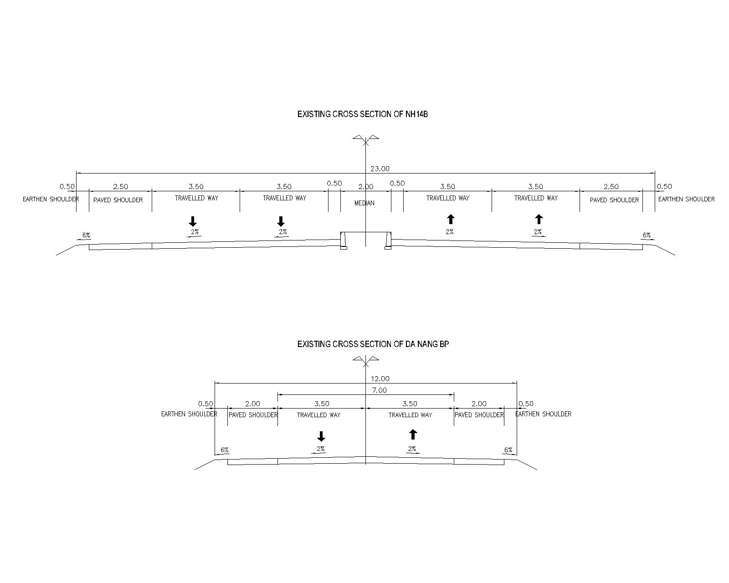
Figure 3.5-6 Cross Section of Connecting Road (NH14B)
Figure 3.5-7 Cross Section of Connecting Road (Da Nang Bypass)

My Son IC
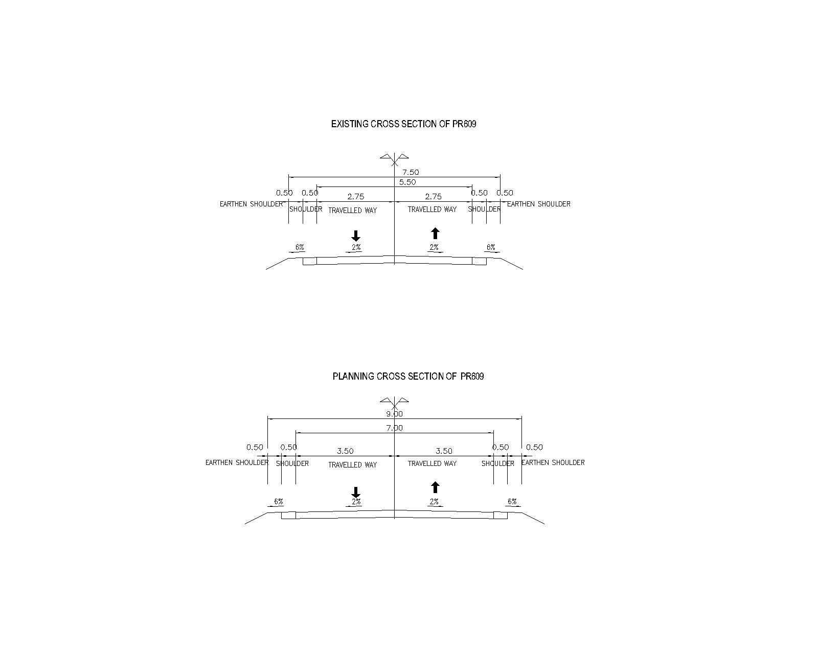
Figure 3.5-8 Cross Section of Connecting Road (PR609)

Figure 3.5-9 Cross Section of Connecting Road (PR609)

Ha Lam IC
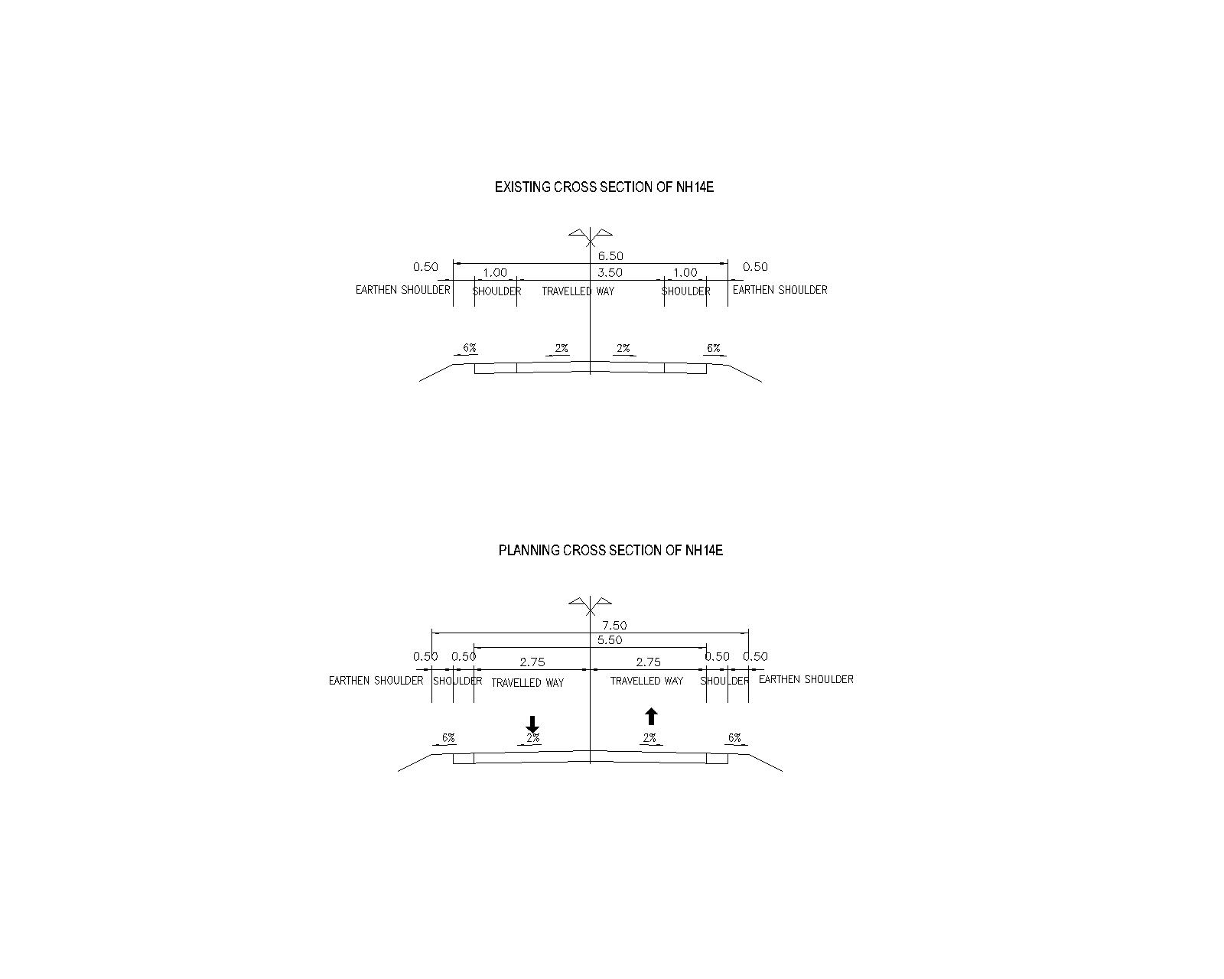
Figure 3.5-10 Cross Section of Connecting Road (NH14E)

Figure 3.5-11 Cross Section of Connecting Road (NH14E)

Tam Ky IC
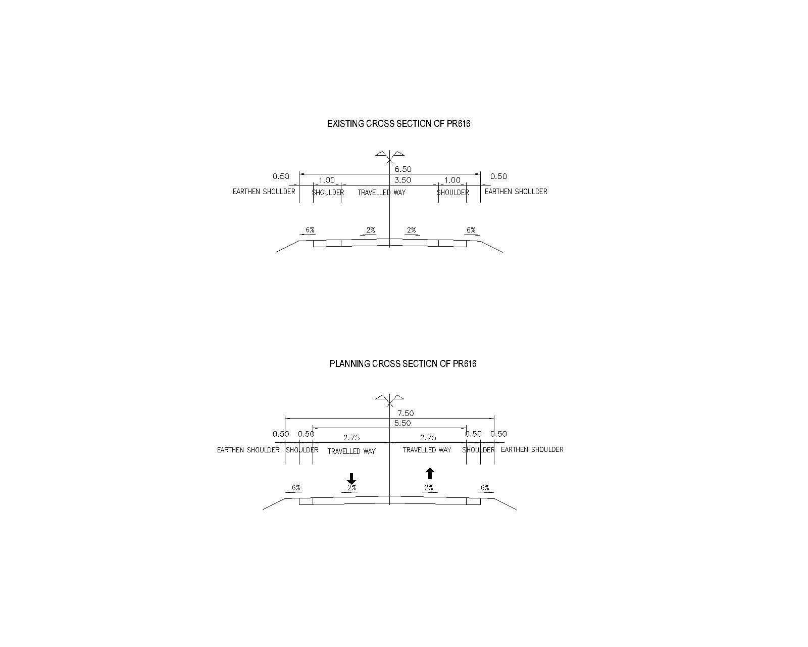
Figure 3.5-12 Cross Section of Connecting Road (PR616)
Figure 3.5-13 Cross Section of Connecting Road (PR616)

Chu Lai IC
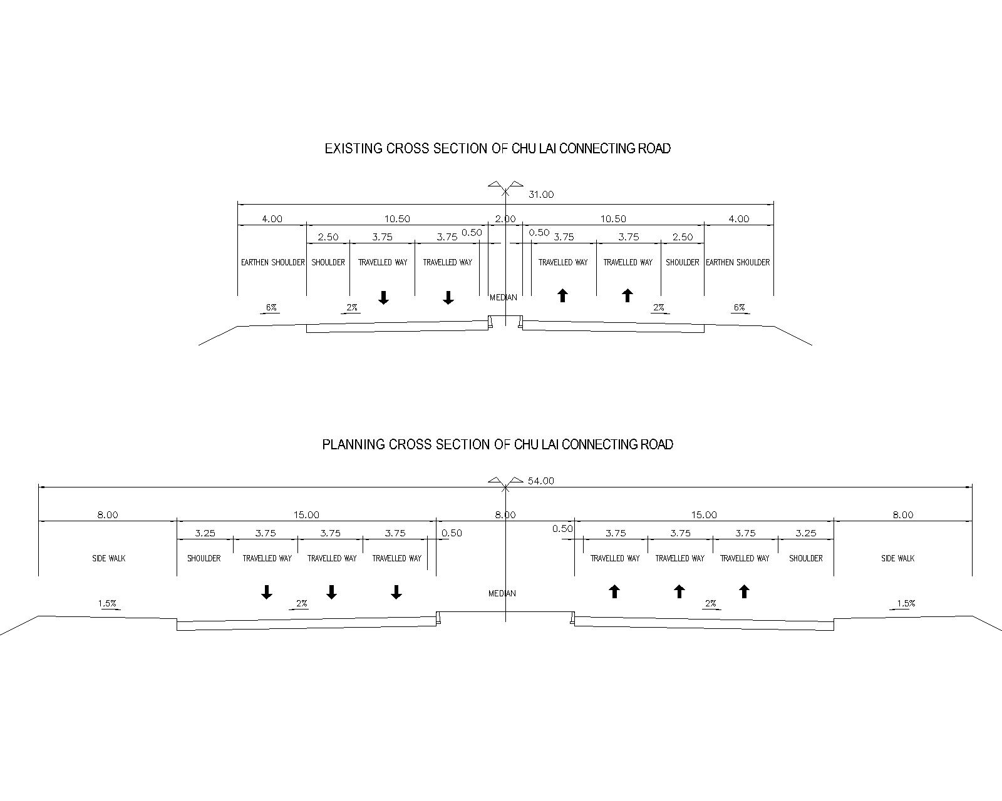
Figure 3.5-14 Cross Section of Connecting Road (Chu Lai)

Figure 3.5-15 Cross Section of Connecting Road (Chu Lai)

Dung Quat IC

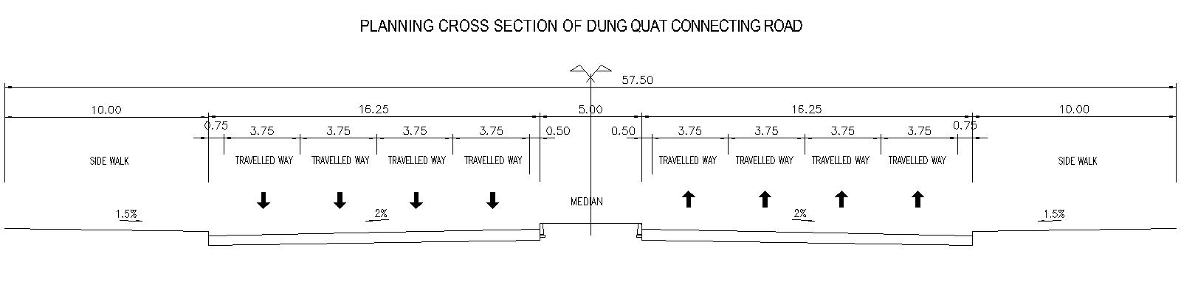 Figure 3.5-16 Cross Section of Connecting Road (Dung Quat)

Binh Son IC

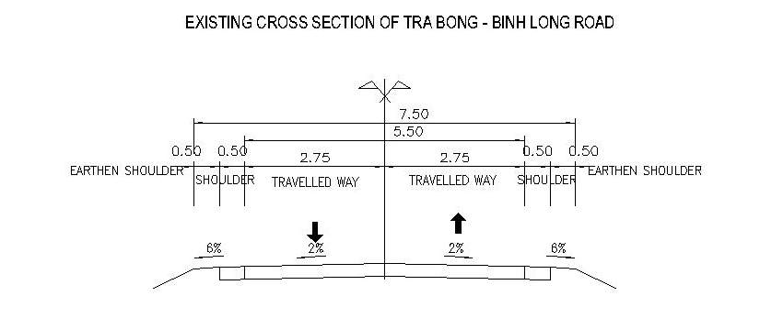
Figure 3.5-17 Cross Section of Connecting Road (Tra Bong – Binh Long Road)

Quang Ngai North IC

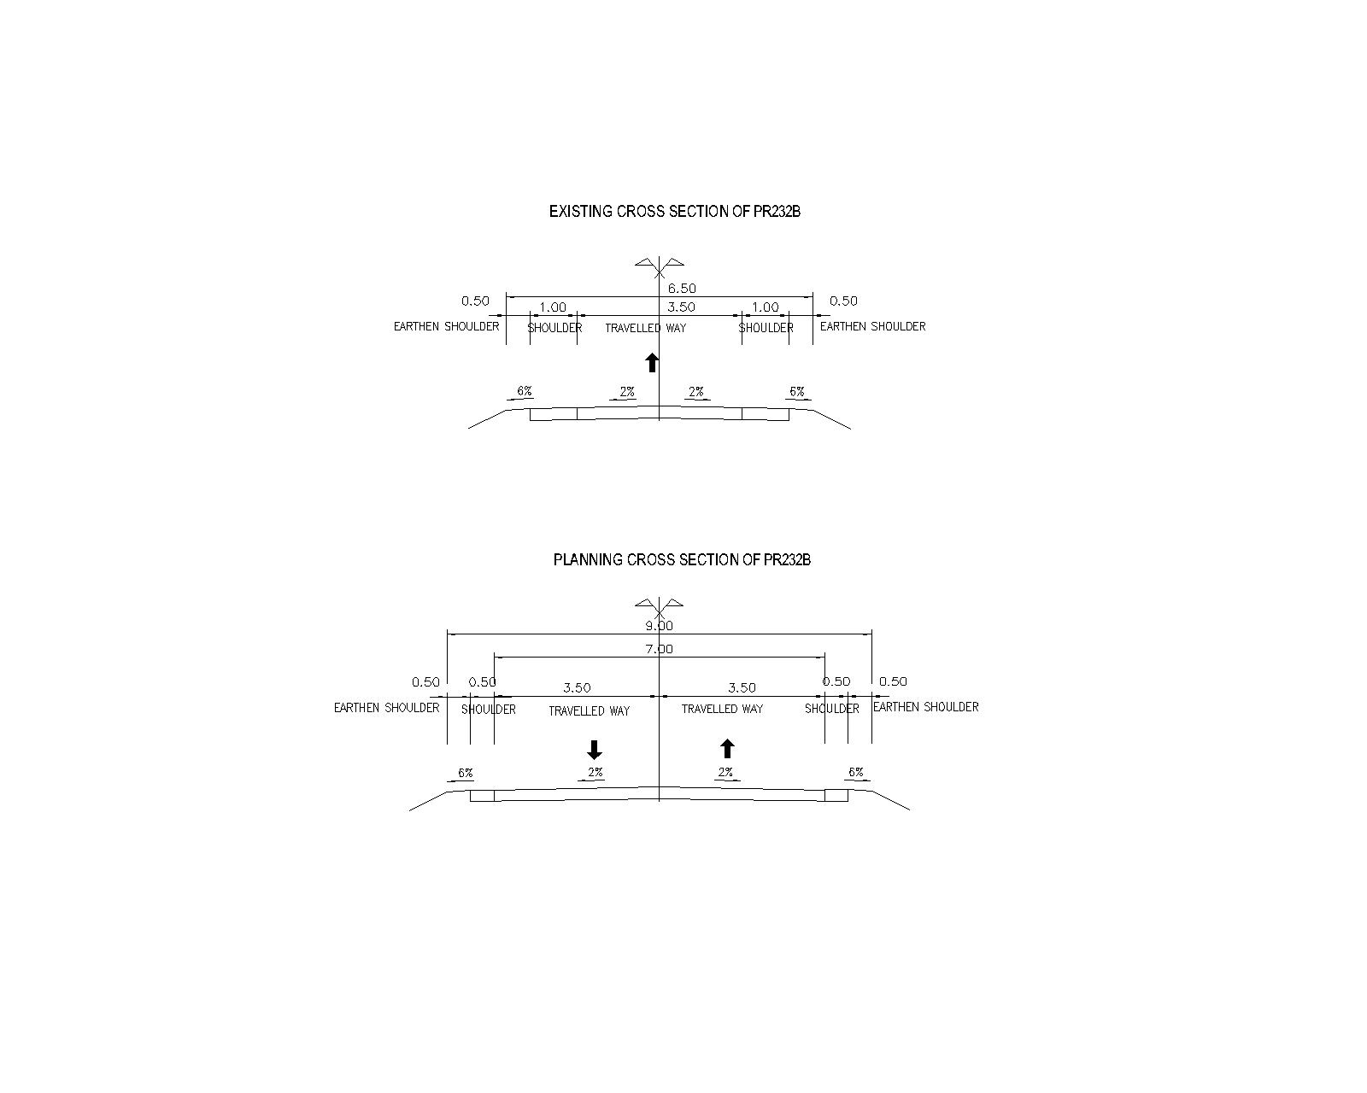
Figure 3.5-18 Cross Section of Connecting Road (PR232B)

Figure 3.5-19 Cross Section of Connecting Road (PR232B)

Ramp Terminal

One Lane Ramp for Expressway (Exit)
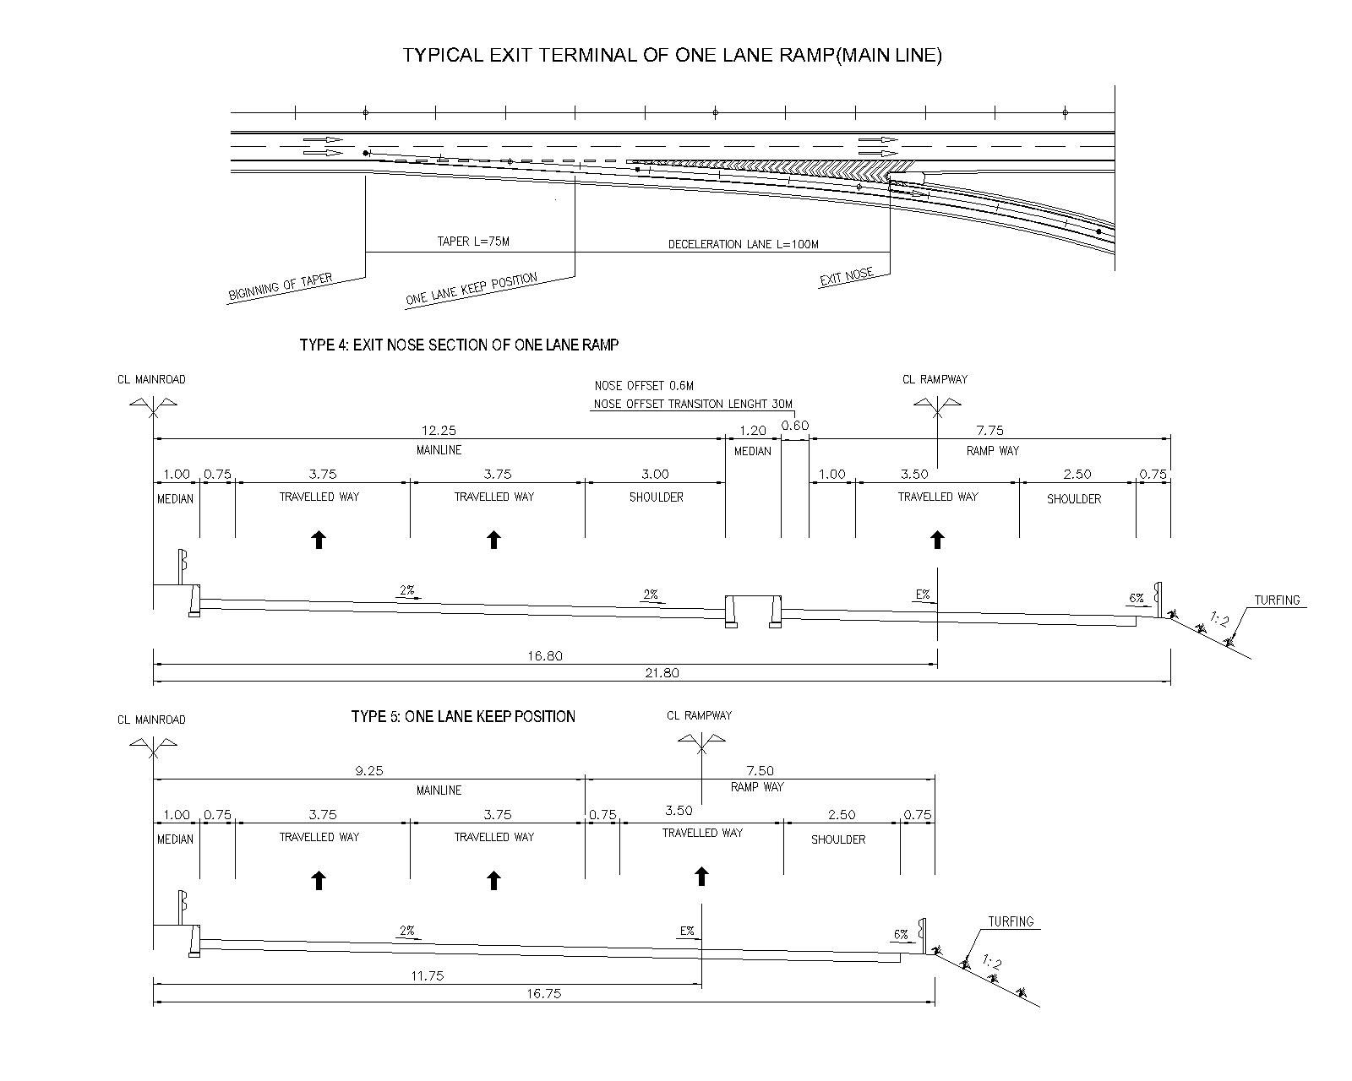
Figure 3.5-20 Typical Exit Terminal of One Lane Ramp (Mainline)

Figure 3.5-21 Typical Cross Section of Exit Nose Section of One Lane Ramp (Mainline)

Figure 3.5-22 Typical Cross Section of One Lane Keep Section of One Lane Ramp (Mainline)

One Lane Ramp for Expressway (Entrance)

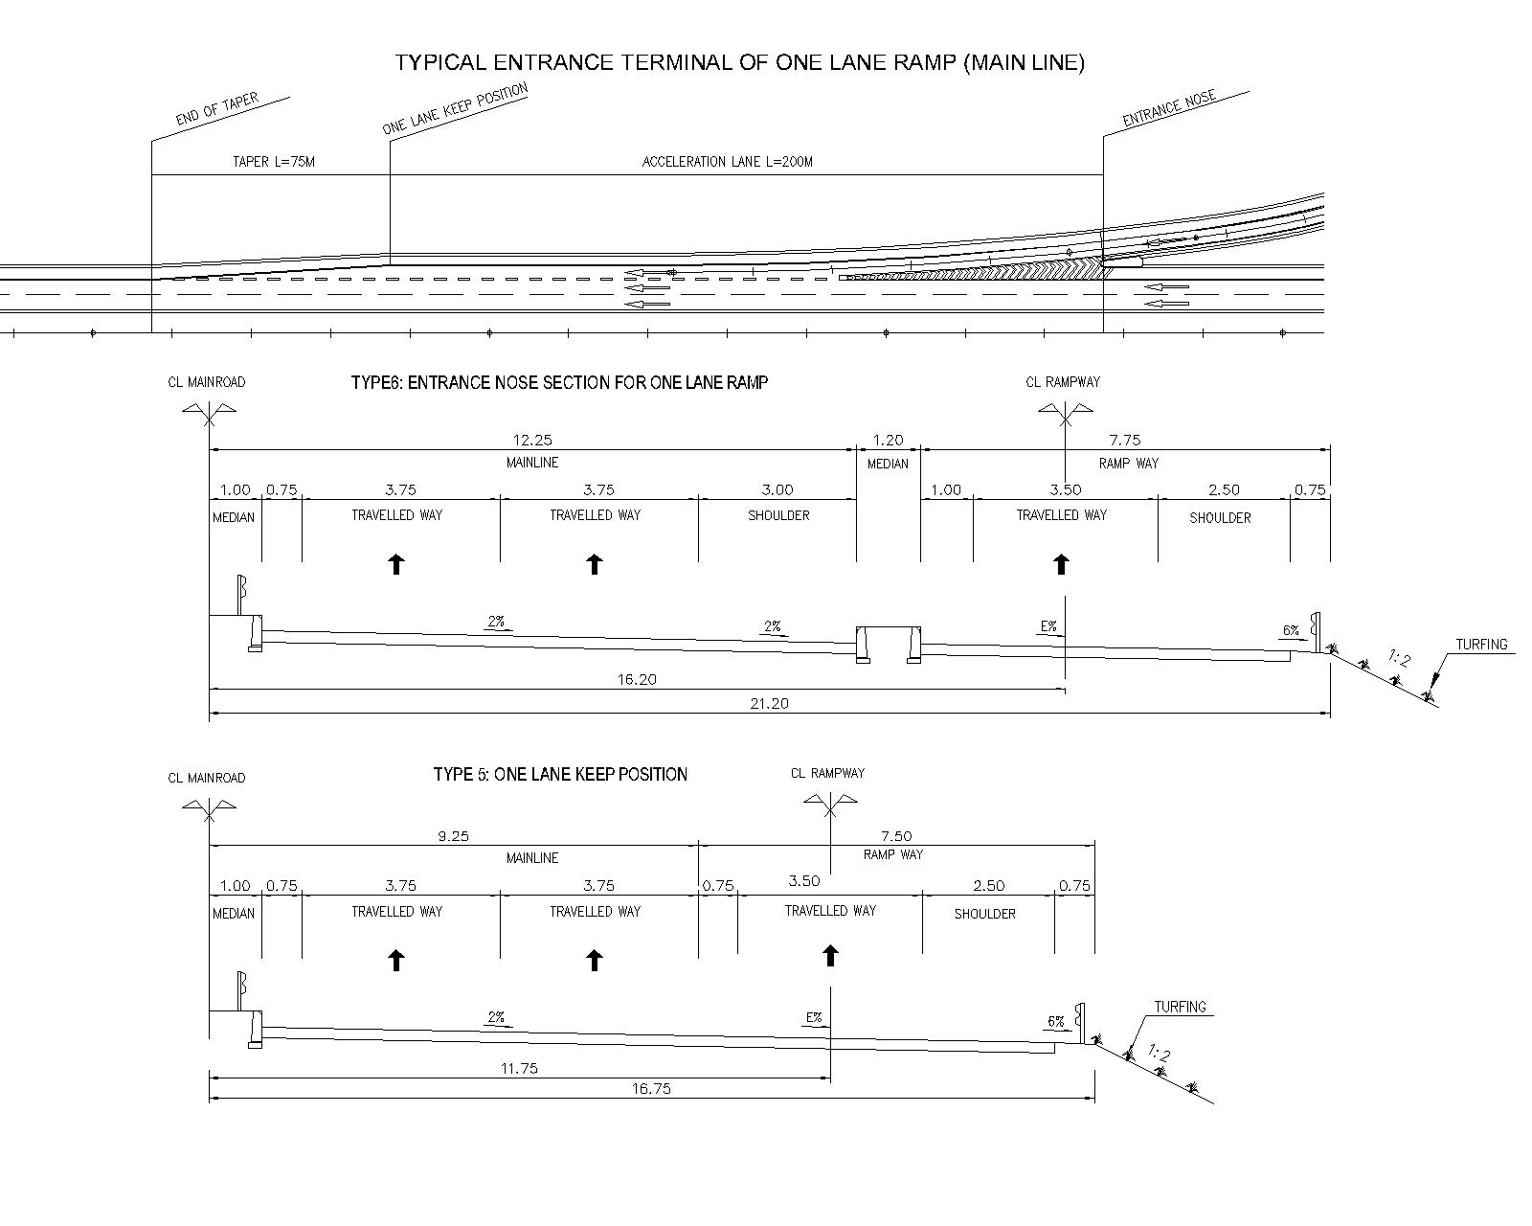
Figure 3.5-23 Typical Entrance Terminal of One Lane Ramp (Mainline)

Figure 3.5-24 Typical Cross Section of Entrance Nose Section of One Lane Ramp (Mainline)

Figure 3.5-25 Typical Cross Section of One Lane Keep Section of One Lane Ramp (Mainline)

Two Lane Ramp for Expressway (Exit)

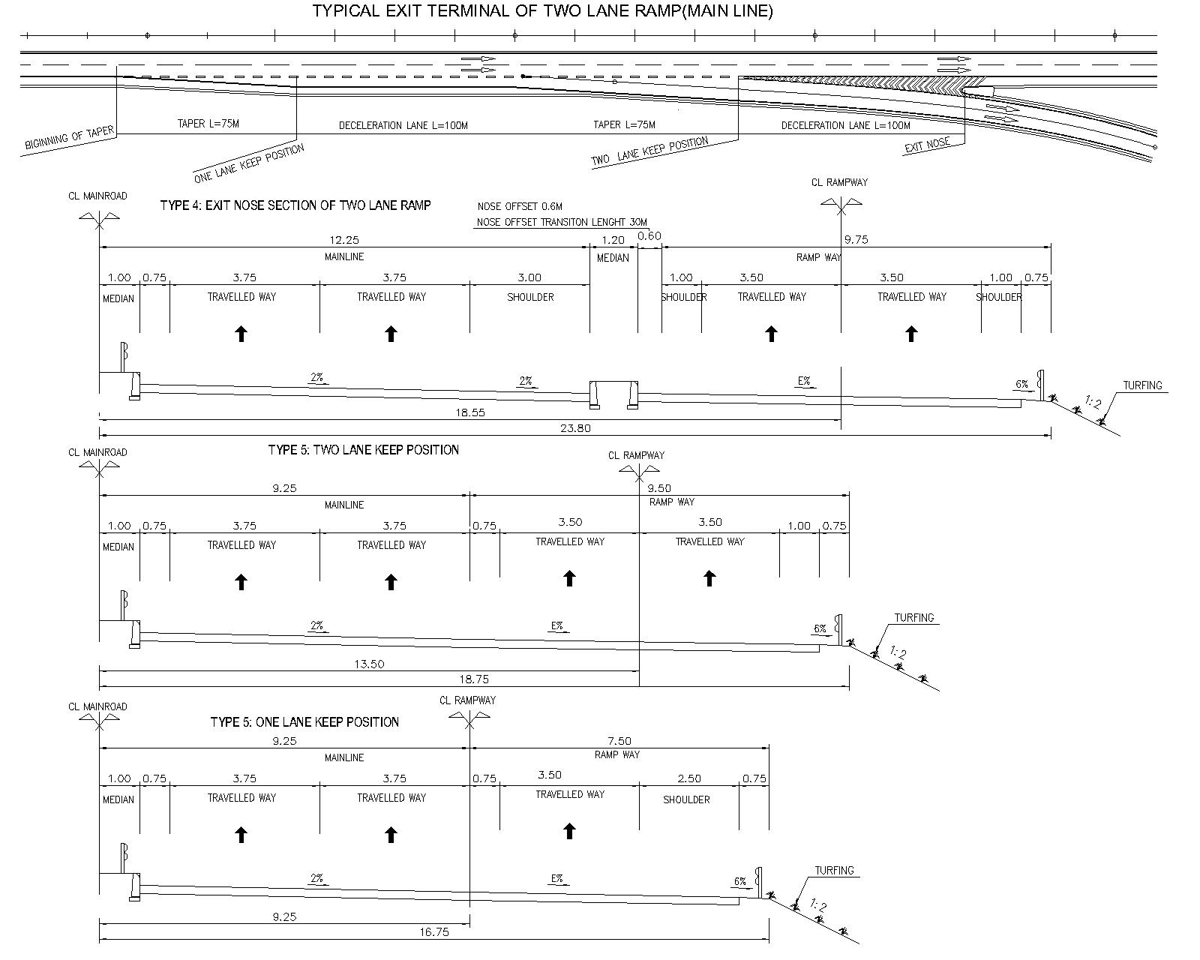
Figure 3.5-26 Typical Exit Terminal of Two Lane Ramp (Mainline)

Figure 3.5-27 Typical Cross Section of Exit Nose Section of Two Lane Ramp (Mainline)

Figure 3.5-28 Typical Cross Section of Two Lane Keep Section of Two Lane Ramp (Mainline)

Figure 3.5-29 Typical Cross Section of One Lane Keep Section of Two Lane Ramp (Mainline)

Two Lane Ramp for Expressway (Entrance)

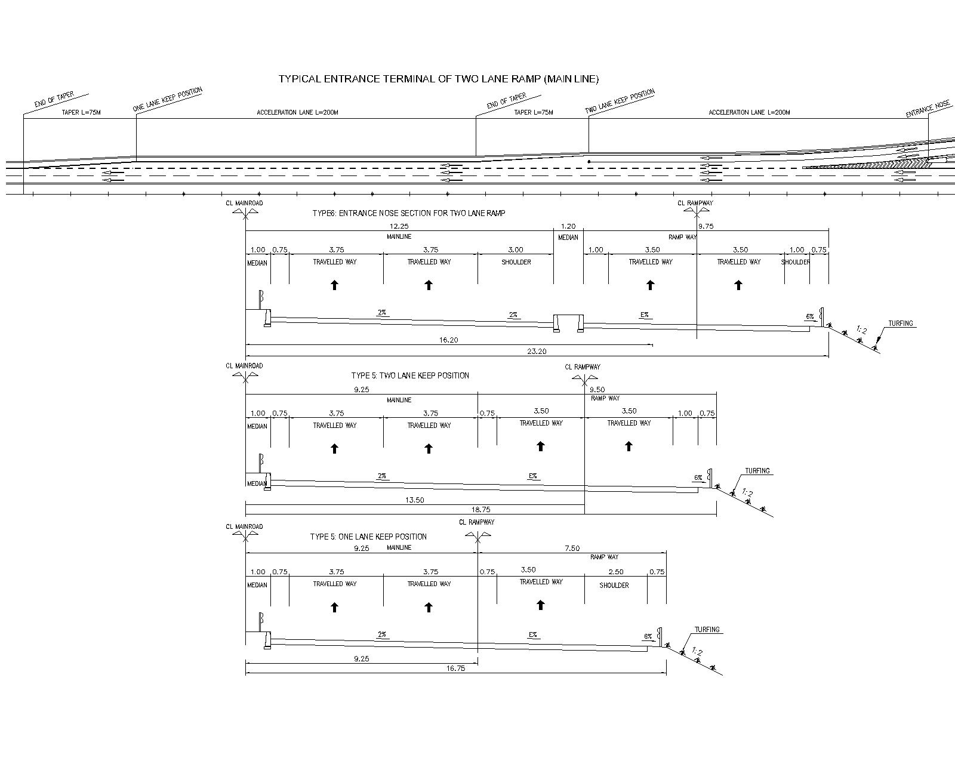
Figure 3.5-30 Typical Entrance Terminal of Two Lane Ramp (Mainline)

Figure 3.5-31 Typical Cross Section of Entrance Nose Section of Two Lane Ramp (Mainline)

Figure 3.5-32 Typical Cross Section of Two Lane Keep Section of Two Lane Ramp (Mainline)

Figure 3.5-33 Typical Cross Section of One Lane Keep Section of Two Lane Ramp (Mainline)

One Lane Ramp for NH14B (Exit)

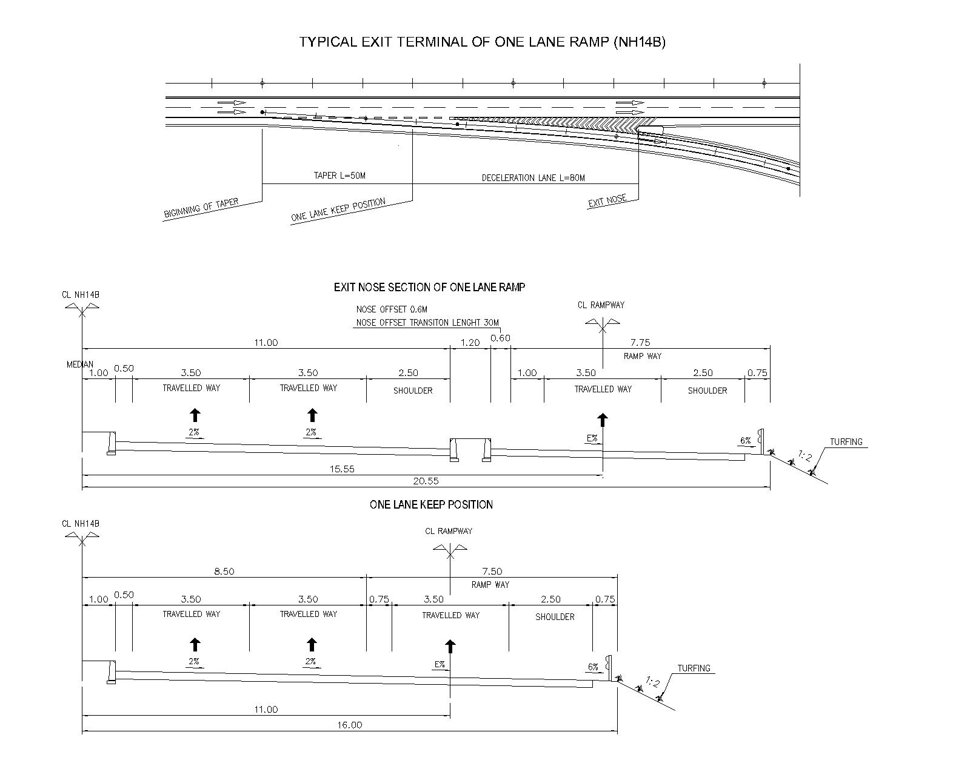
Figure 5.6-34 Typical Exit Terminal of One Lane Ramp (NH14B)

Figure 3.5-34 Typical Cross Section of Exit Nose Section of One Lane Ramp (NH14B)

Figure 3.5-35 Typical Cross Section of One Lane Keep Section of One Lane Ramp (NH14B)

One Lane Ramp for NH14B (Entrance)

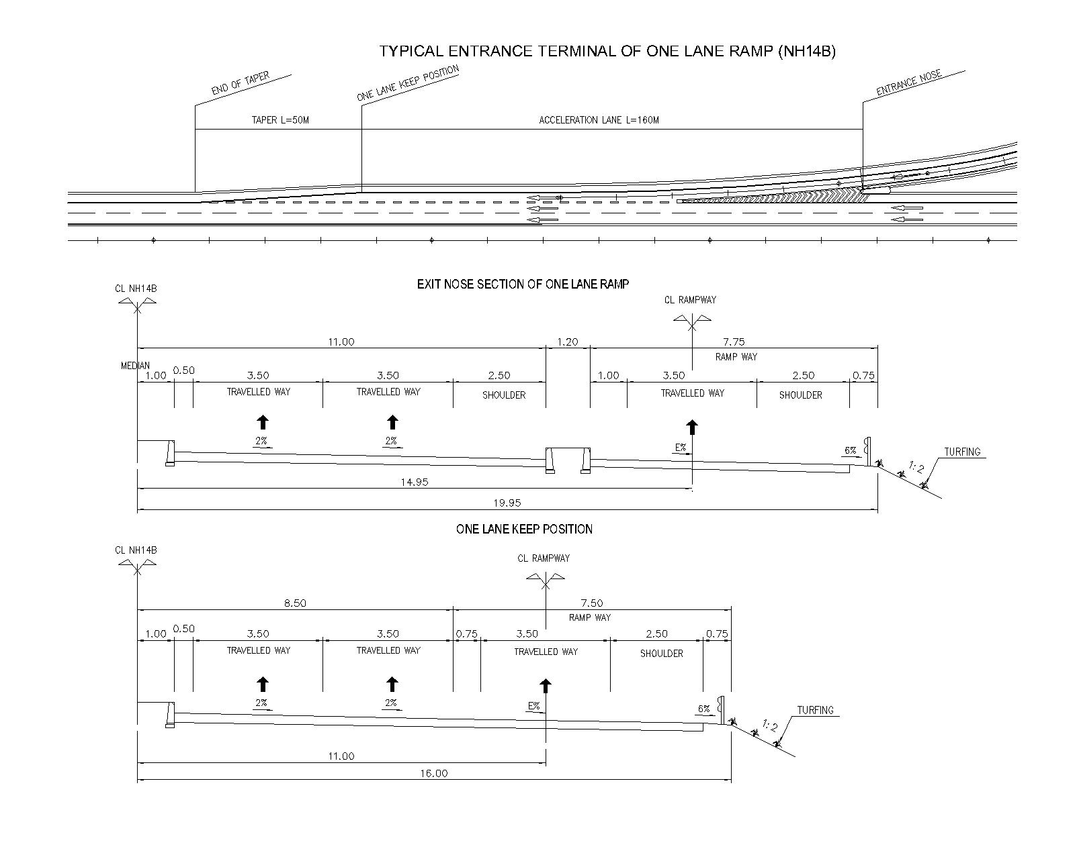
Figure 3.5-36 Typical Entrance Terminal of One Lane Ramp (NH14B)
Figure 3.5-37 Typical Cross Section of Entrance Nose Section of One Lane Ramp (NH14B)
Figure 3.5-38 Typical Cross Section of One Lane Keep Section of One Lane Ramp (NH14B)

Two Lane Ramp for NH14B (Exit)
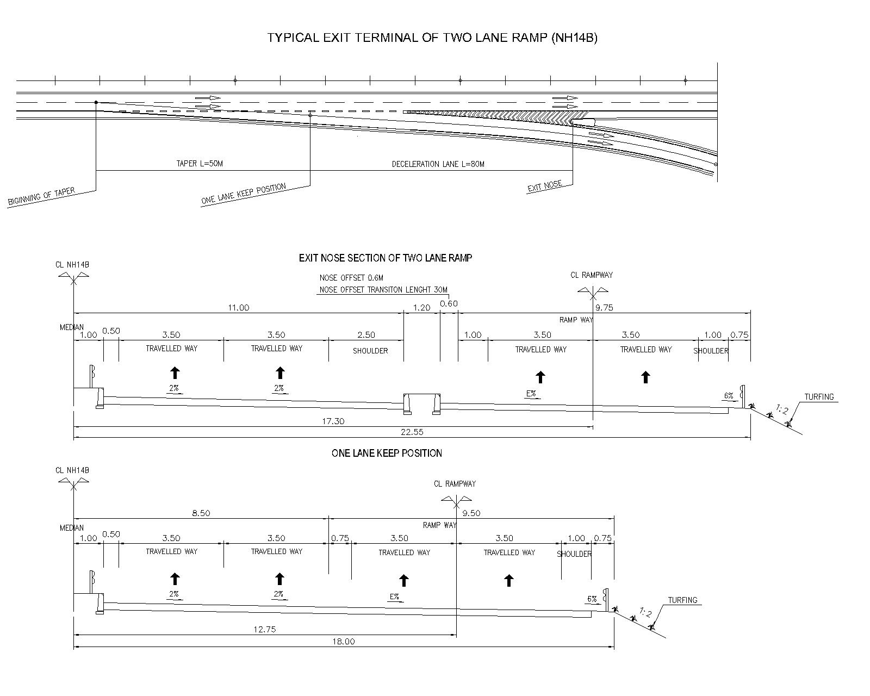
Figure 3.5-39 Typical Exit Terminal of Two Lane Ramp (NH14B)
Figure 3.5-40 Typical Cross Section of Exit Nose Section of Two Lane Ramp (NH14B)
Figure 3.5-41 Typical Cross Section of One Lane Keep Section of Two Lane Ramp (NH14B)

Two Lane Ramp for NH14B (Entrance)

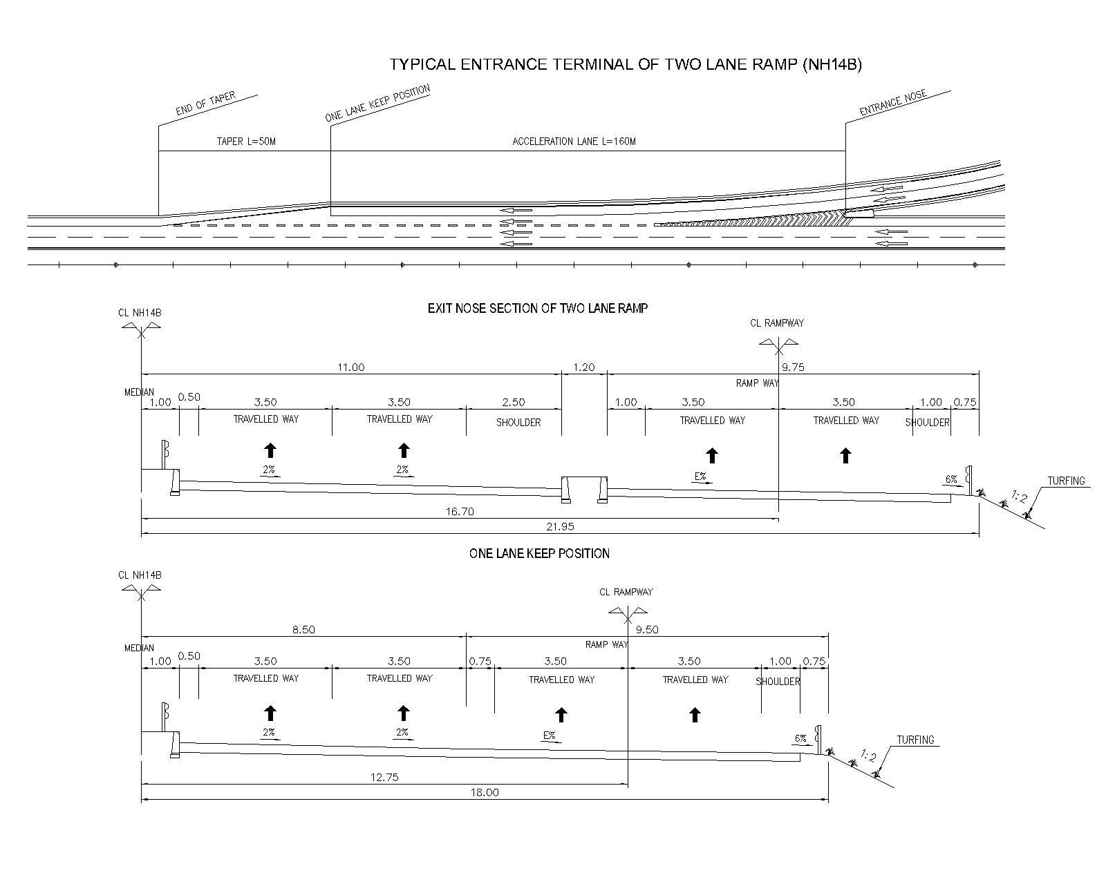
Figure 3.5-42 Typical Entrance Terminal of Two Lane Ramp (NH14B)
Figure 3.5-43 Typical Cross Section of Entrance Nose Section of Two Lane Ramp (NH14B)
Figure 3.5-44 Typical Cross Section of One Lane Keep Section of Two Lane Ramp (NH14B)

Basic Design of Each Interchange

Tuy Loan IC

Alternatives of Tuy Loan IC
Cloverleaf type was proposed in F/S for Tuy Loan IC. Meanwhile, issues on traffic safety and toll gate operation are found in the cloverleaf type IC, and semi direct cloverleaf type and double Trumpet type were studied as alternatives in B/D.

Result of alternative study
.The result of the alternative study is summarized in Table 5.7-1, and roundabout in initial stage and semi direct cloverleaf type in ultimate stage as stage construction were proposed.

Table 3.6-1 Result of comparative study of Tuy Loan IC
Type of Interchange | Cloverleaf | Semi-direct Cloverleaf | Double Trumpet
Layout | 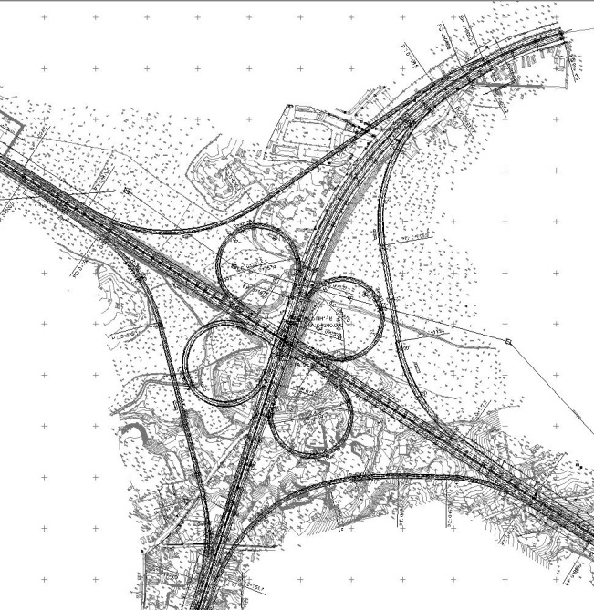  Toll Gate | 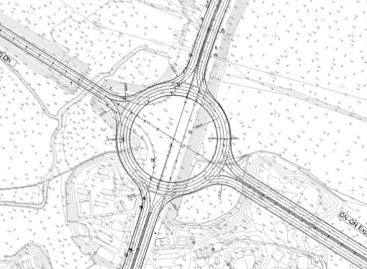  Initial Stage  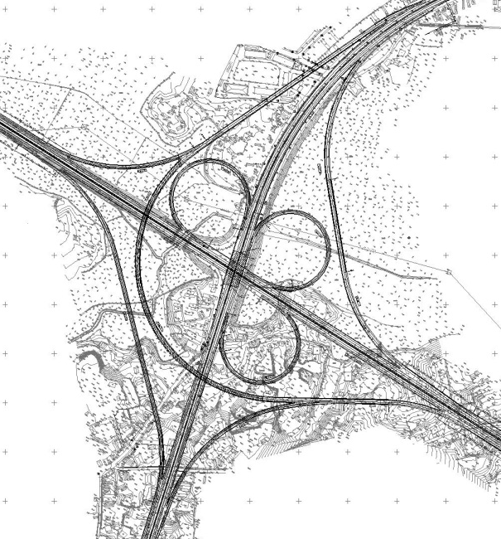  Toll Gate | 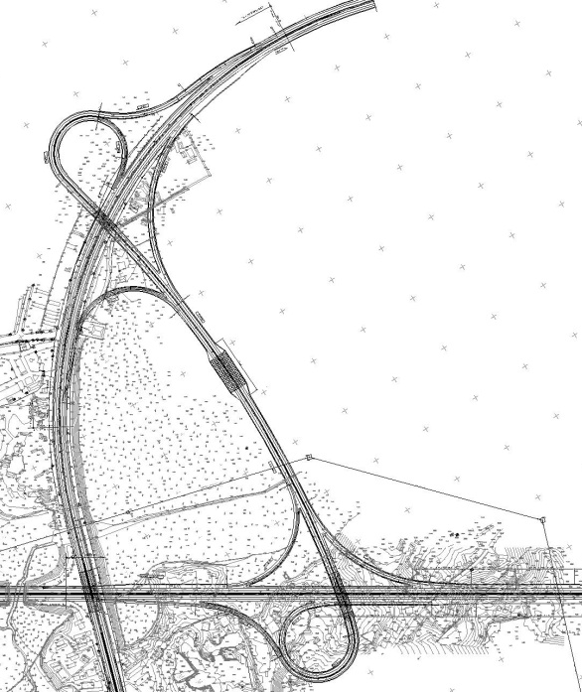  Toll Gate
Ramp Design Speed | 40km/h | 40km/h | 40km/h
Toll Gate | On Expressway | On Expressway | On Rampway
Ramp alignment | Min.R=80m Max.i=4.115% | Min.R=80m,(Roundabout: 65m) Max i=4.115% | Min.R=60m Max.i=4.364%
Length of Rampway | 5,608m | 6,302 (Roundabout: 408m) | 3,633m
Length of Bridge | 60m | 700m | 190m
Advantage | - No need more auxiliary bridges  - A configuration with loop ramps to safely accommodate left-turning movements | - Traffic volume increased mainly on direct ramps from Da Nang ↔ Quang Ngai, that the type of interchange is very suitable  - A configuration with loop ramps to safely accommodate left-turning movements  - Average level of land occupation | - Lowest land acquisition  - This alternative enhances capacity on traffic volume, no conflict with main road, crossing road and ramps.  - It is easy for drivers to notify type of interchange, increasing management efficiency due to one toll plaza installed.
Disadvantage | - Highest land occupation  - It requires more travel distance for the left-turning traffic than other type.  - Use of the loop ramps generates a weaving movement within a short distance | - Need more auxiliary bridges.  - Larger occupation and land acquisition area. | - Need more auxiliary bridges.  - Need to rebuild the toll gate in stage 2 (Stage 1: placement of toll gate on the main road; Stage 2: placement of toll gate on ramp C)
Conclusion | alternative 2, Semi-direct Cloverleaf

My Son IC
Table 3.6-2 summary of My Son IC
Name of IC | No.2 My Son IC
Location of IC (Province) | Km13+257 (Quang Nam Province)
Connecting Road (Road Class) | PR609
Forecasted traffic volume(2035) | 1,954pcu/day
Design Speed | Rampway:40km/h,
Type of interchange | Trumpet
Layout of interchange | F/S (For reference)
Layout of interchange | B/D  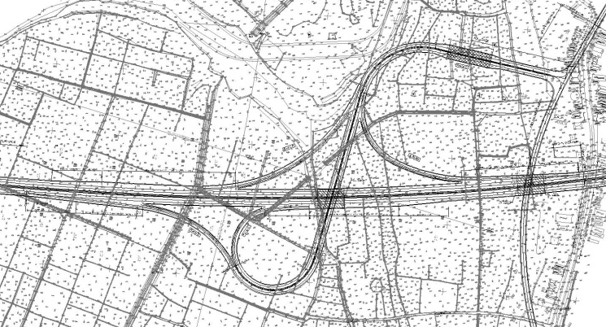  Toll Gate
Alignment of Rampway | Horizontal Alignment: Min.R=60m
Alignment of Rampway | Vertical Alignment: Max i=4.75%
Length of Rampway | A : 303m; B: 405m; C: 755m; C1: 174m; D: 356m  Total : 1993m
Length of Bridge | Da Nang - Quang Ngai expressway overpass Ramp C : L= 40m  Da Nang - Quang Ngai expressway overpass PR609 : L= 40m  Total : 120m
Advantage | - Short distance to NH1A  - It is easy to extend PR609 in the future because connection with this road is in NH1A side (Sea side)  - It is easy for drivers to notify type of interchange, increasing management efficiency due to one toll gate installed  - Average level of land occupation  - Allowing big traffic volume
Disadvantage | - Need consideration of flood discharge

Ha Lam IC
Table 3.6-3 Summary of Ha Lam IC
Name of IC | No.3 Ha Lam IC
Location of IC (Province) | Km40+940 (Quang Nam Province)
Connecting Road (Road Class) | NH14E
Forecasted traffic volume (2035) | 7,988pcu/day
Design Speed | Rampway:40km/h
Type of interchange | Trumpet
Layout of interchange | F/S (For reference)
Layout of interchange | B/D  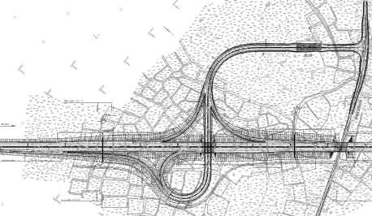  Toll Gate
Alignment of Rampway | Horizontal Alignment: Min.R=60m
Alignment of Rampway | Vertical Alignment: Max i=5.03%
Length of Rampway | A :283m; B:446m; C: 894m; C1: 176m; D:488m  Total : 2287m
Length of Bridge | Da Nang - Quang Ngai expressway overpass Ramp C : L= 40m  Da Nang - Quang Ngai expressway overpass NH14E : L= 40m  Total : 120m
Advantage | - Short distance to NH1A  - It is easy to extend NH14E in the future because connection with this road is in NH1A side (Sea side)  - It is easy for drivers to notify type of interchange, increasing management efficiency due to one toll gate installed  - Average level of land occupation  - Allowing big traffic volume
Disadvantage | - None

Tam Ky IC
Table 3.6-4 Summary of Tam Ky IC
Name of IC | No.4 Tam Ky IC
Location of IC (Province) | Km64+506 (Quang Nam Province)
Connecting Road (Road Class) | PR616
Forecasted traffic volume(2035) | 15,723pcu/day
Design Speed | Rampway:40km/h
Type of interchange | Trumpet
Layout of interchange | F/S (For reference)
Layout of interchange | B/D  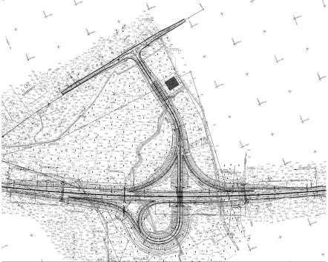  Toll Gate
Alignment of Rampway | Horizontal Alignment: Min.R=60m
Alignment of Rampway | Vertical Alignment: Max i=4.307%
Length of Rampway | A : 292m B: 422m; C:734m; C1:167m; D:410m  Total : 2025m
Length of Bridge | Ramp C overpass Da Nang - Quang Ngai expressway: L= 60m  Total : 60m
Advantage | - Short distance to NH1A  - It is easy to extend PR616 in the future because connection with this road is in NH1A side (Sea side)  - It is easy for drivers to notify type of interchange, increasing management efficiency due to one toll gate installed  - Average level of land occupation  - Allowing big traffic volume
Disadvantage | - Need more auxiliary bridges

Chu Lai IC
Table 3.6-5 Summary of Chu Lai IC
Name of IC | No.5 Chu Lai IC
Location of IC (Province) | Km82+986 (Quang Nam Province)
Connecting Road (Road Class) | Planning Road
Forecasted traffic volume(2035) | 4,120pcu/day
Design Speed | Rampway:40km/h
Type of interchange | Trumpet
Layout of interchange | F/S (For reference)
Layout of interchange | B/D  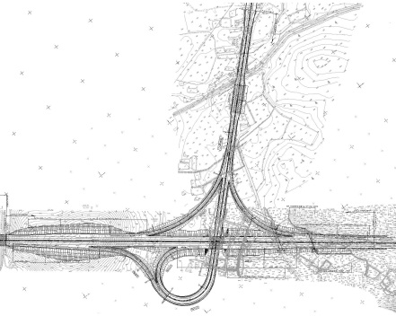  Toll Gate
Alignment of Rampway | Horizontal Alignment: Min.R=60m
Alignment of Rampway | Vertical Alignment: Max i=5.24%
Length of Rampway | A : 358m; B: 412m; C: 796m; C1: 172m; D:371m  Total : 2109m
Length of Bridge | Da Nang - Quang Ngai expressway overpass Ramp C : L= 60m  Total : 60m
Advantage | - Short distance to NH1A  - It is easy for drivers to notify type of interchange, increasing management efficiency due to one toll gate installed  - Average level of land occupation  - Allowing big traffic volume
Disadvantage | - None

Dung Quat IC
Table 3.6-6 Summary of Dung Quat IC
Name of IC | No.6Dung Quat IC
Location of IC (Province) | Km101+740 (Quang Ngai Province)
Connecting Road (Road Class) | Planning Road
Forecasted traffic volume(2035) | 3,440pcu/day
Design Speed | Rampway:40km/h
Type of interchange | Trumpet
Layout of interchange | F/S (For reference)
Layout of interchange | B/D  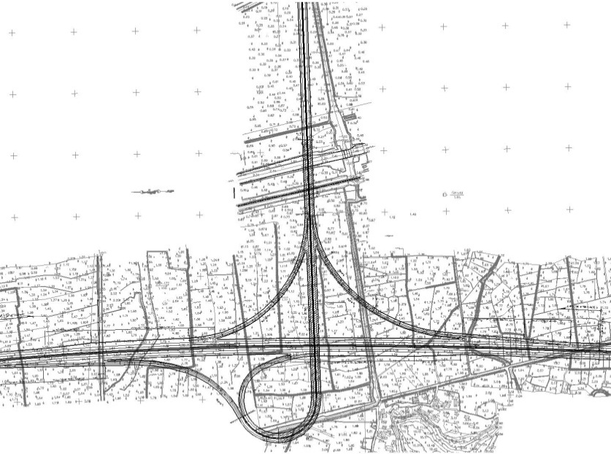  Toll Gate
Alignment of Rampway | Horizontal Alignment: Min.R=60m
Alignment of Rampway | Vertical Alignment: Max i=4.42%
Length of Rampway | A : 314m; B: 519m; C:1232m; C1: 190m; D:430m  Total : 2685m
Length of Bridge | Ramp C overpass Da Nang - Quang Ngai expressway, Railway and NH1A: L= 520m  Ramp A connect to Ramp C : L= 122m  Ramp B connect to Ramp C : L= 143m  Total : 785m
Advantage | - Short distance to NH1A  - It is easy for drivers to notify type of interchange, increasing management efficiency due to one toll gate installed  - Average level of land occupation  - Allowing big traffic volume
Disadvantage | - Need more auxiliary bridges

Binh Son IC
Table 3.6-7 Summary of Binh Son IC
Name of IC | Binh Son IC
Location of IC (Province) | Km112+410 (Quang Ngai Province)
Connecting Road (Road Class) | Province Road PR622
Forecasted traffic volume(2035) | 7,764pcu/day
Design Speed | Rampway:40km/h
Type of interchange | Trumpet
Layout of interchange | F/S (For reference)  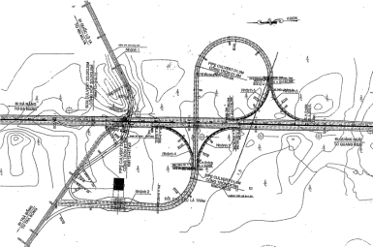
Layout of interchange | B/D  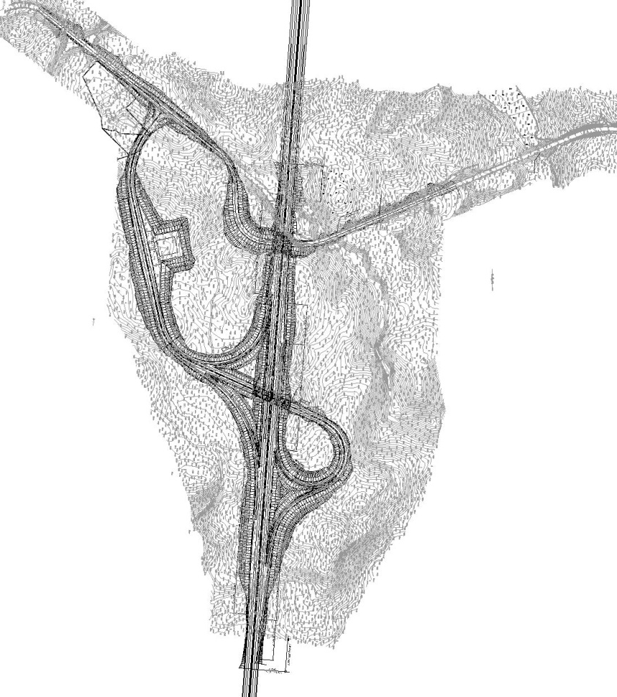  Toll Gate
Alignment of Rampway | Horizontal Alignment: Min.R=60m
Alignment of Rampway | Vertical Alignment: Max i=4.42%
Length of Rampway | C :947m; A: 311m; B: 413m; C1: 223m; D: 377m;  Total : 2271m
Length of Bridge | Da Nang - Quang Ngai expressway overpass Province Road PR622: L= 40m  Ramp C overpass Da Nang - Quang Ngai expressway: L= 50m  Total : 90m
Advantage | - It is easy for drivers to notify type of interchange, ensuring management efficiency due to integrated toll gate installation  - Moderate scale of land acquisition  - Large traffic capacity
Disadvantage | - Need auxiliary bridges  - Realignment of Province Road PR622  - High rock excavation volume

Quang Ngai North IC
Table 3.6-8 Summary of Quang Ngai North IC
Name of IC | Quang Ngai North IC
Location of IC (Province) | Km123+680 (Quang Ngai Province)
Connecting Road (Road Class) | PR623
Forecasted traffic volume (2035) | 5,182pcu/day
Design Speed | Rampway:40km/h
Type of interchange | Trumpet
Layout of interchange | 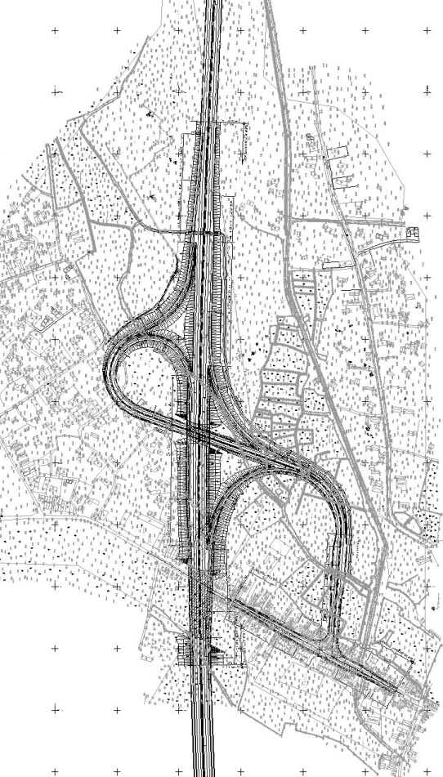  F/S (For reference) 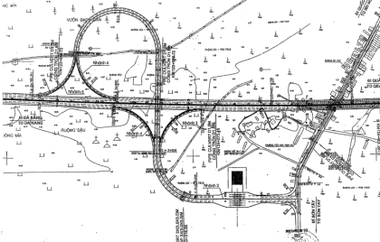
Layout of interchange | B/D  Toll Gate
Alignment of Rampway | Horizontal Alignment: Min.R=60m
Alignment of Rampway | Vertical Alignment: Max i=4.42%
Length of Rampway | A : 250m; B: 398m; C: 765m; C1: 224m; D: 368m  Total : 2005m
Length of Bridge | Da Nang - Quang Ngai expressway overpass Ramp C : L= 40m  Da Nang - Quang Ngai expressway overpass PR623B : L= 110m  Total : 150m
Advantage | - Near to NH1A  - It is easy to extend PR623B in the future because connection point with PR623B is NH1A side (sea side)  - It is easy for drivers to notify type of interchange, ensuring management efficiency due to integrated toll gate installation  - Moderate scale land acquisition and avoidance of resettlement of existing school  - Large traffic capacity
Disadvantage | - Resettlement along PR623B

Basic Layout of All Interchanges
Basic layouts of all interchanges are attached in Appendix 7.

Basic Design of Major River Bridges

General
There are 4 major river bridges in this project named Ky Lam Bridge, Chiem Son Bridge, Tra Bong Bridge, and Tra Khuc Bridge.

Location of Major River Bridges
Each location of these bridges shows Figure 4.2-1.
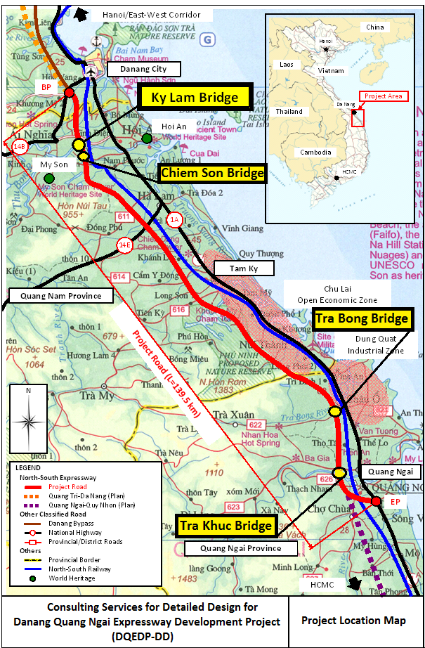

Figure 4.1-1 Location of Major River Bridges

Summary of Major River Bridges
Summary of major River Bridges in the Fs shows Figure-4.1-1

Table 4.1-1 Summary of Major River Bridges in the FS
 |  | 1 | 2 | 3 | 4
 |  | Ky Lam | Chiem Son | Tra Bong | Tra Khuc
1 | Station(Bridge Center) | KM017+662 | Km20+200 | KM109+315 | Km125+385
2 |  | PKG3A | PKG3B | PKGA3 | PKGA5
3 | Road Class/Design Speed | Expressway Class:TypeA,Class120,Design Speed 120km/h
4 | No of lane | Initial Stage:4 lanes Ultimate Stage: Widen to 6 lanes
5 | River Class | Class NorthⅣ | Class Northⅴ | Class ⅴ | Class NorthⅥ
6 | Bridge Length | 950m | 416.5 | 452m | 846.2m
7 | Span Arrangement | 4@40m+65m+5@100m+65m+4@40m | 3@33+55m+90m+55m+3@33m | 11@40 | 65.1m+7@100m+65.1m
8 | Structure Type | Pc Box Girder+Super Tee | Pc Box Girder + I-Girder | Super Tee | Pc Box Girder

Review of Previous Studies
Review of Previous Studies is summarized in Appendix 8: Review of Previous Studies (Major River Bridges)

Basic Design of Four Major River Bridges

Ky Lam Bridge
Basic Design Report of Ky Lam Bridge was submitted to PMU85 as Basic Design Report (Package 3A, Km16+880-Km18+100)

Chime Son Bridge
Based on the Previous Review study and Alternative study results, The Consultant propose 3-span PCI-Girder+ 8-span continuous PC Box Girder as shown in Table 7.2 ,Figure 7.2.1 and Figure 7.2.2

Table 4.3-1 Conclusion of the Alternative Study
No. | Item |  |  | F/S | Consultant’s Proposal | Remark
1 | Bridge Location |  |  | KM020+220 | KM020+203.8 | Same as F/S
2 | Bridge Type | Superstructure |  | 2x(3-Span PCI Girder) +  3Spans PC BOX Girder | 3-Span PCI Girder +4Spans PC Box Girder
2 | Bridge Type | Abutments |  | Inversely T-shape | Inversed T-shape | Same as F/S
2 | Bridge Type | Pier Type | For the PCI Girder | Two Columns Type  (Oval Shape) | Wall type  (Oval Shape)
2 | Bridge Type | Pier Type | For the PC Box Girder | Wall Type  (Oval Shape) | Wall Type  (Oval Shape) | Same as F/S
2 | Bridge Type | Foundation |  | Cast in place pile  (D1.0m&D1.5mm) | Cast in place pile  (D1.0m&D1.5mm) | Same as F/S
3 | Total Span length |  |  | 398.5m | 432.7m
4 | Span Arrangements |  |  | 3@33+55+90+55+3@33m | 33.9+34.7+33.9  +65+2@100+65m

Tra Bong Bridge
Based on the Previous Review study and Alternative study results, The Consultant propose 11-span Super T Girder as shown in Table 7.3 ,Figure 7.3.1 and Figure 7.3.2

Table 4.3-2 Conclusion of the Alternative Study

No. | Item |  | F/S | Consultant’s Proposal | Remark
1 | Bridge Location |  | KM109+315 | KM109+002 | Same as F/S
3 | Alignment |  | Straight (R=∞) | Straight (R=∞) | Same as F/S
4 | Profile |  | Constant Gradient  (I=+0.15% ,  Maximum PH=12.73m) | Included Vertical Carve  (VCL=320m,  i1=+1.3%,i2=-0.8%  Maximum PH=14.128m)
5 | Bridge Type | Superstructure | Super T Girder | Super T Girder | Same as F/S
5 | Bridge Type | End of Girder | Dapped -end Type | Straight Type
5 | Bridge Type | Abutments | Inversed T-shape | Inversed T-shape | Same as F/S
5 | Bridge Type | Piers | Wall type  (Oval shaped type) | Wall type  (Oval shaped type) | Same as F/S
5 | Bridge Type | Pile Cap | Separated | Non Separated
5 | Bridge Type | Foundation | Cast in place pile  (D1.5m) | Cast in place pile  (D1.0m) | Same as F/S
6 | Girder length |  | 438.5m | 438.5mm | Same as F/S
7 | Number of Expansion Joints |  | 4 sets | 3sets

Tra Khuc Bridge
Based on the Previous Review study and Alternative study results, The Consultant propose 8-span continuous PC Box Girder as shown in Table 7.4 , Figure 7.4.1 and Figure 7.4.2

Table 4.3-3 Conclusion of the Alternative Study

No. | Item |  | F/S | Consultant’s Proposal | Remark
1 | Bridge Location |  | KM125+687 | KM125+385 | Same as F/S
2 | Bridge Type | Superstructure | PC Box Girder | PC Box Girder | Same as F/S
2 | Bridge Type | Abutments | Inversed T-shape | Inversed T-shape | Same as F/S
2 | Bridge Type | Piers | Wall type  (Oval shaped type) | Wall type  (Hexagon shaped type)
2 | Bridge Type | Foundation | Cast in place pile  (D1.5m) | Cast in place pile  (D1.5m) | Same as F/S
3 | Girder length |  | 830m | 730m
4 | Span Arrangement |  | 9- Span Continuous | 8 -Span Continuous

Figure 4.3-1 Chime Son Bridge General View

Figure 4.3-2 Chime Son BridgeTypical Cross Section

Figure 4.3-3 Tra Bong Bridge General View

Figure 4.3-4 Tra Bong Bridge Typical Cross Section

Figure 4.3-5 Tra Khuc Bridge General View

Figure 4.3-6 Tra Khuc Bridge Typical Cross Section

Basic Design of Other Bridges

Basic Design of Tunnel

O&M Plan and Design

Location of O&M Buildings
In order to confirm the extent of the topographic survey area, Traffic management Specialist and Architect were mobilized at early February 2012.
After discussion with the World Bank Mission on 15 February 2012, the followings are agreed.
    - Traffic Management Center (TMC): VEC and WB Consultant agreed with the Design Consultant proposal which is relocation of the TMC to near the toll gate provided that the access is limited to the local road. The Design Consultant shall get agreement with local authority for the relocation and the scale of development.
    - Operation and Maintenance Office (OMO): WB consultant proposes to increase the number of OMO to two (2) from one. VEC agreed.
    - SA/PA: WB consultant and VEC agreed with the proposal of the Design Consultant which is increase of two (2) PAs near the beginning and near the end of the expressway.
    - General Construction Sequence: VEC advised the Design Consultant that the construction sequence of the buildings should be further studied to meet efficient development the buildings of center and offices considering the available budget.
In this reporting period, topographic survey for above areas is completed.

Updating EIA and EMP

Examination of validity of the proposed alignment

Alignment alternatives proposed by the studies in the past
The Danang - Quang Ngai Expressway is planned to be constructed along the western side of the existing National Highway NH1A and the North-South Railway.
The beginning point (Km0+000) is planned at Km23+908 of the NH14B in Tuy Loan Village (Hoa Nhon Commune, Hoa Vang District, Danang City) where it will be connected with the southern access road of the Hai Van Tunnel. It will be also connected to the planned North-South Expressway toward Ha Noi in the future.
The end point is planned in the western side of Quang Ngai city, at the intersection with Provincial Road 635 (at Km131+008) in Nghia Ky commune, Tu Nghia district, Quang Ngai province. From here, the Expressway will be connected to the planned North-South Expressway toward Hochiminh City.
The horizontal alignment between the beginning point and the end point had been reviewed and modified many times in the past during the following studies:
    - Pre-F/S : its report was prepared by PMU85 and approved by the Prime Minister on April 21, 2003.
    - F/S 2005: its report was prepared by PMU85 and submitted to MOT on May 11, 2005.
    - JETRO Study : its report was submitted to MOT on April 28, 2008.
    - WB Supplemental Study: its report was prepared and submitted to MOT on June 13, 2009.
    - F/S 2010: its report was approved by MOT on September 10, 2010.
    - D/D Study: officially commenced from December 1, 2011.

Examination of validity of the proposed alignment
The following aspects are considered in examining the adequacy and approprateness of the alignment planning:
    - Physical controls: topography, watercourses, geophysical conditions, land use, and man-made futures.
    - Environmental considerations: affect on adjacent land use, community impacts, ecologically sensitive areas.
    - Economics: construction costs, right-of-way costs, utility impacts, operating and maintenance costs.
    - Safety: sight distance, consistency of alignment, human factor considerations.
    - Highway design policies: functional classification, level of service, design speed, design standards.
    - Impacts on politics, economy and national defense (such as military areas).

Process of alignment planning
The alignment of Da Nang – Quang Ngai Expressway had been firstly examined early in the past before the Pre-F/S 2003. Since then, the alignment of the Expressway hade been reviewed and modified many times. However, it seems that the process of alignment planning can be summarized in two stages: the first stage from 2000s to 2009 which includes the Pre-F/S 2003, F/S 2005, JETRO Study 2008, and the WB Supplemental Study 2009; the second stage from 2010 to this present time which includes the F/S 2010 and the on-going D/D. During the first stage (or “macro level planning”), alignment planning was done based mainly on the topographic maps with scale of 1/50000 and 1/25000. In the second stage (or “micro level planning”), since the F/S 2010, planimetric survey have been carried out and alignment planning are done based on topographic maps with scale of 1/5000 and 1/1000.

In macro-level planning (2003~2009)
The planned Expressway passes through one city and two provinces (Danang City, Quang Nam Province, and Quang Ngai Province) whose a large portion (about 80%) of surface area is mountainous and forest area. The Truong Son Mountain Range lays along the west of the project area, and it narrows the width of the low plain areas between the foots of the mountains in the west and the seashore in the east.
Two alignment alternatives were examined in the F/S in 2005, and the alignment alternative which runs through the low plain areas was considered as the optimum alternative. This selection is considered reasonable due to its geometric aspect, avoidance of cutting and digging of the rocky mountains, avoidance of impacts to military areas, etc.
As shown in the following Figure 1, the alignment planning at this macro level had taken into consideration the following three major control points:
i) Ho Nuoc Mountain at km27-km29
ii) Phu Ninh Lake and Hon Ro Mountain at km70-km75
iii) Hang Ba Mountain, Ga Cao Mountain, Son Tra Mountain at km93-km100
Avoidance of these three control points is considered indispensable for all alignment alternatives. Since all alignment alternatives should run through the narrow areas limited by the rocky mountains and the lakes in the west side and the existing national railway in the east side, only minor changes in alignment between these three control points are allowable.
Although the alignment planning (including the selection of optimum alignment alternative) was done based on topographic maps with scale of 1/50000 and 1/25000, the planning process is considered valid at macro level before F/S 2010.

Figure 1 Three majors control points at macro level of alignment planning

In micro-level planning (2010 ~ present time)
In F/S 2010 and D/D, planimetric survey had been carried out along the alignment determined in F/S 2010 (with width of 70 meters from each side of the centerline). And topographic maps with scale of 1/5000 and 1/1000 had been made for the thruway horizontal alignment planning.
In D/D stage, with the use of the 1/1000 topographic maps, various design controls (schools, temples, graves, memorial monuments, etc.) which could not be identified on 1/25000 topographic maps or satellite images have been found. Site investigations were also carried out to confirm these design controls, and modifications of several sections of alignment were examined between stakeholders.
The following Table 1 summarizes environmentally-sensitive spots/structures avoided by modifications of alignment in F/S 2010 and D/D.
Table 1 Sensitive spots/structures avoided by modifications of alignment
No. | Location | Sensitive Spots/Structures | Avoided by F/S | Avoided by D/D
1 | Km0+800 | 500KV High Voltage Line | x
2 | Km4+400 | 500KV High Voltage Line | x
3 | Km10+000 | Bo Bo Mountaint | x
4 | Km21+000 - Km23+000 | Champa Ruins |  | x
5 | Km24+180 | Hoa Quang Pagoda | x
6 | Km24+450 | Nguyen Thanh Han Secondary School |  | x
7 | Km24+840 | Martyrs Cemetery |  | x
8 | Km34+200 - Km35+000 | Rocky Mountain |  | x
9 | Km44+500 | Ngoc Kho River |  | x
10 | Km46+000 | Binh Chanh River |  | x
11 | Km51+100 | Temple |  | x
12 | Km60+650 | 500KV High Voltage Line | x
13 | Km66+000 | 10KV Electrical Substation | x
14 | Km67+186 | 500KV High Voltage Line | x
15 | Km67+900 | 500KV High Voltage Line | x
16 | Km69+000 | 10KV Electrical Substation | x
17 | Km71+000 | 500KV High Voltage Line | x
18 | Km77+000 | Military Area | x
19 | Km87+280 | War Memorial |  | x
20 | Km91+230 | 500KV Electrical Substation |  | x
21 | Km92+480 | 500KV Electrical Substation |  | x
22 | Km94+000 | Military Area | x
23 | Km94+000 - Km94+600 | Ho May dam |  | x
24 | Km100+000 - Km100+400 | Ham Rong dam |  | x
25 | Km100+220 | 110KV Electrical Substation |  | x
26 | Km100+880 | 110KV Electrical Substation |  | x
27 | Km101+025 | 110KV Electrical Substation |  | x
28 | Km103+245 | 500KV Electrical Substation |  | x
29 | Km103+635 | 500KV Electrical Substation |  | x
30 | Km106+000 | Pagoda | x
31 | Km108+700 | 500KV High Voltage Line | x
32 | Km125+000 | Pagoda | x
33 | Km130+000 | 35/15KV Electrical Substation | x
Data source: D/D Study Team
However, as of February 2012, it seems that the following spots/structures would be significantly affected by the proposed route alignment. (Table 2). Measures to avoid/mitigate impact to these spots/structures should be further examined.
Table 2 Spots/structures likely affected by the proposed alignment (as of February 2012)
No. | Location | Affected village/ hamlet | Characteristics
1 | Km000+450 - Km000+650 | Phu Hoa Hamlet, population density is medium | Mostly are one-storey structures,  Location in F/S is: Km0+000 - Km0+800
2 | Km005+500 - Km005+750 | Thach Bo Hamlet, population density is medium | Mostly are one-storey structure,  Location in F/S is: Km3+100 - Km3+250
3 | Km010+680 - Km013+800 | Provincial Road 609 and Thon Tay Hamlet, population density is medium | Have not been identified in F/S
4 | Km014+040 - Km014+500 | Chau Thuy Hamlet, population density is medium | Mostly are one-storey structures,  Location in F/S is: Km14+100 - Km15+250
5 | Km016+660 - Km016+940 | Ky Long Hamlet, population density is medium | Have not been identified in F/S
6 | Km019+100 - Km019+320 | Xuan Dai Hamlet, population density is medium | Mostly are one-storey structures,  Location in F/S is: Km18+950 - Km19+000
7 | Km023+950 - Km024+280 | Hamlet 5, Duy Son Commune, population density is medium | Mostly are one-or-two-storey structures,  Location in F/S is: Km24+000 - Km24+100
8 | Km024+740 - Km024+840 | Hamlet 5, Duy Son commune, population density is medium | Mostly are one-or-two-storey structures,  Location in F/S is: Km24+000 - Km24+100
9 | Km037+200 – Km037+300 | Hamlet 4, Phuc Tho commune, | Have not been identified in F/S
10 | Km042+660 - Km043+040 | Hamlet 1, Binh Quy Commune population, density is medium | Mostly are one-storey structures,  Location in F/S is: Km42+750 - Km43+500
11 | Km047+100 - Km047+500 | Hamlet 4, Binh Chanh Commune,  population density is medium | Mostly are one-storey structures
12 | Km049+020 - Km049+280 | Binh Hoi Hamlet, Binh Que Commune | One-or-two-storey structures
13 | Km051+020 - Km051+120 | Binh Quang Hamlet, Binh An Commune | Mostly are one-storey structures
14 | Km063+620 - Km063+860 | Hamlet 10, Tam Thai Commune,  population density is medium | Mostly are one-or-two-storey structures,  Location in F/S is: Km62+950 - Km63+600
15 | Km089+060 - Km089+240 | Da Phu Hamlet, Tam My Commune, population density is medium | Mostly are one-storey structures
16 | Km089+340 - Km089+560 | Da Phu Hamlet, Tam My Commune,  population density is medium | Mostly are one-storey structures,  Location in F/S is: Km89+500 - Km89+700
17 | Km100+120 – Km100+760 | Tri Binh Hamlet, Binh Nguyen Commune, population density is medium | Mostly are one-or-two-storey structures
18 | Km105+560 - Km105+900 | Phuoc Binh Hamlet, Binh Nguyen Commune, population density is medium | Mostly are one-storey structures, location in F/S is: Km105+500 – Km105+550
19 | Km116+080 - Km116+880 | Tho Tay Hamlet, Tinh Tho Commune, population density is medium | Mostly are one-storey structure,
20 | Km123+840 - Km124+140 | Ha Trung Hamlet, Tinh Ha Commune, population density is medium | Have not been identified in F/S
21 | Km128+320 - Km128+680 | An Hoi Hamlet, Nghia Ky Commune, population density is medium | Have not been identified in F/S
22 | Km128+750 - Km128+850 | An Hoi Nam Hamlet, Nghia Ky Commune, population density is medium | Have not been identified in F/S
23 | Km129+350 - Km129+450 | An Hoi Nam Hamlet, Nghia Dien Commune, | Have not been identified in F/S
24 | Km131+700 - Km132+450 | Dieu An Hamlet, Nghia Ky Commune, population density is medium | Have not been identified in F/S
25 | Km137+450 - Km137+550 | Nghia Trung Commune | Have not been identified in F/S
Data source: D/D Study Team
It seems that a major shortcoming of the alignment planning process in F/S and D/D is the narrow width of the range of planimetric survey (i.e. only 70 meters from each side of the alignment). It is said that such narrow width of planimetric survey range is commonly applied in many road development projects in Vietnam, and it was determined in TOR for the Consulting Services Contract for D/D (November 2011). However, this width of range for planimetric survey is considered not appropriate. With this narrow range, it is difficult to judge the land use condition, the residential condition, the population density, etc. of the areas in both sides of the alignment. Therefore, it is difficult to examine the possibility to slightly shift the alignment to avoid/mitigate impacts to the populous residential areas along the alignment.
During the D/D stage, further efforts should be paid to examine feasible measures to avoid or mitigate impacts to the spots/structures such as the ones listed in the above Table 2. In order to examine the mitigation measures properly, site investigations should be carefully carried out at the spots/structures listed in the Table, and at other populous residential areas which may be identified as control points for the alignment finalization. Planimetric survey range should be extended wider (to 250 meters as least from each side of the proposed alignment) at specified sections where there is possibility to avoid/mitigate impact to the surrounding populous residential areas.
2) Recommendation on the finalization of alignment planning
In short, at macro level, the alignment planning is considered reasonable with limited information on land use condition, sensitive spots/structures. However, at micro level, it can not assess whether the alignment at some sections of the Expressway is optimum or not, due to the lack of information on land use condition, population density, housing density, etc. of the areas located a little far from the centerline of the alignment (more than 70 meters from the Expressway centerline). Therefore, for the finalization of alignment planning, the following tasks were recommended.
1) Identify the populous residential areas along the alignment based on the existing topographic maps
2) Based on the field surveys and hearings to local people, identify the environmentally-sensitive spots, structures existing along the alignment in the area ranged at least 250 meters from the centerline,
3) Carry out planimetric survey in wider range (at least 250 meters from the centerline) at some specified alignment sections
4) Discuss with the Road Design Team on the possibility to shift the alignment to avoid/mitigate impact to local communities.

Checklist of Environmental Impacts
Table 3 summarizes potential impacts those would be caused by the Project during pre-construction phase, construction phase, and operation phase.
Table 3 Checklist of Environmental Impacts
Environmental Impacts |  | Evaluation |  |  | Remark
 |  | Pre-construction phase | Construction  phase | Operation  phase | (Cause of impacts)
Pollution
1 | Air pollution | - | A | B | - Exhaust gases and dust from construction equipment  - Exhaust gases and dust from vehicles bringing construction materials and excavated soil  - Exhaust gases and dust from vehicles using the Expressway (operation phase)
2 | Surface water pollution | - | A | B | - Contamination/toxic materials from construction sites/camps  - Polluted runoff water from road surface, leakage of toxic materials caused by traffic accident, etc. (operation phase)  - Waste water from the service areas, parking areas, etc. (operation phase)
3 | Groundwater pollution | - | B | C | - Contamination from construction sites
4 | Spoil, waste | - | A | B | - Transportation and disposal of spoils/construction wastes generated from the demolition of structures, and construction of road, tunnel, bridges, etc.  - Solid wastes generated from construction yards/sites, worker camps  - Solid wastes generated from service areas, parking areas, etc. (operation phase)
5 | Soil contamination | - | B | B | - Toxic materials from construction equipment  - Polluted runoff water from road surface (operation phase)
6 | Vibration | - | B | C | - Vibration generated by construction equipment  - Vibration from vehicles bringing construction materials and spoils  - Vibration generated by vehicles using the Expressway (operation phase)
7 | Noise | - | A | A | - Noise generated by construction equipment  - Noise from vehicles bringing construction materials and spoils  - Noise generated by vehicles using the Expressway in operation phase
8 | Ground subsidence | - | C | C | - Ground subsidence may occur at the section with soft soil foundation
9 | Offensive odor | - | - | - | -
10 | Sediment | - | - | - | -
Natural Environment
11 | Protected area | - | - | - | - There is no protected area around the project sites
12 | Terrestrial ecosystem | B | B | C | - Loss of plantation (tree cutoff)  - Civil works (excavation and refilling)  - There is no report on existence of precious species around the project sites
13 | Hydrological situation | - | A | A | - River flows in the project area may be affected by the road embankment, especially in case of flood
14 | Topography and soil erosion | - | A | C | - Excavation works or banking of soil
Social Environment
15 | Land acquisition and resettlement | A | C | - | - Large area of land would be acquired to make land for road, service areas, parking areas, etc.
16 | Living and livelihood (including economic activities) | A | A | B | - Loss of residential land/cultivated land,  - Interruption of production, interruption of schooling,  - Relocation of houses/graves, relocation of public utilities,  - Split of land, split of community, etc.
17 | Heritage, Cultural/Archaeological properties | - | A | O | - Champa ruins (in Duy Trinh Commune, Km22+000) may be encroached
18 | Landscape (aesthetics and visual effects) | - | C | C | - High road embarkment may cause damage to rural landscape in some sections
19 | Traffic (congestion and accident) and public facility | - | A | B | - Vehicles involving in construction works may cause traffic congestion and accident on the access roads  - Increased traffic volume on linking roads may cause more traffic congestion and accident on these roads (operation phase)
20 | Split of community | - | A | A | - Split of land/ community, communication impedence, etc. (in construction phase and operation phase)
21 | Public health condition | - | B | C | - Influx of new labour may bring epidemics such as HIV
22 | Hazard | - | A | A | - Damage of flood may be more severe due to the highly-embarked road  - Accidents involving trucks transporting hazardous materials on the bridges may pollute the river water
23 | Religious consideration | B | B | B | - Several religious establishments may be relocated in pre-construction phase, or may be affected by noise and vibration during construction phase and operation phase
24 | Ethnic minorities and indigenous peoples | - | - | - | - There is no any report on the existence of ethnic minorities and indigenous peoples in the project area
Others
25 | Unexplored bombs and mines | C | C | - | - Unexploded bombs and mines may exist in the project area
Note A: serious negative impact is expected
B: negative impact is expected to some extent
C: limited impact / negligible impact
O: To be assessed together with other items

Potential Impacts and Mitigation Measures
Table 4 summarizes major impacts that may be caused by the Project during pre-construction phase, construction phase, and operation phase. Significant negative impacts (which is marked by “▲”) and the associated mitigation measures are described in detail in the next following sections.
Table 4 Major impacts caused by the Project
Environmental items | Pre-construction phase | Construction phase | Operation phase
Pollution
Air pollution | - | ▲ | ○
Surface water pollution | - | ▲ | ○
Groundwater pollution | - | ○ | -
Spoil, waste | - | ▲ | ○
Soil contamination | - | ○ | ○
Vibration | - | ○ | ○
Noise | - | ▲ | ▲
Natural Environment
Protected area | - | - | -
Terrestrial ecosystem | ○ | ○ | ○
Hydrological situation | - | ▲ | ▲
Topography and soil erosion | - | ▲ | ○
Social Environment
Land acquisition and Resettlement | ▲ | ○ | -
Living and livelihood (including economic activities) | ▲ | ▲ | ○
Heritage, Cultural / Archaeological Properties | - | ▲ | ○
Landscape (aesthetics and visual effects) | - | ○ | ○
Traffic (congestion and accident) and public safety | - | ▲ | ○
Split of community | - | ▲ | ▲
Public health condition | - | ○ | ○
Hazard | - | ▲ | ▲
Religious consideration | ○ | ○ | ○
Ethnic minorities and indegious peoples | - | - | -
Unexplored bombs and mines | ○ | ○ | -
Note ▲ significant negative impact is expected
○ negative impact is expected in some extent
- limited impact / negligible impact

The Project has aimed to minimize these impacts through careful selection of the route in consultation with the public, and completion of impact assessments compliant with Vietnam and World Bank regulations. Descriptions of anticipated impacts and corresponding mitigation measures are described in the subsequent sections.

Air Pollution and Mitigation Measures
During construction phase, main sources of air pollution are:
- Temporary dust emissions due to exposure of slope surface, uncovered stockpiling area and excavation activities;
- Dust emission due to blasting;
- Dust from vehicles and unpaved access roads;
- Gases emissions from batching plants and concrete mixing stations;
- Gases emissions during payment of road surface by asphalt plant; and
- Exhaust fumes from construction plant and vehicles.
The Contractor shall undertake at all times to prevent dust nuisance as a result of his activities, and shall implement the measures to control air pollution that shall include, but not be limited to the followings:
1) Construction materials shall be supplied only from the quarries that have exploitation license and operated under a good environmental management.
2) Earth, rock or debris shall not be deposited on public or private right of way as a result of Contractor’s operations, including any deposits arising from the movement of construction plant or vehicles.
3) Provide water spray vehicles to water the unpaved ground, storage piles and other areas where airborne dust may originate. The water spray operation should be carried out in dry and windy day, at least twice a day (morning and afternoon).
4) Any vehicles with an open load carrying area used for moving potentially dust-producing materials shall have properly fitting side and tailboards. Materials having the potential to create dust shall not be loaded to a level higher than the side and tail boards, and shall be covered by a clean tarpaulin in good condition. The tarpaulin shall be properly secured and shall extend at least 300 millimeters over the edges of the side and tailboards.
5) Trucks transporting construction materials should meet allowable exhaust gas emission standards (stated in Decision 249/2005/QĐ-TTg on October 1, 2005), and should be carefully covered.
6) Site for stockpiling soils and sand should be located far more than 300m from the populous residential areas.
7) All soils excavated from the land surface during the works to construct road foundation shall be transported as soon as possible to the sites for reuse or disposal.
8) Concentration of construction machinery and vehicles near the populous residential areas should be avoided.
9) Measures to control air pollution at construction yards:
a) Debris, construction wastes, vegetation or other materials shall be not burned on the site.
b) Conveyor belts shall be fitted with wind-boards, and conveyor transfer points and hopper discharge areas shall be enclosed to minimize dust emission. All conveyors carrying materials that have the potential to create dust shall be totally enclosed and fitted with belt cleaners.
c) Where dusty materials are being discharged to vehicles from a conveying system at a fixed transfer point, a three-sided roofed enclosure with a flexible curtain across the entry shall be provided. Exhaust fans shall be provided for this enclosure and vented to a suitable fabric filter system.
10) Measures to control air pollution at concrete batching plant, asphalt melting stations, etc.
a) Concrete batching plants, crushing plant sites and their ancillary areas shall be frequently cleaned and watered to minimize any dust emissions.
b) Dry mix batching shall be carried out in a totally enclosed area with exhaust to suitable fabric filters.
c) A suitable air pollution control system shall be installed and operated whenever the batching plant is in operation.
d) All stockpiles of sand and aggregate within the batching plant site shall be enclosed on three sides with geotextile sheets (if they are greater than 20m3), and shall be enclosed on three sides with walls extending above the stockpile and 2000mm beyond the front of the stockpile (if they are greater than 50m3).
e) The asphalt melting station should be equipped with flue gas control device, operation of asphalt melting will be in enclosed mode; cement and concrete will be mixed within an enclosed structure.
f) Cement and other such fine-grained materials delivered in bulk shall be stored in closed silos fitted with a high-level alarm indicator. The high level alarm indicators shall be interlocked with the filling line such that in the event of the hopper approaching an overfill condition, an audible alarm will operate, and the pneumatic line to the filling tanker will close.
g) All air vents on cement silos shall be fitted with suitable fabric filters provided with either shaking or pulse-air cleaning mechanisms. The fabric filter area shall be determined using an air-cloth ratio (filtering velocity) of 0.01 - 0.03 m/s.
11) Measures to control air pollution at construction site:
a) Use temporary barriers to control dust around the construction sites near the populous residential areas.
b) All vehicles shall have their engine turned off while parked on the site.
c) Construction machinery should be located as far as possible from the construction site boundary.
d) Areas within the construction site where there is a regular movement of vehicles shall have a hard surface and be kept clear of loose surface material to the satisfaction of the Engineer.
e) Construction roads should be paved with gravel or asphalt to reduce generation of air-borne dust, and mitigate impacts to residential areas.
f) All roads within the construction sites and roads leading to the sites shall be sprayed by using water bowsers with spray bars, hose pipes etc. to control dust to the satisfaction of the Engineer.
g) Wheel washing facilities shall be provided at the exit of all construction sites to prevent dusty material from being carried off-site on vehicles and deposited on public roads. Wash-water shall have sand and silt settled out and removed at least on a weekly basis to ensure the continued efficiency of wheel wash operations.
h) On site vehicle speeds shall be restricted to a maximum of 15km/hour to reduce dust resuspension and dispersion by traffic within sites.
i) Heights from which excavated materials are dropped shall be controlled to the minimum practical to limit the fugitive dust generation from unloading.
j) Areas of reclamation shall be completed, including final compaction, as quickly as possible consistent with good practice to limit the creation of wind blown dust.
k) To minimize dust emissions, the amount of spoil exposed and the dust generation potential shall be kept as low as possible, this can be accomplished by surface compaction, temporary fabric covers, minimizing the extent of exposed soil and the prompt re-vegetation of completed earthworks.
l) During breaking/crushing or demolition works watering shall be implemented to control dust. Water sprays shall be used during the handling of excavated material and at active cuts, excavation and fill sites. Excessive watering should be avoided.
In operation phase, according to result of the Simulation of Air Pollutants Diffusion (Minutes of Discussions on the North-South Expressway Construction Project [Da Nang – Quang Ngai Section] between JICA and the Government of the Socialist Republic of Vietnam, October 21, 2010), the predicted concentrations of CO and SO₂ satisfy the Vietnamese standard and the Japanese standard at 20m from the centerline (i.e. a location near the border of the Expressway and private land). The predicted concentration of TSP also satifies the Vietnamese standard. (There is no international standard value for TSP).
The maximum predicted concentration of NOx at 20m from the centerline is 353µg/m³ and it exceeds the Vietnamese standard (200µg/m³ : QCVN05:2009). However, most international standards including Japanese standard and WHO standard (200µg/m³) are set for NO₂. Considering the ratio of NOx to NO₂ (less than 50% of NOx is NO₂), the predicted concentration of NO₂ satisfies the international standards.
For the tunnel section, since the distance from the tunnel to the nearest commune is more than 400m, no significant impact on ambient air is foreseen.
Therefore, it can conclude that no structural measure is needed to mitigate impacts of air pollution in operation phase. However, the following measures should be applied to reduce dust generated from the road surface when the vehicles move on.
- The road and bridge surface should be maintained periodically to limit dust generated from the aged asphalt layer. Spraying water onto road surface should be done at least 10 days/time in long-lasting-sunny hot or dry seasons.
- The ejector of water spraying vehicles should be properly designed so as the water flow is strong enough to push mud and soil into tracks at the road sides, avoiding muddiness creation on the road surface.

Surface Water Pollution and Mitigation Measures
During construction phase, the following issues on water pollution are anticipated:
- Wastewater generated from construction equipment (e.g. uncontrolled release of bentonite from boring machine);
- Wastewater from bored piling locations. Re-suspension of bottom sediment and mud caused by construction of bridge foundation within water courses;
- Soil erosion / flush away from uncovered stockpiling locations, uncovered excavation site and unprotected slope surface during adverse weather conditions;
- Uncontrolled surface water run-off carrying sediment laden discharges directly into natural water bodies such as river estuaries, and local irrigation channels;
- Domestic sewage generated by construction workers, such as kitchen, shower, etc.
The Contractor shall undertake at all times to prevent water pollution as a result of his activities, and shall implement the measures to control water pollution that shall include, but not be limited to the followings:
1) The Contractor shall comply with the Vietnamese legislation and other regulations currently applied in Vietnam insofar as they relate to water pollution control.
2) Protection of the water environment shall be recognized as a key constraint for any construction work. The Contractor shall devise and arrange methods of working to minimize water quality impacts to the satisfaction of the Engineer.
3) The Contractor shall at all times ensure that all existing water courses and drains within, and adjacent to, the Site are kept safe and free from any debris and any excavated materials arising from the Works.
4) For construction of the bridge piers bundled site boundaries shall be established to prevent any wastewater discharging directly to the water body environment.
5) The earthwork sites where exposed land surface is vulnerable to runoff, etc. shall be consolidated and/or covered;
6) The Contractor shall ensure that rain run-off from the construction sites is not deposited directly into any watercourse or the marine environment.
7) All drainage facilities and erosion and sediment control structures shall be regularly inspected and maintained to ensure proper and efficient operation at all times and particularly following rainstorms.
8) Wastewater shall be collected, re-used and/or disposed of off-site after oil/grease removal and settlement of suspended solids. Sediment tanks of sufficient capacity, constructed from pre-formed individual cells of approximately 6-8m3 capacity shall be used at all sites for settling waste-waters prior to disposal.
9) Construction wastes shall be collected and re-used wherever possible. Otherwise should be disposed in the small deposit area invulnerable to surface run-off, along with soil erosion prevention measures.
10) The material stockpile sites shall be located far away from water bodies and areas prone to surface run-off. If some must be placed near bridge construction sites, the stockpiles should be surrounded by interception ditches or retaining structures to prevent the erosion and materials into the water bodies. The loose materials should be bagged and covered.
11) The fuel storage and equipment maintenance yard should have weather/rain protection and should be on concrete pads to prevent dripping and leaking oils from entering the water bodies via surface runoff. All spoil soil disposal sites should only be allowed in the dedicated areas where will be erosion control measures and landscaping plan following the disposal operations.
12) For construction for bridges, there should be strict waste control plan to restrict discharge or dumping of any directly discharge of wastewater, slurry, waste, fuels and waste oil into the water. All these materials should be collected and disposed at the banks. The slurry and sediment should be pumped to the banks for disposal and should not be allowed to discharge to the rivers directly.
13) Drainage from vehicle maintenance areas, plant servicing areas and vehicle wash bays shall be passed via a petrol interceptor prior to discharge.
14) The Contractor shall ensure that no tools or machinery are washed in any water source or areas that drain into an existing watercourse or to the marine environment.
15) The Contractor shall weekly check all equipment for prevention of oil and or lubrication leaks and ensure that all equipment oil and lubrication replacements are performed only in bounded maintenance and repair areas.

During operation phase, the vehicle’s tail gas, oil and other harmful substances fallen on road surface will increase year by year and may be flushed into the surrounding water bodies, and pollute these water bodies. In addition, solid wastes and sewage generated from the service facilities along the Expressway such as: Traffic Management Center, Expressway Operation Office, Parking Yards, Toll Stations, Service Areas with stores, toilets, hotels, maintenance services, etc. may also cause partial pollution to the surrounding water bodies. Therefore, these services facilities should be provided with properly-designed waste water treatment facilities. Water quality of Class B of the National Technical Regulation on Domestic Wastewater QCVN14:2008/BTNMT should be applied for discharged water from these facilities.

Impacts of Spoil/Waste Soils and Mitigation Measures
It is estimated that about 3.4 million m³ of excavated soil would be generated from the road foundation construction work (removal of the upper soil 0.5m from the existing land surface), of which 2.2 million m³ may be reused in filling the low areas along the Expressway or filling the opened areas around interchanges, or utilized by the third parties. The estimated volume of waste soils remaining after being reused is about 1.2 million m³ . These residual soils should be disposed somewhere in a proper manner.
The criteria for selecting the locations for soil deposit pits and spoil disposal sites should include the requirement of the project, topographical and geological conditions, as well as the requirements for environmental protection and soil conservation.
During the D/D Study, attempts were made to maximize the reuse of waste soils in filling the areas within the land acquisition demarcation lines (GPMB lines) along both sides of the Expressway where tree planting is possible to mitigate impacts of air pollution and noise. Reuse of waste soils was also taken into consideration in the design of the interchanges with aim to use waste soils to fill the areas around the interchanges for tree planting and grassing.
The D/D Study Team had also carried out a survey on the candidate sites for disposing residual waste soils. The selection and use of these sites were agreed by the relevant commune PCs and district PCs. Details about these waste soil disposal sites will be described in the Final Updated EIA Report.
During the construction phase, in order to mitigate impacts of waste soils, the Contractor should be obligated to :
- The Contractor should use the waste soil disposal sites designated in D/D for disposing waste soils. If the Contractor intends to use the sites other than the designated ones, his should obtained approval from the Environmental Supervision Consultant and agreements in written from relevant local commune PCs and district PCs.
- The Contractor should negotiate and pay proper compensation to the users of the lands to be used for disposing waste soils.
- These sites should be adequately planned by the design consultants; the design (based on the 1/5000 topographic map) should include a retaining wall with enough strength, slope protection; drainage facility, and access road.
- For the waste soil disposal site near the river, the retaining wall should be built and the waste soil should be piled up from coarse soil in the bottom and fine soil to the top;
- For the site located near a creek or a ditch, structures such as pipe culvert, French drain, etc. should be used to prevent wash out of the spoil during rainstorm;
- Structures such as mortar rubble masonry pavement and grouted rubble toe protection form should be used to ensure the stability of the site.
- Drainage ditch should be built around the site.
- For the site near the residential area, transportation of waste soil at night should be prohibited, and the access roads shoud be frequently watered on the dry days to control dust flying.

Excessive Noise and Mitigation Measures
There will be a wide range of noise causing by construction activities during project construction works (e.g. concrete mixers, backhoes, bulldozers, cranes, lorries, air compressors, batching plant, generators, earth work, piling, transportation, construction vehicle movement, etc.). The approved EIA have identified the following noise sources:
- Operation of the various equipments during construction (air compressor, powered mechanical equipment, bulldozers, excavators, etc);
- Materials from vehicle transporting within construction site and beyond the construction boundary; and
- Piling/boring activities during construction of foundations / piers.
During the pre-construction phase, the route network for transportation of construction materials and waste soils should be properly planned to avoid/mitigate impacts of noise, air pollution, and vibration to residential areas and other acoustically sensitive receptors.
During construction phase, the Contractor shall undertake at all times to prevent noise and vibration generated by his activities, and shall implement the measures to control noise and vibration that shall include, but not be limited to the followings:
1) The Contractor shall abide by the provisions of the Conditions of Contract regarding environmental protection and Vietnam’s Law on Environmental Protection, as well as other relevant legislations.
2) The Contractor shall at its own expense take all appropriate measures to ensure that work carried out (including works by sub-contractors), whether on or off the site, will not cause any unnecessary or excessive noise.
3) Construction activity near residential areas should be scheduled in daytime only, and the noisy equipment should be prohibited from night operation. During construction in daytime, the construction site should be fenced.
4) The Contractor shall select, use and maintain his plant and equipment, and adopt such methods for construction that the maximum vibration levels, measures on any building or structure outside or within the site limits, do not exceed the permitted levels specified in TCVN 6962-2001.
The above are limits for transient vibrations. For continuous or sustained periods of vibrations, the permissible peak particle velocity shall be equal to two thirds (2/3) of the value given above.
5) The Contractor shall be responsible for repairing any damage caused as a result of vibrations generated from or by the use of his equipment, plant.
6) Although construction shall be banned in night time, some may still occur for technical and other reasons (e.g., bridge piles required continued, around clock concrete pouring). If the work is occurred in the night time and near villages and other residential areas, which would result in particularly significant impacts, the Contractor shall submit to the Engineer a noise statement including full and comprehensive details of all powered mechanical equipment proposed for use during night time hours 22:00 to 06:00 hours and the proposed working methods and noise level reduction measures. The noise statement shall include detailed noise calculations to demonstrate the anticipated noise generation. Special measures (such as use of noise barriers) shall be proposed if excessive noise and vibration is anticipated. The noise statement shall be submitted to the Engineer at least seven days before the planned start of any works. No work shall be carried out until the Engineer has notified the Contractor in writing of his consent based on the noise statement submitted in relation to such work. Such consent of the Engineer shall not in any event relieve the Contractor of its obligations under the Contract or Vietnamese law.
7) Restriction of rock drilling to the shortest period possible.
8) Blasting works shall be restricted to a defined hour i.e. mid day, and all affected residents shall be prewired of the blasting schedule.
9) All powered mechanical equipment used in the works shall be effectively sound reduced using the most modern techniques available in Viet Nam. Equipment shall be selected with due consideration for having lowest noise levels, and ensuring that these equipment are regularly maintained to keep such levels during its operation.
10) All equipment, engines and motors shall be equipped with proper silencers or mufflers during construction.
11) Positioning air compressors for various construction plant / caisson foundations on rubber sheets.
12) Construction equipment should be well maintained to keep it in a best operating conditions and lowest noise levels.
13) The Contractor shall ensure that all equipment engines and motors are equipped with proper mufflers.
14) Restrict long heavy vehicles and speed near the populous residential areas.
15) Transportation of construction equipment and materials on existing roads shall be carefully designed to minimize adverse impact on residents, as well as traffic on the existing road. The transportation vehicles should be required to slow down and banned from horning when passing populous residential areas.
16) Notice boards will be erected at all construction sites providing information about the project, as well as contact information about the site managers, environmental staff, telephone number and other contact information so that any affected people can have the channel to voice their concerns and suggestions.
17) The use of temporary noise barriers, or acoustic screens or enclosures shall be properly examined at the road sections close to the populous residential houses to shield residences from road traffic noise.
18) After completion of road construction, trees which can be grown well in infertile areas (such as white eucalyptus, red eualyptus, cajuput, acassia aneura, pine, etc. ) shall be planted along sections of road near the populous residential areas to mitigate impact of traffic noise to residents living along the road.
19) For workers who must work with excessive noisy machines such as piling, explosion, mixing, etc., ear pieces should be provided for noise control and workers protection.

During operation phase, noise and vibration are generated mostly by the moving vehicles. Mitigation measures should be implemented to ensure the good quality of acoustic environment includes engineering measures, management measures and planning requirements.
In the first several years of the operation phase, when the traffic volume is not so high, the noise impact would be not serious. However, the traffic volume is anticipated to increase year by year, and the noise level would raise higher and higher consequently.
Since there are many noise sensitive receptors located near the Expressway, it is necessary to conduct the noise monitoring during the operation phase in short and long term. Based the monitoring result, in case of necessary, the following mitigation measures would be implemented.
- Relocation of residents/structures: this measure is a most effectiveness method. However it is costly and lead to the need of resettlement. Residents/structures located within the Expressway protection corridor (50m from the road edge) would be subject to be relocated first. The relocation would be more feasible if there is good cooperation from local authorities and local residents. This measure is recommended where the receptor (such as school, hospital, etc.) is located near by the road, such as Tinh Ha Primary School (Km??).
- Noise barrier: this measure is costly and only applicable at the Expressway section where it passes through a densely populous residential area. Along the planned Expressway, the densely populous residential areas are normally located under the bridge abutments, therefore the noise barrier is considered unnecessary in this project.
- Tree planning: this measure is the most recommendable in the project. Tree planted properly in the opened areas (within the Expressway protection corridor) at the sections passing through the residential areas may effectively reduce noise level, air pollution, and contribute to the improvement of landscape and eco-system.
Besides, the use or horn should be prohibited at the sections of the Expressway near the noise sensitive receptors.

Impacts on Terrestrial Ecosystem and Mitigation Measures
The planned Expressway with extension about 140km will pass through 38 communes, 12 districts in Da Nang City, Quang Nam Province and Quang Ngai Province. Permanent occupation of land by the planned Expressway woud lead to the loss of vegetation cover in a large area. Field research indicates that within the lands to be permanently occupied, there are plants as follows:
a) In plain terrain:
Planted agro-ecosystem, mostly includes plants around villages and along riversides. Main types of plants are: mango, jackfruit, Melia azedrach, Dendrocalamus membranaceu, Spiny Bamboo - Bambusa spinosa, banana, orange, roseapple, Averrhoa carambola, Ricinus communis; Ficus hirta; Mimosa pigra; Bidens bipinnata; Eupatorium odoratum; Ageratum conycoides; Musa sp; Imperata cylindrica; Euphorbia thymifolia, Muntingia calabura; and some other Rubiaceae species.
b) In low mound/hill terrain:
Scrubs, trees in bald hills include mainly some heliophilous species belonging to Euphorbiaceae and Alangiaceae family, and species belonging to family Poaceae. Plant composition in the area includes: White eucalyptus, Acacia, yellow flower senna, coconut, bamboo, banana, Melia azedrach, Dendrocalamus membranaceus, Ageratum conycoides and some species belonging to family Asteraceae, Arecaceae, Fabaceae, Convolvulaceae.
The vegetation composition along these road sections consists of paddy, fruit trees, pepper, peanut, sesami, cassava, watermelon, sweet potato trees…. According to the approved EIA Report, a total of about 23,251 fruit and timber trees; and 835,729 industrial trees shall be cut off, thus impacting both economic activities and tree biomass in local areas.
In addition, during the construction phase, particularly at the construction sites of bridge and tunnel, considerable flow of workers and trucks would be introduced, leading to reduction of vegetation cover, if the construction is not well managed.
Presence of trucks hauling loose materials which generates air-borne dust would pose a detrimental effect on the growth of plants near the proposed road. The dust accumulating on the leave surface of plants would prevent the photosynthetic function.
The lime and cement would produce hardpan soil if they are dumped to the soil. Although these impacts are short term, a certain period of time is required to restore the vegetation cover after the works are completed.
However, the impacts of land acquisition and construction on the vegetation cover are considered insignificant, because the biodiversity values of the trees and vegetation to be cut down are low, and the quantity of affected trees and vegetation are relatively low. The affected trees and vegetation may be recovered whenafter the Expressway is constructed.

Impacts on Hydrological Situation (Flood and Inundation) and Mitigation Measures
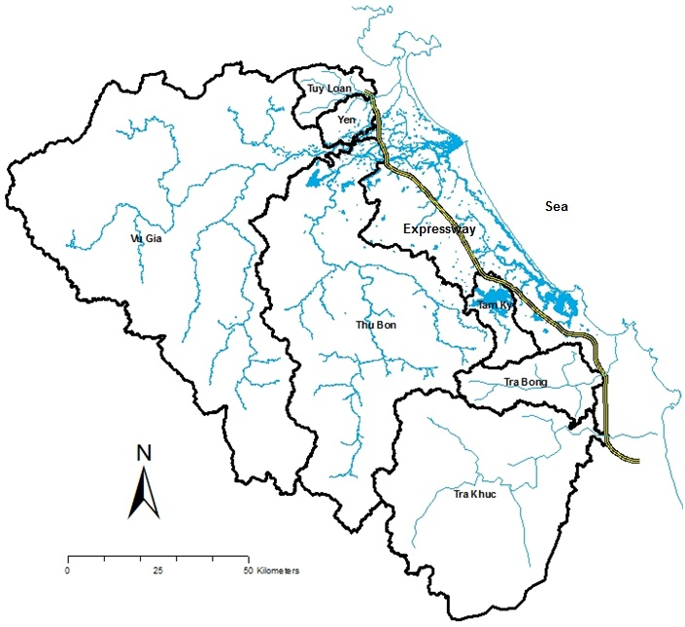
The planned Expressway will cross 5 large river basins of Vu Gia, Thu Bon, Tam Ky, Tra Bong and Tra Khuc (see Figure 2). The catchment areas of these rivers are 5,793 km² (Vu Gia River), 3,588 km² (Thu Bon River), 267 km² (Tam Ky River), 577 km² (Tra Bong River) and 2,928 km² (Tra Khuc River). Other small river basins which are crossed by the planned Expressway are Tuy Loan, Yen, Ly Ly, etc. Details on the hydrological characteristics of these river basins are described in the Hydrological Analysis Report prepared by the D/D Study Team in February 2012. Many areas in the project area are prone to flood every year. During flood season, the Expressway with high road embankment may act as a dyke that hinders the flow of flood water from the upstream of the river basins.

Figure 2 Rivers and their basins

During the D/D Study, results of the hydrological analysis mentioned above and comments of local residents had been taken into consideration for the design of culverts, underpasses, and bridges along the Expressway. Location, type and technical specifications of these structures had been designed so as it can maximize the flow of flood water and thus mitigate impacts of inundation.
The list of these cross structures is shown in the detailed design report of each package.

Impacts on Topography, Soil Erosion and Mitigation Measures
Rainfall is often considered to be one of the triggering elements for soil erosion at gravity which include water erosion, collapse and landslide. As the project is located in an area with adequate rainfall which often concentrates in a certain period, proper measures such as well scheduled construction and improvement of drainage system might considerably reduce the soil erosion that would occur due to land disturbance by road construction.
During construction phase, the Contractor shall undertake at all times to prevent soil erosion, and shall implement the measures to control soil erosion that shall include, but not be limited to the followings:
1) The Contractor is required to reuse the excavated soil as much as possible unless the soil is considered not suitable for filling. Fertile soil (or surface soil) shall be distributed free to local people who need it for their own purpose. The residuals shall be reused to form the ground around the interchanges, the areas along the Expressway within the acquired land, or recover the vegetation in some affected areas due to the Expressway project (such as: borrow pit, temporary sites...)
2) The Contractor shall plan his works to minimize surface excavation works during the rainy season where practicable.
3) Precautions to be taken at any time of year when rainstorms are likely, actions to be taken when a rainstorm is imminent or forecast, and actions to be taken during or after rainstorms shall be developed by the Contractor. Particular attention shall be paid to the control of surface runoff during storm events, especially for sites located near steep slopes.
4) In rainy season, prior to construction of roadbed, culverts will be completed with drainage system. The storm water interception and drainage system should be constructed before construction of side slopes.
5) Riprap or rock material should be used to embed the surface of the road sideslopes. Planting at the surface of the road sideslopes is also recommended. Retaining structures such as gabions, cribs, or other types of green barricades and grid work should be used to batter back against the cutting slopes.
6) At the sections involving high filling, the construction of road should be scheduled to avoid rainy season. If can not, drainage system will be improved to ensure that storm water be drained smoothly and quickly, and the working surface will be covered.
7) The overall slope of the works areas and construction yards shall be kept to a minimum to reduce the erosive potential of surface water flows.
8) The earthwork sites where exposed land surface is vulnerable to runoff, etc. shall be consolidated and/or covered.
9) The material stockpile sites shall be far away from surface water bodies and areas prone to surface run-off. Loose materials shall be bagged and covered. Open ditch shall be built around the stockpile sites to intercept wastewater. If necessary, retarding basins shall be constructed to remove sands and other solids in storm water before it reaches the downstream rivers.
10) Open stockpiles of construction materials (e.g. aggregates, sand and fill material) of more than 50m³ shall be covered with tarpaulin or similar fabric during rainstorms. Measures shall be taken to prevent the washing away of construction materials, soil, silt or debris into any drainage system.
11) At the start of site establishment, perimeter cut-off drains to direct off-site water around the site shall be constructed and internal temporary drainage works and erosion and sediment control facilities shall be implemented.
12) Cut-off drains should be built near sensitive areas to catch rainwater before it reaches the critical areas, and diverging drains should be built to avoid excessive concentration of rainwater flow. Concrete dissipation structures should be built to slow down storm water in drains, and hence reduce its downstream erosive potential.
13) Channels, earth bunds, netting, tarpaulin and or sand bag barriers shall be used on site to manage surface water runoff and minimize erosion.
14) All exposed earth areas shall be completed and revegetated as soon as possible after earthworks have been completed. If excavation of soil cannot be avoided during the rainy season, or at any time of year when rainstorms are likely, exposed slope surfaces shall be protected by temporary drainage measures.
15) The overall slope of the works areas and construction yards shall be kept to a minimum to reduce the erosive potential of surface water flows.

Impacts of Land Acquisition and Resettlement and Mitigation Measures
This section will be updated after the Updated RAP Report is prepared

Impacts on Local Residents’ Living, Livelihood, Economy and Mitigation Measures
This section will be updated after the Updated RAP Report is prepared

Impacts to Cultural/Archaeological Properties and Mitigation Measures
1) Impacts to Archaeological Properties
An archaeological investigation was carried out by the Institute of Archaeology of the Vietnamese Academy of Social Sciences in 2010 (refer to the “Report of the Archaeological Investigation (Stage 1) Along the Da Nang - Quang Ngai Expressway, May 2010”).
According to this investigation, there is a group of Champa architectural ruins that may be affected directly or indirectly by the Project. These ruins are located in Chiem Son Tay Valley of Chiem Son Hamlet, Duy Trinh Commune, Duy Xuyen District, at section Km 21+800 - Km22+450 of the planned Expressway (Figure 3). These ruins (namely Go Gach, Go Loi, Trien Tranh and Chua Vua) have been recognized and ranked as provincial-level archaeological sites under the Decision No. 754/QĐ UB on March 13, 2006 of Quang Nam Province Committee.
The ruins of Go Gach and Trien Tranh would be encroached seriously by the road alignment proposed in F/S (see Figure 4). However, in D/D, the alignment had been modified and consequently the encroachment to Go Gach ruin is avoided. A part of the Trien Tranh ruin remains to be encroached by the alignment proposed in D/D.
The Trien Tranh Ruin lies in the western residential area of Chiêm Sơn Hamlet, belonging to the Úc Đạp mountain foot (the Eo mountain foot) in the Southeast of Chiêm Sơn Tây Valley. The hill is about 10m high over the paddy field, and has relatively steep slope currently-covered by the eucalyptus trees and high dense shrubs. There are several large deep holes on the mound those were dug by people looking for gold and ancient relics. On the mound surface, it can observe a large number of bricks which are usually used for Champa architecture. The carefully whittled sandstones, similar to the stone used to make other Champa tower bases, are frequently found. According to result of the site observation, it suggests that there may be a collapsed Champa tower here, and the tower foundation might still be buried deeply in the ground.
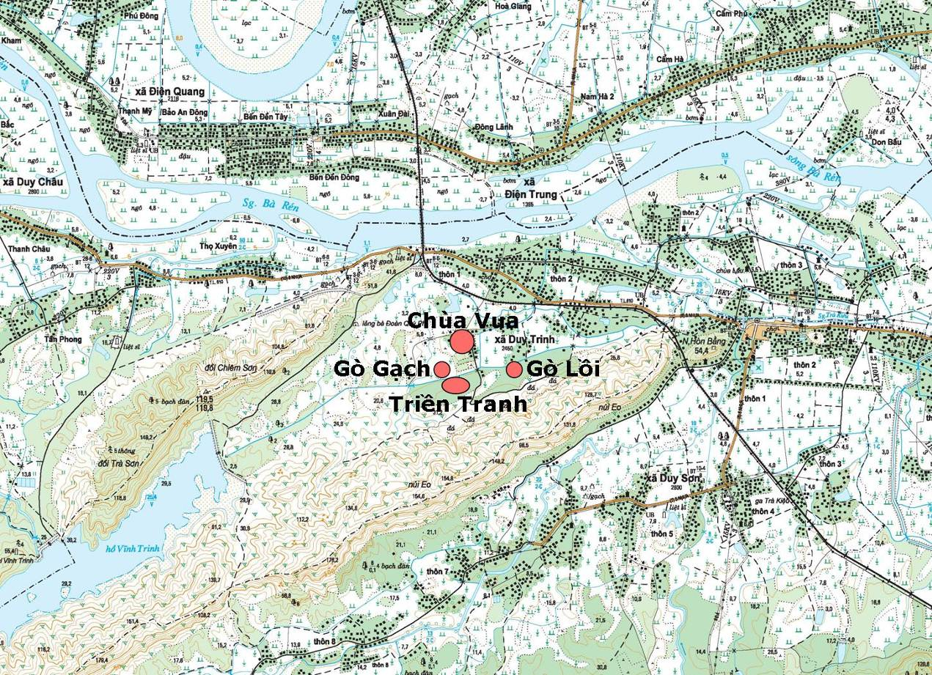Figure 3 Distribution of Champa ruins in the valley of Chiêm Sơn Tây
Planned Expressway

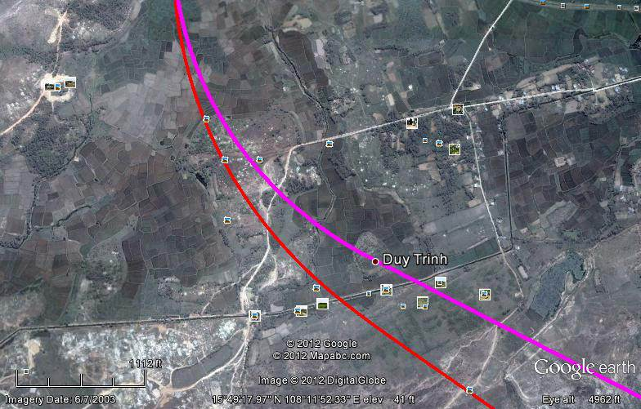Figure 4 Location of Champa ruins, F/S and D/D alignments.
Chùa Vua
Triền Tranh
Gò Lồi tranh
Gò Gạch tranh
D/D Alignment
F/S Alignment

The planned Expressway will pass through the western part of Trien Tranh Ruin from Km 21+800 to Km 22+150. Measures to avoid/mitigate impact to this site should be carefully examined before and during construction phase.
During operation phase, the above-mentioned Champa ruins would be affected by vibration caused by running vehicles on the Expressway. However, these impacts are considered insignificant, because these ruins are under the ground and relatively far from the Expressway (distances from the Expressway to Go Gach, Go Loi and Chua Vua are 120m, 400m and 450m respectively).
Besides, several significant archaeological artifacts of the ancient “My Thien Pottery Kiln” have been found scattered on the bank of Tra Bong River in Binh Trung Commune, Binh Son District. Quang Ngai Province (Km 108+400 ~ Km 108+600). They have been collected and stored in the local museum or in local residents’ houses as private collections.
The Vietnamese Government has issued the Law on Cultural Heritage and several regulations for preservation of the heritages. They prohibit a project proponent from changing original constituents of heritages by adding, moving/exchanging artifacts in monuments, or renovating/restoring, and taking other acts without permission from the Ministry of Culture and Information (MOCI). Besides, a project proponent is banned from changing surrounding environments and landscapes of heritages by illegally cutting trees, breaking stones, digging, excavating and constructing and other activities which negatively impact the relics. The Law on Cultural Heritage also requires a project proponent on construction at places affecting relics to coordinate with the MOCI and to create conditions for the MOCI to supervise the process of construction. If a project proponent realizes that there may be relics, antiques or national precious objects in the project areas, he/she must temporarily stop the construction works and promptly inform the MOCI.
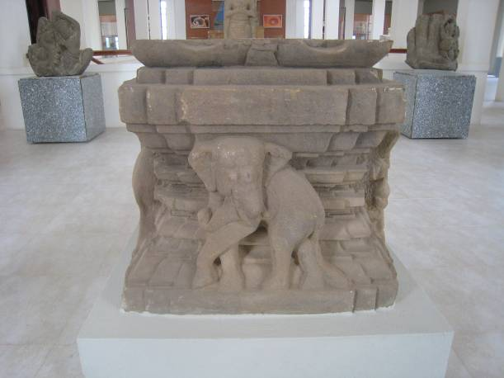
Therefore, in order to avoid suspension of construction works which may cause severe delay of the project, it is recommended that a test excavation at Trien Tranh Ruin should be carried out prior to the commencement of construction. According to recommendation of the Institute of Archaeology, the test excavation is necessary to evaluate the size of the site and its distribution under the ground, and the influence intensity of the construction on the archaeological site.
A stone altar found at Trien Tranh site, one of the Champa ruins in Duy Trinh Commune
PMU85 would discuss with the Cultural and Information Department of Quang Nam Province PC, and Cultural and Information Division of Duy Xuyen District PC to assess the need of the test excavation. If it comes to conclusion that the test excavation is needed, VEC would sign a contract with the Institute of Archaeology or another specialized institute to carry out the test excavation prior to the commencement of construction works at this road section.
After the test excavation, a meeting between relevant agencies would be organized to discuss about result of the test excavation, and decide whether an official excavation prior to the commencement of construction works at this road section should be done or not. Cost for the test excavation and official excavation should be included in the cost for EMP implementation.
During construction phase, some archaeologically-valuable artifacts or sites would be unearthed in chance. According to the regulations of the Law of Cultural Heritage, a Physical Cultural Property Chance-Finds Procedures should be prepared before hand to minimize impacts to these artifacts or sites. If valuable or invaluable relics are discovered, the local related departments should be notified immediately. The excavation should be stopped until the authorized department identifies the relics.
2) Impacts to Religious, Cultural Properties
A number of religious/cultural properties such as pagoda, temple, church, etc. located within the land to be acquired for the project (land acquisition demarcation line, or “GPMB line” in short) or near the planned Expressway would be affected directly or indirectly by the project. Table 5 shows the project-affected religious/cultural properties identified by the D/D Study Team as of May 2012. The others will be identified and described in the Final Updated EIA Report together with the relevant impact mitigation measures.
Table 5 Identified Religious /Cultural Properties Likely Affected by the Project (as of May 2012)
(1) Phuoc Hue Pagoda (Phước Huệ Tự)
- Location: Km104+300 (200m from the centerline, in the east)
- Commune: Bình Nguyên (Phước Bình Hamlet)
- District: Bình Sơn District
- City/Province: Quảng Ngãi Province
- Extent of affect by the project: To be affected by dust, noise during construction phase. (The pagoda is located near the road to be used for transportating construction materials, and the main gate of the pagoda will face the expressway). The expressway would hinder people’s accessibility to the pagoda. Local residents request to plant trees between the pagoda and the expressway.
(2) Binh Loc Temple (Nghĩa tự và Miếu Bình Lộc)
- Location: Km103+650 (right close to the land acquisition demarcation line [GPMB line], in the east)
- Commune: Bình Nguyên (Phước Bình Hamlet)
- District: Bình Sơn District
- City/Province: Quảng Ngãi Province
- Extent of affect by the project: The expressway will pass through the front gate of the temple, and encroach the access road to the temple. Attempt to relocate the temple is undertaking in replying to local residents’ request.
(3) Day Temple and Long Xuan Pagoda (Miếu Dây và Nghĩa Tự đường Long Xuân)
- Location: Km109+800 (400m from the centerline, in the East, close to the abutment of the planned Tra Bong Bridge)
- Commune: Bình Long (Long Xuân Hamlet)
- District: Bình Sơn District
- City/Province: Quảng Ngãi Province
- Extent of affect by the project: During construction phase, the temple and pagoda would be affected by dust, noise, vibration, etc. caused by the construction works of the bridge abutment.
(4) Linh Miếu Pagoda (Linh Miếu Tự)
- Location: Km109+800 (200m from the centerline, in the East, close to the abutment of the planned Tra Bong Bridge)
- Commune: Bình Long (Long Xuân Hamlet)
- District: Bình Sơn District
- City/Province: Quảng Ngãi Province
- Extent of affect by the project: During construction phase, the temple and pagoda would be affected by dust, noise, vibration, etc. caused by the construction works of the bridge abutment.
(5) Doi 8 Temple (Miếu Đội 8)
- Location: Km121+650 (inside of the GPMB lines)
- Commune: Tịnh Hà (Lâm Bộc Bắc Hamlet)
- District: Sơn Tịnh District
- City/Province: Quảng Ngãi Province
- Extent of affect by the project: Totally affected and should be relocated under the project scheme.
(6) Phuoc Son Pagoda (Nghĩa tự Phước Sơn)
- Location: Km121+650 (inside of the GPMB lines, near by Doi 8 Temple)
- Commune: Tịnh Hà (Lâm Bộc Bắc Hamlet)
- District: Sơn Tịnh District
- City/Province: Quảng Ngãi Province
- Extent of affect by the project: Totally affected and should be relocated under the project scheme.
(7) Pho Thanh Pagoda (Chùa Phổ Thạnh)
- Location: Km125+000 (a part of the pagoda and its land is located inside of the GPMB lines)
- Commune: Tịnh Hà (Ngân Giang Hamlet)
- District: Sơn Tịnh District
- City/Province: Quảng Ngãi Province
- Extent of affect by the project: 1/3 of the pagoda land and a part of the pagoda structure would be encroached by the project. The pagoda should be relocated under the project scheme.

Data: D/D Study Team (Resettlement Group, Archaeological and Cultural Study)

Impacts to Local Communities (Traffic Congestion, Accidents) and Mitigation Measures
In addition to impacts of loss of residential land and production land, resettlement, interruption of production activities, interruption of schooling, split of communities, etc., health and well-being of local communities may be affected by:
- Spread of disease due to poor house keeping and accumulation of domestic waste within the construction site;
- Stagnant water may result in mosquitoes breeding;
- Threats of spreading HIV/AIDS, as there will be a large construction force in the relatively remote areas during construction for a significant period time. This force is highly mobile and unsafe sex conduct could bring the HIV/AID risk to the local communities;
- Affected living standard and income of local residents due to occupation of lands for cultivation, aquaculture, etc.;
- Traffic congestion, traffic safety.
Since the affected communities may have not experienced about large-scaled project near the locality in the past, they would be prone to the impacts caused by the Project. The following measures should be taken to mitigate impacts to health and well-being of local communities.
1) During the pre-construction phase
- Consultation meetings with local governments, local communities, and residents affected by the project should be organized to dismiss information about the project, collect opinions of local people about the project, and to promote their participation into the project implementation.
- The contract between the project owner and contractors should define the contractor's responsibility and obligation to implement mitigation and protection measures.
- Occupation of fertile farmland and woodland should be minimized;
− In order to minimize obstruction to local residents’ movement, the project should properly design underpasses, overpass bridges at the sections where the Expressway crosses the local roads, rural roads.
- The Resettlement Plan should be prepared to address the impacts of relocation, decrease in income, and loss means of livelihood caused by the project to local residents. Local authorities and VEC should ensure that any involuntary resettlement will be carried out in accordance with the agreed Resettlement Action Plan, World Bank Operational Policies (OP 4.12, OP 4.10), and the Government’s laws and regulations on involuntary resettlement. The resettlement sites should be well developed with physical infrastructures and social services, such as approach roads, water supply sytem, electric power supply system, drainage and sewage water treatment systems, etc.
- The Livelihood Restoration Programs should be developed to ensure that living and livelihood of the severely-affected Displaced Persons (DPs) and vulnerable groups will be restored at least to the level similar to those before resettlement. Results of consultation with DPs and other stakeholders, especially local NGOs should be duly taken into consideration during the preparation of the programs. To meet the World Bank Policy requirements, payment for all assets (including land, structures, crops, and other assets) must be based on the replacement cost with the assets value at full market price. DPs’ assests should be restored at least to the level similar to those before resettlement.

2) During the construction phase
- In order to minimize impacts of an influx of new people into the local community, wherever possible, suitable local companies and organizations should be involved. For unskilled manual labor, men and women in the locality should be employed.
- Should there be a large influx of new people, then they are likely to be housed on the site. Adequate living standards with suitable services (water supply, sanitation and power supplies) should be provided for these temporary housing areas. Effluents discharged from these premises should be treated properly before discharged to the surrounding water bodies.
- Opportunities to use local services (e.g. for food supplies etc) should also be encouraged so that the local population benefits from an influx of new people.
- Temporary obstruction of traffic should be avoided or minimized by:
+ Carefully preparing the construction plan in order to minimize the area and period of road occupation/ closure, and avoid concentration of construction vehicles;
+ Providing prior notices to local residents on the road occupation / closure through sign boards and mass media;
+ Specifying road occupation sites, construction sites, etc. to avoid vehicles mistakenly enter the sites;
+ Allocating personnel at place vulnerable to traffic congestion to instruct detour.
- After completion of construction, the land used for temporary purposes should be reclaimed for agricultural development;
3) Mitigation Measures Regarding Impacts on Community Health
The need for preparation of an HIV/AIDS Prevention Program had been agreed among JICA and GOV as described in the “Minutes of Discussions on North-South Expressway Construction Project (Da Nang – Quang Ngai Section) between Japan International Cooperation Agency and the Government of the Socialist Republic of Vietnam” signed on October 21, 2010, considering that the Project would gather a lot of workers for civil works during the implementation stage, which may raise risk of HIV/AIDS infections.
It is also agreed that HIV/AIDS activities for the whole section of the project, including both Japanese ODA Loan portion and the WB Loan portion, will be financed under the WB loan.
The objectives of the above mentioned activities are several folds: (i) lower the risk of HIV/AIDS transmissions among targeted groups: road agency staff, construction works, sex workers, and residents in the project affected areas; (ii) reduce in the rate of HIV infections among the targeted groups; and (iii) support institutional strengthening with MOT by increasing awareness of the importance of HIV/AIDS in the transport sector. Main activities of the HIV/AIDS Prevention Program are described in Attachment 15 of the Minutes of Discussions.
Based on the HIV/AIDS Prevention Program, the project should address the needs for better dissemination of information about HIV/AIDS and other risks such as drug abuse and human trafficking. The Program should contain awareness campaigns at the construction sites and in the communities, as well as developing peer educators and community monitoring combined with the prevention of human trafficking, awareness on safe migration, and community monitoring.
Infectious diseases should be prevented or controlled by the following measures:
+ Obligate Contractor to duly implement the HIV/AIDS Prevention Program during construction stage;
+ Obligate Contractor to prepare and execute the health education plan for construction workers;
+ Obligate Contractor to periodically report about the health education activities carried out by the Contractor;
+ Health education activities carried out by the Contractor should be monitored by the environmental supervision consultant;
+ Contractor should submit periodical reports about health education activities to local health authorities.
4) Traffic Accident Management and Prevention
Traffic volume in the interchanges with NH14B, NH14E, PR 605,PR 610, PR 616, PR617, PR623, PR602, and other local roads shall be increased due to the involvement of construction materials transportation vehicles resulting to potential traffic accidents, especially for children and students. To minimize risks, the road safety awareness program should be included in the Project (see Section 3.14 for further details).

Impacts of Split of Communities and Mitigation Measures
The planned Expressway with about 140km of extension will split a number of communies. The D/D Study had identified 85 villages/residential areas which would be split by the planned Expressway (see Section 4.4.5 in the Draft Updated EIA Report). The split of these communities and the split of cultivated lands would cause significant impacts to local residents’ daily life and production activities. In many cases, the planned Expressway also hinder local residents in accessing from their house to the paddy field, schools, hospitals, markets, authority offices, churches, pagodas, templse, cemetery, etc.
In D/D, attempts were made to adjust the Expressway alignment in order to avoid the split of residential areas as much as possible. In addition, the underpass, flyover, road under the bridge/viaduct were designed at about 130 road sections where the Expressway crosses the existing road or where there is request from local residents. Side road (collector road) were also designed with aim to improve accessibity of local residents. The list of these cross structures is shown in the detailed design report of each package.
Besides, relocation of school, hospital, pagoda, etc. is recommended where it is split from the village by the planned Expressway. The Tinh Ha Primary School located on the provincial road 623B near Km124+000 of the planned Expressway is an example. This school is not affected directly by the planned Expressway, but pupils going to this school would be hindered by the planned Expressway and the Quang Ngai North Interchange. Therefore, the relocation of this school is considered as the optimum option, and the school relocation plan is being discussed by local authorities and local residents.

Hazard and Mitigation Measures
During operation phase, among traffic accidents occurred on the Expressway, accidents involving vehicles transporting hazardous materials or chemicals are particularly dangerous because it would significantly pollute the river water and affect a large number of people living in the basin downstream of the river when it occurs accident on the bridge. Among the rivers crossed by the planned Expressway, the followings are particularly important, because they supply water for domestic use and irrigation to the populous residential areas in downstream of the river:
- Yen, Tuy Loan and Vu Gia rivers: supplies water for Da Nang city
- Tam Ky river : supplies water for Tam Ky city
- Ky Lam and Chiem Son rivers : supplies water for Hoi An city and Nam Phuoc town
- Tra Bong river : supplies water for Chau O town
- Tra Khuc river : supplies water for Quang Ngai City.
In order to prevent impacts of hazardous leakage accidents, the planned bridges crossing over the rivers such as the above mentioned should be designed with properly-strong guardrails. In addition, the drainage facilities associate with these bridges should be properly designed so as surface runoff from the desk of bridges can be collected, removed or discharged into the suitable designated areas far away from the river to prevent it flowing directly into the river.
In addition, an on-line- monitoring system and an emergency telephone lines should be installed in the Ky Lam, and Tra Khuc super bridges. The phone should be connected with the emergency center. An emergency leading group should be created by the Traffic Management Center. If an accident occurs, the leader of the Center will be immediately informed, and the remaining procedures in the emergency plan shall be triggered. The emergency equipment should be prepared and kept on the sites near the Ky Lam and Tra khuc Bridges.

Impacts of Construction Materials Exploitation and Transportation (Access Roads) and Mitigation Measures
The transportation of materials such as cement, timber, steel, asphalt, etc. will take place through about 30 existing roads as listed in Table 6 and Figure 5. Total extension of these entrance access roads is estimated to be 130,819 m.

Table 6 Selected Entrance Access Roads
PKG | No. | No. of EAR | Length | Existing width | Pavement | Structure
PKG1 | 1 | No.1 (QL14B) | 5,523m | 22.5m(20.0m paved) | As paved
PKG1 | 2 | No.2 | 5,816m | 6.0m | Aggregate | Bridge: 2  Culvert: 6
PKG2  PKG3A | 3 | No.3 (TL609) | 8,828m | 8.0m(6.0m paved) | As paved | Bridge: 1  Culvert: 4
PKG2  PKG3A | 4 | No.3-2 | 3,344m | 6.0m(3.5m paved) | As paved | Bridge: 1  Culvert: 4
PKG2  PKG3A | 5 | No.3-3 | 992m | 3.0m (need widening) | soil
PKG3A  PKG3B | 6 | No.4 | 9,540m | 6.0m(4.0m paved) | As paved | Bridge: 1 Culvert: 4
PKG3A  PKG3B | 7 | No.5 (TL610) | 10,690m | 8.0m(6.0m paved) | As paved | Bridge: 5  Culvert: 4
PKG4 | 8 | No.5-2 | 2,474m | 6.0m | As paved
PKG4 | 9 | No.5-3 | 1,256m | 5.0m | Aggregate | Bridge: 1
PKG5 | 10 | No.6 (TL611) | 5,284m | 6.0m(5.0m paved) | As paved | Bridge: 3
PKG5 | 11 | No.6-2 | 1,229m | 4.0m | soil
PKG5 | 12 | No.7 (QL14E) | 5,018m | 6.0m | As paved | Culvert: 1
PKG6 | 13 | No.8 | 4,708m | 6.0m | Aggregate | Culvert: 13
PKG6 | 14 | No.9 | 4,903m | 4.0m (need widening) | soil | Culvert: 3
PKG7 | 15 | No.10(TL615) | 5,558m | 6.0m | As paved | Bridge: 2  Culvert: 5
PKG7 | 16 | No.11 (TL616) | 4,356m | 6.0m | As paved | Bridge: 1  Culvert: 5
PKGA1 | 17 | No.11-2 | 2,517m | 6.0m | As paved | Culvert: 7
PKGA1 | 18 | No.12 | 4,356m | 4.0m (3.5m paved) | As paved | Culvert: 4
PKGA1 | 19 | No.13 | 3,600m | 4.0m | soil | Bridge: 1  Culvert: 4
PKGA2 | 20 | No.14 | 3,134m | 6.0m | Aggregate | Culvert: 2
PKGA2 | 21 | No.15(TL617) | 4,177m | 4.0m (need widening) | As paved | Culvert: 3
PKGA2 | 22 | No.16 | 3,719m | 3.0m (need widening) | soil
PKGA2 | 23 | No.17 | 2,911m | 3.0m (need widening) | soil
PKGA3 | 24 | No.18 | 1,200m | 3.0m (need widening) | soil
PKGA3 | 25 | No.19 | 2,254m | 7.0m | Aggregate | Culvert: 3
PKGA3 | 26 | No.20 | 1,834m | 6.0m | Aggregate | Culvert: 1
PKGA3 | 27 | No.21 (TL622) | 1,805m | 6.0m | Aggregate | Culvert: 2
PKGA4 | 28 | No.22 | 4,383m | 3.0m | soil | Culvert: 3
PKGA4 | 29 | No.23(TL622C) | 4,961m | 6.0m | As paved | Bridge: 1  Culvert: 5
PKGA4 | 30 | No.24(TL623) | 5,342m | 6.0m | As paved | Bridge: 1
PKGA5 | 31 | No.25(TL623B) | 6,084m | 6.0m | As paved
Data source: D/D Study Team, Preliminary Construction Plan, May 2012.

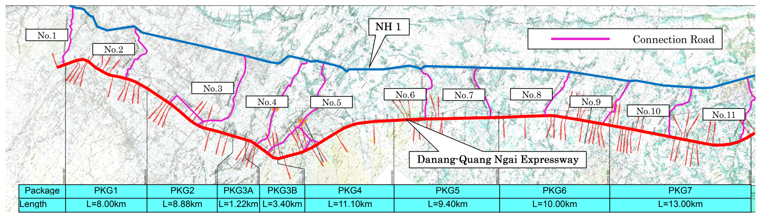

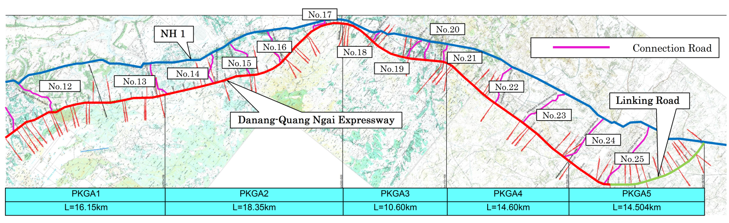

Figure 5 Selected Entrance Access Road

The following principles are applied in selecting the entrance access roads:
- First basis of selection
+ It should be public road. (national road, provincial road)
+ The road pavement width is more than 6 m desirably.
+ The areas along the road are low density residential areas.
- Second basis of selection (if there is no road which satisfies the first basis)
+ It should be public road. (district road)
+ As for a road lot, not less than 8 m is desirable.
- Third basis of selection (If there is no road which satisfies the first basis and second basis)
+ Rural road or forest road
+ Widening of road width is feasible.
During construction phase, a significant number of trucks transporting construction materials would use these roads, and cause degradation of local residents’ living conditions by increase in air pollution, noise, traffic jam, traffic accidents, etc. In particular, increase in traffic accident is anticipated at the road sections near the schools. Dust generated by the trucks transporting construction materials would be the main cause of damage to the surrounding plants, vegetation, etc. and degradation of water quality of the surrounding waterbodies. For the roads which need widening, local residents would be affected due to the land acquisition, loss of cultivated lands, etc.
To mitigate impacts to residents living along the entrance access roads during construction phase, these roads should be properly used and managed as follows:
− The entrance access roads selected and described in the construction plan prepared by the D/D Study Team should be firstly used. Widening of existing roads, and development of new access road should be avoided.
− If the Contractor proposes new access roads, these will be checked/approved by the Da Nang City PC, or Quang Nam Province PC, or Quang Ngai Province PC, and agreed by the commune PCs. The new road should be designed so as large volume excavations is avoided, and the width of the road is strictly controlled.
− Compensation to farmers should be done efficiently and fairly if land acquisition is required for the newly-built access road.
− All newly built and improved access roads should be designed with the proper drainage system, road slope retaining structures, etc.
− Warning signs, speed bumps should be placed at the road sections near the sensitive receptors such as schools, hospitals, pagodas, markets, etc. to reduce risk of traffic accident.
− Contractors should formulate proper construction materials transportation plans to mitigate impacts to local residents and environment.
− Nocturnal transportation and construction activities are prohibited at the road sections near the residential areas.
− For unpaved access roads, contractors shall spray water on the roads 2 – 3 times a day during the dry season.
- Pavement of linking roads must be regularly maintained during construction phase to reduce impacts of dust, noise, and risk of traffic accident.

Public Consultation

Organization of Public Consultation Meeting
The Da Nang – Quang Ngai Expressway is planned to pass through more than 40 communes in 14 districts of Da Nang City, Quang Nam Province, and Quang Ngai Province.
During the D/D Study, public consultation meetings were organized in all project-affected communes as required by the World Bank. Participants to these meetings were local stakeholders which includes: PAPs, leaders of the hamlets/communities, representatives of mass organizations and unions (such as women’s association, association of farmers, youth union, veterans’ organization, etc.,) and NGOs. Representatives of local authorities at provincial, district, and commune levels (who are responsible for land acquisition, resettlement, natural resources and environment, communications and transport, industry and trade, agriculture, etc.), representatives of PMUs, District Land Fund Development Centers, and members of the D/D Study Team (including Resettlement Team, Social & Environmental Team, Road Design Team, etc.) were also participated to the meetings as the project executors.
Contents of the public consultation meetings are generally as followings:
- Diffusion of information on the project, on the land acquisition, compensation and resettlement, etc. to the local stakeholders;
- Discussion with the local stakeholders on the environmental and social issues that may be caused by the project to the commune, as well as other issues concerned by the local stakeholders;
- Collection of local residents’ comments and requests on the project plan, and other information necessary for preparation of the impact mitigation measures.
Information such as project outlines, impacts that may cause by the project to the commune, proposed impact mitigation measures, etc. were explained to local people during these public consultation meetings. It was also an opportunity for local residents to raise questions, comments, opinions, etc. on the Project, and for the SAE Team to collect information on the environmentally-sensitive spots/structures which could not identified on the topographic maps. Comments and opinions raised by participants in the public consultation meetings were also useful and contributable for the SAE Team to plan the impact mitigation measures that match with the actual natural and socio-economic conditions of the localities.
As of present time, the Project Team had organized 18 public consultation meetings in the following communes:
- Dien Tho (Dien Bang District, Quang Nam Province) on 11 January, 2012
- Dien Quang (Dien Bang District, Quang Nam Province) on 12 January, 2012
- Dien Tien (Dien Bang District, Quang Nam Province) on 13 January, 2012
- Binh Long + Binh Truong (Binh Son District, Quang Ngai Province) on 14 March, 2012
- Tinh Tho (Son Tinh District, Quang Ngai Province) on 15 March, 2012
- Tinh Ha (Son Tinh District, Quang Ngai Province) on 16 March, 2012
- Nghia Dien (Tu Nghia District, Quang Ngai Province) on 19 March, 2012
- Nghia Trung (Tu Nghia District, Quang Ngai Province) on 20 March, 2012
- Nghia Thuong (Tu Nghia District, Quang Ngai Province) on 21 March, 2012
- Hanh Thuan (Nghia Hanh District, Quang Ngai Province) on 22 March, 2012
- Nghia Ky (Tu Nghia District, Quang Ngai Province) on 23 March, 2012
- Hoa Phong on 12 April, 2012
- Hoa Tien on 13 April, 2012
- Tam Ngoc on 19 April, 2012
- Tam Xuan 1 on 20 April, 2012
- Tam Xuan 2 on 21 April, 2012
- Tam Dai on 23 April, 2012
- Tam Thai on 23 April, 2012

Public Opinions
As of May 2012, the issues frequently raised in the public consultation meetings organized in the project-affected communes are as following (Table 7).
Table 7 Typical issues frequently raised in the consultation meetings (as of May 2012)
No. | Issue | Description
1 | Compensation | The compensation price (for the loss of land and property) issued by Provincial People’s Committees is too low compared to the market price. If it’s not adjusted appropriately, the PAPs will not be able to restore their life and livelihood.  According to Vietnam laws and regulations, residents living in the project’s safety corridor will face many constraints and difficulties in using their lands and rebuilding their houses. At present time, there is no valid policy regarding this issue. However, it should be considered as a remarkable adverse impact caused by the project, and the corresponding mitigation measures should be properly prepared.  In Quang Ngai Province, the Provincial Sub-project Management Unit (PSPMU) is assigned as agency in charge of managing budget for land acquisition, paying compensation, and implementing the resettlement sites construction plan, while district PCs, including the Land Fund Development Centers have to deal with PAPs’ troubles and grievances. This mechanism is unsuitable and unsustainable, due to the fact that it causes many complexities and disadvantages to PAPs. Actually, there were many complaints from local PAPs and authorities on the PSPMU’s unclear and irresponsible activities. To ensure sustainable resettlement, a proper decentralization mechanism should be applied, so as district PCs can directly manage the tasks of compensation and resettlement, including the relevant budget management, making decision on the location and the construction plan of the resettlement sites.
2 | Resettlement | The maximum surface area of a land plot in the resettlement site is 300m² as planned by the local authorities. It is said not enough for displaced farmers for re-establishing their production, particularly husbandry. In addition, many residents who will lose their land for the project are very worried about their remaining land which will be not enough to help their children in sustaining living in the future.  Construction of resettlement sites should be completed before relocation.  Resettlement sites should have clean water resource for daily use.  Relocation should be planned in dry season and not disturb local people’s agricultural activities.  Most of residents living close to the planned Expressway want to be relocated because they think that it is hard to maintain their daily life.  Budget for construction of the resettlement sites has not been determined clearly.
3 | Living condition and livelihood | The Expressway will cause obstruction to many local roads and deteriorate local people’s transportation. Many farmers will have to transport (with or without bulkily agricultural stuffs and productions) to/from their fields via the underpasses planned by the project. Therefore, it needs to consult with local people on the proper design of the underpasses.  Farmers who lose most of their agricultural land will be rather difficult to find out alternative livelihoods, particular the elders.  Some especially vulnerable households should be provided with special supports in order to maintain their living and livelihood.  Budget for implementating the Income Restoration Programs has not been determined clearly.
4 | Construction works | Construction works normally causes many impacts such as: air pollution, excessive noise, road degradation, crop damage, etc., but contractors normally don’t undertake proper measures to mitigate these impacts. Therefore, the contractors are requested to duly manage their construction works as well as their employed workers.
Data: Summary Note on Outcome of Consultation Meetings for Updating Resettlement Plan, Resettlement Team, D/D Study Team, June 01, 2012.

This Section will be updated after all planned public consultation meetings are organized.

Environmental Management Plan (EMP)

Purpose of the Environmental Management Plan
An Environmental Management Plan (EMP) is a practical and achievable tool to ensure that any negative environmental impacts are minimized and any possible environmental, safety and efficiency benefits are maximized during the construction and operation phases of a development. This EMP therefore provides practical guidelines for environmental management to ensure all works undertaken by the developer, engineers, and contractors have minimal impact on the environment, and are in accordance with all relevant laws, regulations, technical guidelines and codes of practice of the Socialist Republic of Vietnam, and the World Bank’s operational policies.
The EMP addresses all issues identified in the EIA by: (i) organizing all measures to mitigate environmental impacts during the construction and operation; (ii) establishing an organizational structure, procedures, and institutional responsibilities for implementation; and (iii) identifying the monitoring requirements needed for the successful implementation of the suggested mitigation measures, and a budget and source of financing for each activity.
The EMP will also assist different stakeholders in managing the environmental issues of the Project: (a) The Project’s executing authority -- to make it better able to manage the implementation of the EMP; (b); supervisors – to ensure that the EMP is properly implemented; (c) environmental engineers – to assist them to work with the Contractors to implement the EMP; and (d) Contractors – to help them develop project-specific EMP implementation plans.
Simultaneously, the EMP is the summary of commitments by the project owner presented in the EIA and the related implementation process. The EMP will enable VEC, the World Bank and other relevant authorities in Da Nang City, Quang Nam and Quang Ngai Provinces to supervise the application of mitigation measures and compliance of commitments by the Contractors.

Summary of the Environmental Management Plan
The EMP contains guiding environmental principles and procedures for communication, reporting, training, monitoring and plan review to which all staff, engineers, consultants, supervisors, Contractors and sub-Contractors are required to comply with throughout the pre- construction, and constructions stages of the project.
The EMP is structured as follows:
Project Description: summarizes the DQEP description, its justification and its main components
Environmental Legislative Framework: Outlines the major laws, regulations, national standards and technical guidelines, The World Bank Policies and the relevant clearance documents that may affect the Environmental Impact Assessment (EIA) process of the project.
Roles and Responsibilities for Environmental Management during Construction: defines the roles and responsibilities for environmental management for all actors involved in the project. It also gives a detailed description of the environmental duties of the actors directly involved in the project: PMUs, The Environmental Control Officer (ECO), the Environmental Monitoring Consultant (EMC), the Construction Supervision Engineers (CSE) and their Workplace Safety and Environmental Supervisor (SES), The Contractors, sub-contractors and the Contractor’s on-site Environmental Officer (DEO).
Overview of Environmental and Social Issues: summarizes the main environmental and social impacts identified in the EIA, the approach for identification of environmental issues along the Expressway alignment, and the mitigation measures needed to reduce or minimize negative impacts.
Environmental Compliance Framework: describes the minimum environmental and social issues that should be put into place, describes the Contractor’s EMP implementation plan, the management of Contractors, the compliance with legal and contractual requirements, the compliance framework procedures and the penalties that shall be imposed for not compliance with the EMP.
Environmental Monitoring Requirements: describes the monitoring program that shall be carried out by the Contractor’s on-site Environmental Officer (DEO), supervision engineers and the environmental monitoring consultant (EMC). It also describes how site inspections shall be carried out.
Environmental Training for Site Personnel: describes the training programs and methodologies that will need to be implemented for all actors involved in the environmental management of the project
Implementation Schedule: presents the general schedule for EMP implementation and the requirements and staffing needs for initiation of the works.
Reporting: describes the different reports that have to be prepared by Contractors, ECO, and EMC during the project construction.
Budget: Presents the estimated budget for EMP implementation.
A series of annexes provides details for the main components of the EMP:
Annex 1: presents the Terms of Reference for the Independent Environmental Monitoring Consultant (EMC) to be appointed by VEC who will be responsible for carrying out environmental sampling and monitoring four times a year, on all environmental-related issues regarding the Contractor’s works
Annex 2: presents the Terms of Reference for the environmental supervision of all construction activities. This environmental supervision will be included in the overall technical supervision of Expressway construction.
Annex 3: presents the environmental and social specifications for Contractors. These specifications are to be included in all biding documents and contracts.
Annex 4: presents site-specific impacts and proposed mitigation measures along the alignment of the Expressway. This table is also a useful instrument for supervising the implementation of the EMP during construction.
Annex 5: describes the Environmental Monitoring Plan (EMoP) that shall be carried out by the EMC.
Annex 6: presents the “do’s and don’ts” of the EMP to be followed by all personnel involved in the implementation of the DQEP and the basis for a the Code of Conduct established for the project.

Implementing Organizations
A successful EMP requires active involvement from all parties involved in the process of environmental management: (1) those responsible for organizing or implementing the EMP, and (2) those enforce the standards, laws and regulations relevant to the project, supervise the EMP and the overall environmental performance during the construction and operation of the project.
For the DQEP, the following agencies/organizations should be involved in the implementation and supervision of the EMP.
- Department of Natural Resources and Environment (DONRE) of Da Nang City, Quang Nam Province, and Quang Ngai Province, and other related local agencies
- The Vietnam Expressway Corporation (VEC), Project Management Units (PMU85 and PMU1)
- The Environmental Control Officer (ECO)
- The Environmental Monitoring Consultant (EMC)
- The Construction Supervision Consultant (CSC) and its Workplace Safety & Environmental Supervisors (SESs).
- The Contractors and its Environmental Officer (DEO)
- The Ministry of Transportation (MOT)
- WB and JICA
The organizational structure for the EMP implementation and supervision during construction phase is shown in Figure 6. The organizational structure may be revised after discussion with PMUs, VEC, and WB.
The roles and responsibilities of these parties and the line of communication with respect to environmental protection works are described in detail in the EMP.
Figure 6 Organization Structure for EMP implementation and supervision (in construction phase)

Summary of the Environmental Monitoring Plan (EMoP)
Main objectives of the EMoP during the construction phase are:
- To monitor the actual project impact on physical, biological and socio-economic receptors. This will indicate the adequacy of the EIA.
- To recommend mitigation measures for any unexpected impact or where the impact level exceeds that anticipated in the EIA.
- To ensure compliance with legal and community obligations including safety on construction sites.
- To monitor the rehabilitation of borrow areas and the restoration of construction camp/sites as described in the EMP.
- To ensure the safe disposal of construction wastes.
Main objectives of the EMoP during the operation phase are:
- To appraise the adequacy of the EIA with respect to the project's predicted long-term impact on the corridor's physical, biological and socio-economic environment.
- To evaluate the effectiveness of the mitigation measures proposed in the EMP, and recommend improvements in the EMP, if necessary.
- To monitor the survival rate of roadside plantations.
VEC will be in charge of environmental monitoring during the construction and the operation phase. Selected Environmental Monitoring Consultant (EMC) will conduct monitoring and submit reports on the monitoring results to VEC on quarter basis during construction phase and twice a year in operation phase.
A monitoring plan for the project providing paramaters, frequency, locations and applicable monitoring method, is presented Annex 5 of the EMP.
The whole monitoring process shall be carried out according to Environmental Monitoring Technical Standard issued by MONRE. In order to ensure the survey accuracy and credibility, monitoring staff shall duly conduct the survey in accordance with rules, including collecting and preserving samples, equipment set-ups and monitoring, etc.

Review of Previous Studies
Review of Previous Studies is summarized in Appendix 8: Review of Previous Studies (Social and Environmental)

Updating Resettlement Action Plan (RAP)

General
The Resettlement Action Plan (RAP) will be updated in accordance with WB guidelines based on the detailed designs prepared under these services. Updating data shows that approximately 139,5 km length of the road alignment crosses through 42 communes of 13 districts of 3 provinces and city as listed in the following table:
Table 12.1: Scope of land acquisition and resettlement
No. | Province | District | Commune | Length (m) | Total affected households^{(*)} | Total affected persons^{(*)} | Total affected land area (ha) ^{(*)}
1 | Da Nang | Hoa Vang | Hoa Nhon, Hoa Phong, Hoa Tien | 7,965 | 424 | 1,738 | 50, 6
2 | Quang Nam | Đien Ban | Đien Tien, Đien Thọ, Đien Quang | 12,235 | 686 | 3,200 | 84,1
3 | Quang Nam | Duy Xuyen | Duy Trinh, Duy Son, Duy Trung | 9,265 | 437 | 1,942 | 62,7
4 | Quang Nam | Que Son | Que Xuan 2, Phu Tho | 10,185 | 613 | 2,185 | 88,1
5 | Quang Nam | Thang Binh | Binh Quy, Binh Chanh, Binh Que, Binh An | 12,700 | 513 | 2,089 | 84,2
6 | Quang Nam | Phu Ninh | Tam Thanh, Tam Phuoc, Tam Dan, Tam Thai, Tam Dai | 14,115 | 672 | 2,673 | 92,8
7 | Quang Nam | Tam Ky City | Tam Ngoc | 1,947 | 114 | 399 | 7,1
8 | Quang Nam | Nui Thanh | Tam Xuan 1, Tam Xuan 2, Tam Anh Bac, Tam Anh Nam, Tam Hiep, Tam My Tay, Tam My Dong, Tam Nghia | 30,788 | 1,451 | 5,734 | 223,3
9 | Quang Ngai | Binh Son | Binh Chanh, Binh Nguyen, Binh Trung, Binh Chuong, Binh Long | 12,312 | 673 | 2,720 | 102,4
10 | Quang Ngai | Son Tinh | Tinh Tho, Tinh Ha | 13,688 | 482 | 1,821 | 86,7
11 | Quang Ngai | Tu Nghia | Nghia Ky, Nghia Dien, Nghia Trung, Nghia Thuong | 12,048 | 598 | 2,380 | 64,8
12 | Quang Ngai | Quang Ngai City | Quang Phu | 270 | - | - | -
13 | Quang Ngai | Nghia Hanh | Hanh Thuan | 1,745 | 143 | 597 | 11,8
Total | 3 | 13 | 42 | 139,500 | 6,806 | 19,720 | 908
^{(*)}: up-to-date data
The impacts on land acquisition will be updated with detailed measurement survey (DMS) after the detailed engineering design is made available and the demarcation of the affected area is marked by the benchmarks on the ground by local authorities and PMU 85.

Review of Previous Studies

Relevant Regulations

F/S Results
Relevant information from RAP report, land acquisition compensation, as well as economic and financial analysis will be updated in accordance with Vietnam’s rules and the WB’s guidelines.

Review Comments
The project’s relevant regulations weren’t specified in the F/S, but they were listed in the RAP report in Jan 2011 as follows:
Table 12.2 Legal framework of RAP in January 2011
Types of regulation | Regulation No.
WB’s policy | Involuntary Resettlement, PO 4.12- December 2001
Vietnam’s law | Land Law 2003/QH11
Decree | 197/2004/ND-CP and 17/2006/ND-CP; 188/2004/ND-CP 123/2007/ND-CP; 84/2007/ND-CP; 79/2003/ND-CP; 131/2006/ND-CP; 69/2009/ND-CP
Circular | 57/2010/TT-BTC; 14/2009/TT-BTNMT; 114/2004/TT-BTC
Province People’s Committee’s Decisions | 36/2009/QĐ-UB (Danang PPC), 23/2010/QĐ-UB (Quang Nam PPC), 66/2009/QD-UBND (Quang Ngai PPC)

Recommendations
The Circular No. 114/2004/TT-BTC was replaced by Circular No. 145/2007/TT-BTC, and the Province People’s Committee’s decisions should be made right after replacement cost survey is completed.

Land Acquisition and Resettlement Plan

F/S Results
Based on results of Inventory of Loss (IOL), 7,825 households (HHs) of 38 communes of 11 districts and cities are affected. In which 4,506 households are severely affected due to loss of more than 10% of their total agricultural land (1,336 HHs: 10% - 30%; 1,733 HHs: 30% - 70%; 1,437 HHs: > 70%). The land and assets identified are subjects to verification during detailed measurement survey following detailed design.

Review Comments
According to current technical design, 42 communes of 13 districts and cities will be affected by land acquisition. However, the total number of affected person still has not finalized yet.
Severe impacts are defined as loss of more than 20% of total productive land, or loss of business or any income-generating activities.
In addition, it’s noted that during the Detailed measurement survey (DMS), land owners are not easily identified as there are buying/selling transactions or land are divided among household members without properly registering to the local authorities. Therefore, this issue is also subject to investigation.

Recommendations
DMS must be implemented soon in order to finalize land acquisition and resettlement impacts. Besides, supplementary social surveys shall also be conducted timely to identify potential affected people who were missed in the F/S survey (e.g in Dien Ban District) and to update profile of project’s affected persons, especially severely affected households.

Results of Public Consultation

F/S Results
Consultation with relevant parties was held to adjust alignment for reducing negative impacts on environment and land acquisition.
Meeting and group discussions with local authorities and other stakeholders were also conducted to study on socio-economic characteristics of affected communities.

Review Comments
Though many alignments were adjusted thanks to consultations, still some local parties state their lack of project information and suggest for alignment change. Thus, supplementary socio-economic studies are required to update following those changes.

Recommendations
Meetings and group discussions with all stakeholders should be held timely and adequately in coming months. In the first stage of public information and propaganda all fields of DQEP as well as the RAPs, there shall be at least 42 community consultation meetings in 42 affected communes and in the second stage there should be conducting 13 stakeholders workshops in 13 affected districts and cities in order to disclose the updated Resettlement Action Plan.

Mitigation measures to social and resettlement impacts
Policies of compensation, allowance and resettlement of the project are following the World Bank Policy on Involuntary Resettlement (OP 4.12- December 2001) and the laws and regulation of the Government of Viet Nam (GOV). Major mitigation measures are applied for each kind of impact as follows:

Loss of house, structures and land:
Affected people will be compensated for their loss of house, structures and land at replacement cost with additional allowances so that they will be able to maintain or otherwise improve their pre-project living standards.
In order to ensure all compensations are paid at replacement cost, the project contracted with licensed independent land valuers to carry out Replacement Cost Survey (RCS) for all affected assets based on the prevalent market prices. Findings of the RCS will be submitted to the PPC for comparison, revisions and final decision making.
For displaced households, resettlement sites will be well developed with physical infrastructures and social services such as internal roads, water and power supply system, drainage and sewage water treatment systems, and etc.

Loss of livelihood and source of incomes:
Livelihood restoration programs are developed for vulnerable and severely affected households to ensure they can restore income and livelihoods to pre-project levels. The programs are designed in consultation with APs and other stakeholders, especially local NGOs.
The implementation of livelihood restoration programs, including outcome of the training, extension services, and etc. will be closely monitored by the project authorities and the external monitoring agency. A post-implementation evaluation by the external monitoring agency would be carried out to determine whether the objectives of the income rehabilitation and livelihood restoration have been achieved. The project authorities will provide additional resources for continuous assistance to the APs until they restore their livelihoods and incomes.

Vulnerable groups
Vulnerable households are defined in the project as: 1) Certificated poor households, 2) Female headed households with dependents, 3) Households with disabled or severe disease persons, 4) Children and elderly households who are with no other means of support, 5) Landless households; 6) Ethnic minority, and 7) Socially policed households. Depending on particular cases, they will get additional assistances in term of cash, livelihood or land.

Working steps and the implementation arrangement
The updating of resettlement action plans will include following main steps:
Main steps
Responsibilities
Supports needed
Review of existing reports and policies
Collect secondary data and related information

Resettlement Consultants
Resettlement Consultants (RCs)
PMU 85: to provide all reports available
PMU 85: to introduce RCs to DCSCCs and local authorities
SURVEY
- Replacement cost survey
- Detailed Measurement Survey (DMS)
- Resettlement site survey
- Supplement social survey

-External valuers
-DCSCCs and RCs
-RCs
-RCs

- PMU 85: to provide introduction letters
- DD consultants to provide detail maps of ROW and underpass, overpass, interchanges

Prepare the draft URPs
Consultation meetings

-RCs
-RCs
PMU 85: assist to get permits from local authorities
Final draft URPs

Submission to World Bank

-RCs
PMU 85-VEC
DCSCCs
Getting feedbacks from World Bank and revising URPs

RCs
PMU 85: to provide consultations on how to deal with WB’s requirement
PMU 85: to provide advices on how to narrow the gaps with WB’s requirement*
Final approval of URPs

Division and schedule of Updated Resettlement Plan (URPs) Reports
Since all land acquisition and resettlement activities are conducted in district level by District Resettlement and Site Clearance Councils, the URP reports will be divided district by district as follows:
Table 12.3 Division and schedule of the URP Reports
Province | District | URP No. | Estimated finishing time
Da Nang | Hoa Vang | URP 1 | 10/2012
Quang Nam | Đien Ban | URP 2 | 7/2012
Quang Nam | Duy Xuyen | URP 3 | 2/2013
Quang Nam | Que Son | URP 4 | 2/2013
Quang Nam | Thang Binh | URP 5 | 2/2013
Quang Nam | Phu Ninh | URP 6 | 1/2013
Quang Nam | Tam Ky City | URP 7 | 1/2013
Quang Nam | Nui Thanh | URP 8 | 1/2013
Quang Ngai | Binh Son | URP 9 | 7/2012
Quang Ngai | Son Tinh | URP 10 | 7/2012
Quang Ngai | Tu Nghia | URP 11 | 2/2013
Quang Ngai | Quang Ngai City | URP 12 | 1/2013
Quang Ngai | Nghia Hanh | URP 12 | 1/2013

Construction Planning

General

Review of Previous Studies
Review of Previous Studies is summarized in Appendix 12: Review of Previous Studies (Construction Planning)

Project Cost Estimate

General
Review of Previous Studies is summarized in Appendix 13: Review of Previous Studies (Project Cost Estimate)

Comparison of Unit Cost between Now and F/S

Total Cost with Unit Cost of F/S

Total Cost with Unit Cost of Present Market

Conclusion

