THE SOCIALIST REPUBLIC OF VIETNAM
MINISTRY OF TRANSPORT
VIETNAM EXPRESSWAY CORPORATION
PROJECT MANAGEMENT UNIT 85

Consulting Service for Detailed Design for Danang Quang Ngai Expressway Development Project

IDA Credit No. 3843-VN

TECHNICAL REPORT
(Revision-1)
Alignment Alternative Study for Section between KM 70 and KM 80

September 2011

Joint Venture of
Nippon Koei Co., Ltd.
Nippon Engineering Consultants Co., Ltd.
Chodai Co., Ltd.
Thai Engineering Consultants Company Limited

Table of Contents

Page
- Answer to Comments from PMU85 1
- Comparison of Alignment Alternatives 2
- Alignment Alternatives Plan 6
- Profile Plan of Alignment Alternatives 7
- Conclusion 8
- Answer to Comments from PMU85
Item No | Item Reference | Observations and Comments | Answers
1 |  | Cost estimation for alternative 2&3 must be compared to identify the economic efficiency. | Rough construction cost estimate of Alternative 2, Alternative 3, and Alternative 4 are 19 million USD, 22.4 million USD, and 17.5 million USD respectively.
2 |  | The difference of “high embankment and deep cut” between alternative 2 and 3. (Depth for cutting and elevation for embankment?) | Length of high embankment and deep cut of Alternative 2, Alternative 3, and Alternative 4 are as follows:.  Alternative 2: Fill 5m<h<10m: 2.9km  Cut 5m<h<10m: 1.05km, 10m<h<20m: 0.25km  Alternative 3: Fill 5m<h<10m: 1.5km, 10m<h<20m: 0.8km  Cut 5m<h<10m: 0.85km, 10m<h<20m: 0.45km,  20m<h<30m: 0.65km  Alternative 4: Fill 5m<h<10m: 1.25km  Cut 5m<h<10m: 1.05km, 10m<h<20m: 0.2km)
3 |  | Reason of need of consensus of resident at km2+800 (as our understanding this section is belonging to realignment section). | Land acquisition is most crucial issue on smooth project implementation. Residential area at KM 2+800 on Alternative-2 is about 300m and to be seriously considered in the comparison.
4 |  | “Water pollution during construction”- you are kindly requested to make this term clearly. As our understanding it is impossible to prevent pollution during construction for all alignments. Then, as for your study, how serious the pollution during construction is ? (in comparison between Alternative 2 &3) | In terms of water pollution magnitude during construction, Alternative 3 is higher than Alternative 2 and Alternative 4 due to longer passing length of hilly area which requires slope works. However, water pollution during construction on both Alternatives would be protected properly level by environmental mitigation measures.
5 |  | Your proposal is Alternative 2. But according to us, Alternative 3 has more basic advantages than Alternative 2 such as: least impact to residents 3%/6%, farm land (very important with residents) 28%/58%, provide the development land for Chu Lai IZ 650/450ha and better landscape. | In terms of contribution for economic development, Alternative 3 is higher than Alternative 2. Our alternative ranking was given based on multi-criteria of economic development, technical advantages. We would like to finalize alternative selection after discussion with concerned agencies.

2. Comparison of Alignment Alternatives
KM 71+200 - KM81+600
Items |  | Alternative-1 | Alternative-2 | Alternative-3 | Alternative-4
 |  | F/S Alignment | New Alignment
Length |  | Fair  10.302 km (1.00) | Good  9.992 km (0.969) | Good  9.977 km (0.968) | Good  9.948 km (0.965)
Land Use |  | Residential: 1.3km (13%)  Farmland: 5.7km (55%)  Hilly area: 3.3km (32%) | Residential: 0.6km (6%)  Farmland: 5.8km (58%)  Hilly area: 3.6km (36%) | Residential: 0.3km (3%)  Farmland: 2.8km (28%)  Hilly area: 6.9km (69%) | Residential: 0.3km (3%)  Farmland: 5.5km (55%)  Hilly area: 4.1km (42%)
Residential Area  (Passing length) |  | Fair  (1.3km) | Fair  (0.6km) | Good  (0.3km) | Good  (0.3km)
Additional Industrial Zone |  | Fair  (Restrict development area of Chu Lai development plan) | Good  (Provide about 400ha potential development area for Chu Lai development plan) | Good  (Provide about 650ha potential development area for Chu Lai development plan) | Good  (Provide about 550ha potential development area for Chu Lai development plan)
Horizontal Alignment |  | Good  (R≧4,900m) | Good  (R≧5,000m) | Good  (R≧5,000m) | Good  (R≧5,000m)
Constructability |  | Fair | Good | Fair | Good
Required Structures | Bridge | Fair  (Middle 1 bridge,  Small 2 bridges) | Fair  (Middle 1 bridge,  Small 2 bridges) | Fair  (Middle 1 bridge,  Small 3 bridges) | Fair  (Middle 1 bridge,  Small 2 bridges)
Required Structures | Slope Protection | Good  (Fill 5m<h<10m: 2.5km  Cut 5m<h<10m: 0.5km  10m<h<20m: 0.2km) | Good  (Fill 5m<h<10m: 2.9km  Cut 5m<h<10m: 1.05km  10m<h<20m: 0.25km) | Fair  (Fill 5m<h<10m: 1.5km  10m<h<20m: 0.8km  Cut 5m<h<10m: 0.85km  10m<h<20m: 0.45km  20m<h<30m: 0.65km) | Good  (Fill 5m<h<10m: 1.25km  Cut 5m<h<10m: 1.05km  10m<h<20m: 0.2km)
Landscape |  | Fair | Fair | Good  (High elevation) | Fair
Environment Impact |  | Fair  (Cut: 175,000m3  Fill: 750,000m3  Hilly area: 3.3km ) | Fair  (Cut: 700,000m3  Fill: 1,050,000m3  Hilly area: 3.6km) | Poor  (Cut: 1,920,000m3  Fill: 1,160,000m3  Hilly area: 6.9km) | Fair  (Cut: 630,000m3  Fill: 700,000m3  Hilly area: 4.1km)
Project Cost  (Construction Cost Ratio, Land Acquisition length) |  | Fair  (1.00, Residential: 1.3km) | Good  (0.86, Residential: 0.6km) | Good  (1.02, Residential: 0.3km) | Good  (0.79, Residential: 0.3km)
Ranking |  | 4 | 2 | 3 | 1
Remarks |  |  | Need consensus of residents at KM 2+800

  - Basis of Comparison Items
a) Length
CAD design data shown in “Alternative Alignment Plan”

b) Land Use
Scaled up on satellite photo of “Alternative Alignment Plan”

c) Residential Area
Scaled up on satellite photo of “Alternative Alignment Plan”

d) Additional Industrial Zone
Measured on “Alternative Alignment Plan”

e) Horizontal Alignment
Alternative-1: F/S Plan & Profile Drawing
Alternative-2, 3, 4: CAD design data shown in “Alternative Alignment Plan”

f) Constructability
Earth work balance: Alternative-1(575,000m3 Fill)
Alternative-2 (350,000m3 Fill)
Alternative-3 (760,000m3 Cut)
Alternative-4 (70,000m3 Fill)

g) Required Structure (Bridge)
Alternative-1: F/S Drawing
Alternative-2, 3, 4: Planned based on river information on 1:25,000 topographic map

h) Required Structure (Slope protection)
Alternative-1: F/S Plan & Profile Drawing
Alternative-2, 3, 4: CAD design shown in “Profile Plan of Alternative Alignment”

i) Landscape
Alternative-1: F/S Plan & Profile Drawing
Alternative-2, 3, 4: CAD design shown in “Profile Plan of Alternative Alignment”

j) Environmental Impact
Alternative-1: F/S Cross Section Drawing
Alternative-2, 3, 4: CAD design with 3-D terrain model obtained from Google Earth

k) Project Cost
Preliminary construction cost was estimated with referring to cost estimate by F/S review (WB):
(Unit: USD)
No | Items | ALT-1 | ALT-2 | ALT-3 | ALT-4
1 | Earthwork | 2,570,500 | 4,490,500 | 7,208,400 | 3,313,800
2 | Soft-ground Treatment | 643,630
3 | Pavement | 10,878,388 | 10,551,044 | 10,535,205 | 10,504,582
4 | Drainage | 479,146 | 511,413 | 603,283 | 469,825
5 | Slope Protection | 549,608 | 586,620 | 692,001 | 538,917
6 | Miscellaneous Work | 2,226,618 | 2,376,564 | 2,803,490 | 2,183,304
7 | Culvert | 4,664,624 | 497,875 | 587,313 | 457,388
Total |  | 22,012,514 | 19,014,016 | 22,429,691 | 17,467,817
Cost Ratio |  | 1.00 | 0.86 | 1.02 | 0.79
3. Alignment Alternatives Plan
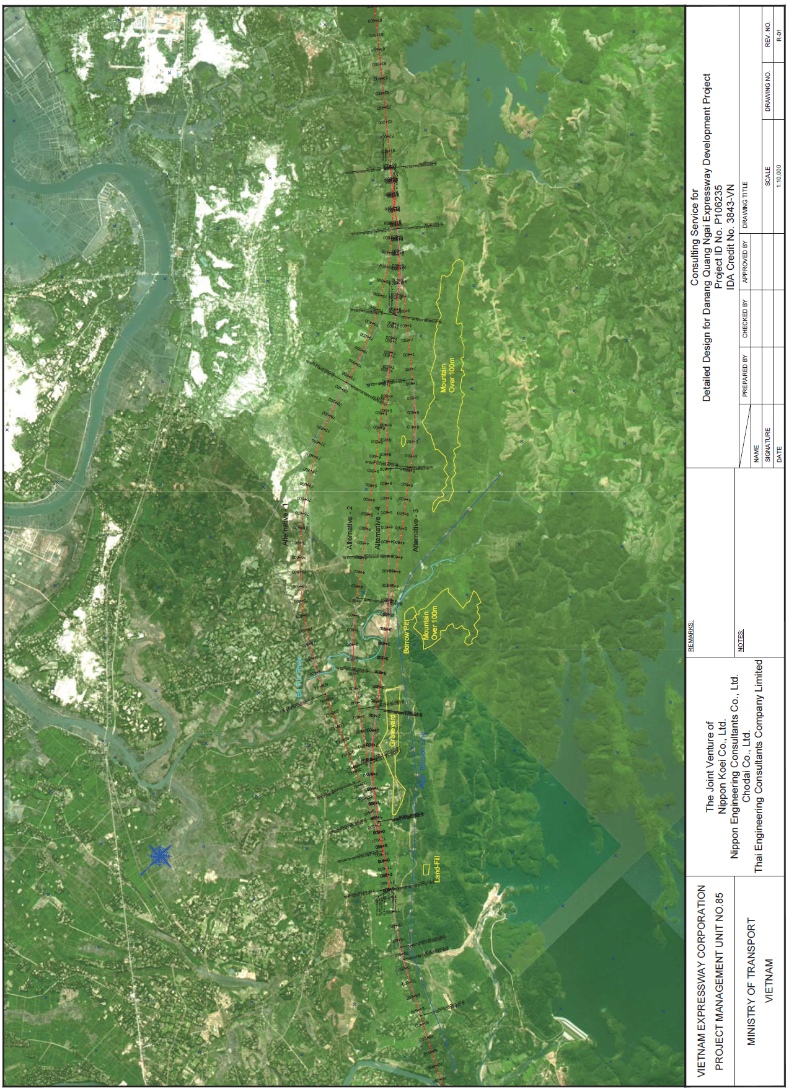
4. Profile Plan of Alignment Alternatives
Alternative-2 Alternative-3 Alterantive-4
5. Conclusion
Alternative-4 is recommended based on alignment comparison and advantages of the alternative-4 are as follows:
- Wide area for additional industrial zone is available
- Less impact to residential area
- Slope protection works is not required
- Project cost is lowest

